CarePath: An Online Disease/Healthcare System CPS731 Team 1
Veezish Ahmad (501080184)

Jessica Morcos (501093695)

Barbod Salehiporva (501120154)

Group 1

Table of Contents

Pre-PhaseI: Software Project Management Plan (SPMP)
  - Gantt Chart (excel format)
  - Team Organization and Management

Phase-I: Requirements Analysis
  - Discuss about System Domain & Objectives
  - Define System Major Actors/Components
  - Glossary
  - Table of Functional Requirements (FR)
  - Table of Non Functional Requirements (NFR)
  - Table of Assumptions (A)
  - Table of Responsibilities (R)
  - Table of Use Cases (UC)
  - Use Case Diagrams (UCD)
  - Use Case Scenarios (STD)
  - Activity Diagrams (AD)
  - Traceability (initial)

Phase-II: System Design
  - Apply Fixes on Phase-I
  - Class Diagram (initial)
  - Discuss and Apply selected Design Pattern(s)
  - Class Diagram (update)
  - Updated Sequence Diagrams (USD)
  - Traceability (update)

Phase-III & IV: System Implementation & Testing
  - Implementation of System Objects (coding)
  - Implementation of System UIs (coding)
  - Test Plan & Test Cases with Sample Results

Group 1

CarePath: An Online Disease/Healthcare System Pre-Phase 1 & Phase 1
CPS731 Group 1

Veezish Ahmad (501080184)

Jessica Morcos (501093695)

Barbod Salehiporva (501120154)

Group 1

Team Organization

Role | Team Member | Core Responsibilities | Key Deliverables / Tasks (per Gantt Chart) | Project Phases
Project Manager | Veezish | Oversees project planning, schedule tracking, cost estimation, and deliverable submission. Ensures consistency between requirements, design, and implementation. | Methodology & Initial Planning (1.1), Functional/Non-Functiona l Requirements (1.2), Class & Sequence Diagrams (1.6), Apply  Design Patterns (2.1), Slides & Demo (3.2.2) | Pre-Pha se I → Phase IV
System Designer / Backend Developer | Barbod | Designs system architecture, integrates backend components, performs unit testing and debugging. | Draft SPMP (1.1.1),  Requirements Docs (1.4), Integrate Components (2.4), Unit Tests & Debugging (3.1), System  Demos (3.2.1) | Phase I  → IV
UI/UX & Requirements Engineer | Jessica | Develops user interface and manages requirements documentation. Designs use cases and actors for clarity. | Use Cases & Actors (1.3), Define Classes & Attributes (1.5), Develop  UI (2.3), Project  Documentation (3.2) | Phase I  → IV
Quality Assurance & Testing Coordinator | All Team Members | Conducts validation testing, compiles final report, and ensures compliance with objectives. | Final Testing & Validation (4.1), Final Report  Compilation (4.2), Final Demo & Presentation (4.3) | Phase IV

Group 1

Table of Contents

Pre-PhaseI: Software Project Management Plan (SPMP)
  - Gantt Chart (excel format)
  - Team Organization and Management

Phase-I: Requirements Analysis
  - Discuss about System Domain & Objectives
  - Define System Major Actors/Components
  - Glossary
  - Table of Functional Requirements (FR)
  - Table of Non Functional Requirements (NFR)
  - Table of Assumptions (A)
  - Table of Responsibilities (R)
  - Table of Use Cases (UC)
  - Use Case Diagrams (UCD)
  - Use Case Scenarios (STD)
  - Activity Diagrams (AD)
  - Traceability (initial)

Group 1

Pre-PhaseI: Software Project Management Plan (SPMP)

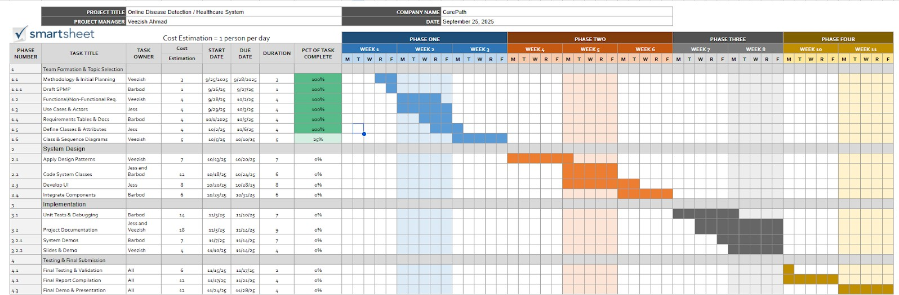
Gantt Chart (excel format)

Group 1

Team Organization and Management

Team Organization

Role | Team Member | Core Responsibilities | Key Deliverables / Tasks (per Gantt Chart) | Project Phases
Project Manager | Veezish | Oversees project planning, schedule tracking, cost estimation, and deliverable submission. Ensures consistency between requirements, design, and implementation. | Methodology & Initial Planning (1.1), Functional/Non-Functiona l Requirements (1.2), Class & Sequence Diagrams (1.6), Apply  Design Patterns (2.1), Slides & Demo (3.2.2) | Pre-Pha se I → Phase IV
System Designer / Backend Developer | Barbod | Designs system architecture, integrates backend components, performs unit testing and debugging. | Draft SPMP (1.1.1),  Requirements Docs (1.4), Integrate Components (2.4), Unit Tests & Debugging (3.1), System  Demos (3.2.1) | Phase I  → IV
UI/UX & Requirements Engineer | Jessica | Develops user interface and manages requirements documentation. Designs use cases and actors for clarity. | Use Cases & Actors (1.3), Define Classes & Attributes (1.5), Develop  UI (2.3), Project  Documentation (3.2) | Phase I  → IV
Quality Assurance & Testing Coordinator | All Team Members | Conducts validation testing, compiles final report, and ensures compliance with objectives. | Final Testing & Validation (4.1), Final Report  Compilation (4.2), Final Demo & Presentation (4.3) | Phase IV

Group 1

Management Parameters

Parameter | Description | Alignment with Gantt Chart
Leadership & Coordination | The Project Manager (Veezish Ahmad) leads planning and progress tracking meetings every two days to maintain alignment with Gantt milestones. | Reflected in Tasks 1.1 and  3.2 (Planning & Documentation).
Task Allocation | Tasks are divided according to individual strengths and technical roles.  Responsibilities mirror the actors defined in Phase I (use case mapping). | Gantt Tasks 1.1 – 3.2.2  show member ownership for each module .
Communication Plan | Regular updates via Microsoft Teams and shared Google Drive. Major decisions logged in the SPMP document. | Ongoing through Weeks 1 – 11 of Gantt.
Progress Monitoring | Weekly status reports reviewed against Gantt Chart timeline. Progress percentages tracked per task (25%–100% completion). | Gantt shows incremental progress values (e.g., Class Diagrams 25%) .
Quality  Assurance | Each phase includes internal reviews before submission. Unit tests and final validation (Phase III–IV) ensure  alignment with FR/NFR and STD tables. | Tasks 3.1 & 4.1.
Risk & Change Management | Contingency buffer built into Phase II–III for design iteration. Change  requests logged in SPMP and approved by Project Manager. | Week 6–10 of Gantt (Design and Integration phase).
Documentation Control | Versioning handled through Google Docs and GitHub. Documentation Lead (Jess) consolidates Phase Reports and SPMP sections. | Task 3.2 (Project Documentation).

Group 1

Phase I: Requirements Analysis

System Domain and Objectives

System Domain:
The Online Disease Detection / Healthcare System is part of the healthcare informatics domain. It integrates artificial intelligence and databases to support patients and healthcare providers. The system allows patients to input symptoms, medical history. The AI engine processes this input and produces likely disease predictions along with recommended next steps. Structural aspects include the user interfaces (patient portal, doctor portal, admin dashboard), a secure database, and an AI engine. Behaviorally, the system interacts in real time with users, enabling early intervention and providing decision support for medical professionals.

Objectives:
    - Provide patients with accessible, AI-assisted preliminary disease detection.

    - Improve early diagnosis and intervention to reduce healthcare costs and risks.

    - Ensure secure storage, management, and exchange of medical data.

    - Comply with regulations (HIPAA/PHIPA) and maintain trustworthiness.

In Scope:
    - Patient registration and authentication.
    - Symptom input and AI-based disease prediction.
    - Secure storage and retrieval of electronic health records (EHR).

    - Doctor access to patient data and predictions.

    - Administrative functions for user management and compliance enforcement.

Out of Scope:
    - Direct medical treatment or prescription services (system is an advisory tool, not a replacement for a licensed physician).

    - Hospital management functions such as pharmacy logistics, billing, or scheduling.

    - Emergency medical services requiring real-time intervention.

Group 1

System Major Components/Actors

Major Component / Actor | Responsibilities & Roles
Patient | Inputs symptoms, views results, communicates with doctor
Doctor | Reviews patient data, confirms/adjusts predictions, consults with patients
AI Engine | Analyzes inputs, generates disease predictions
Database | Stores encrypted medical data, patient history, and system logs
Admin | Manages users, oversees compliance and maintenance
System | Manages authentication, session control, request routing, error handling, and communication

  - Content of the Current Document and Glossary
All diagrams, tables and items in this document should have been assigned identifiers. The # symbol indicates a unique number for each member of a given category.

Category | Identifier
Use Case | UC#
Assumption | A#
Functional Requirements | FR#
Non Functional Requirements | NFR#
Scenario Textual Description | STD#
Sequence Diagram | SD#
Activity Diagrams | AD#
Class Diagrams | CD#
Test Case | TC#

Group 1

Table of Functional Requirements (FR)

Patient

FR ID | Description | Traceability
FR01 | The system shall allow patients to register/login | UC01, STD01,
 | securely. | AD01, R01, R08,
 |  | R25, R28, R33,
 |  | NFR03, NFR06,
 |  | A01, A02, A06
FR02 | The system shall allow patients to input symptoms. | UC02, STD02,
 |  | AD02, R02, R03,
 |  | R06, R07, R22,
 |  | R25, NFR01,
 |  | NFR04, A01, A03
FR03 | The system shall send alerts for abnormal readings | UC03, STD03,
 | to patients. | AD03, R06, R23,
 |  | NFR01, A01
FR04 | The system shall allow patients to review AI | UC03, STD03,
 | predictions. | AD03, R04, R20,
 |  | R23, NFR01, A07
FR05 | The system shall allow patients to update or | UC02, STD02,
 | correct previously entered data. | AD02, R07, R25,
 |  | R32, NFR01, A03
Doctor
FR ID | Description | Traceability
FR06 | The system shall allow doctors to view and edit | UC04, STD04,
 | patient reports. | AD04, R09–R13,
 |  | R25, R28, R32,
 |  | NFR03, NFR02,
 |  | A04
FR07 | The system shall allow doctors to annotate | UC04, STD04,
 | predictions with comments/notes. | AD04, R11, R12,
 |  | R25, NFR03, A04
FR08 | The system shall alert doctors when predictions are | UC03, UC04,
 | flagged as low confidence. | STD03, STD04,
 |  | AD03, AD04,

Group 1

 |  | R23, R14, R25, NFR01, A04, A07
FR09 | The system shall maintain longitudinal patient data for trend analysis. | UC04, UC05, STD04, STD05, AD04, AD05, R09, R13, R25, R32, NFR02, A05
FR10 | The system shall allow doctors to report incorrect predictions/system issues. | UC04, UC06, STD04, STD06, AD04, AD06, R14, R38, R39, A04, NFR02

AI Engine

FR ID | Description | Traceability
FR11 | The system shall generate possible disease | UC03, STD03,
 | predictions. | AD03, R17–R20,
 |  | R23, NFR01,
 |  | NFR05, A03, A07
FR12 | The AI Engine shall continuously learn and refine | UC03, STD03,
 | predictions from new data. | AD03, R18, R21,
 |  | NFR01, A03
FR13 | The AI Engine shall detect anomalies or | UC02, STD02,
 | incomplete data. | AD02, R22, R25,
 |  | NFR01, A03
FR14 | The AI Engine shall flag low-confidence | UC03, STD03,
 | predictions for doctor review. | AD03, R23, R14,
 |  | R11, A04, A07,
 |  | NFR01
FR15 | The AI Engine shall ensure predictions are | UC03, STD03,
 | generated within response time limits (< 2s). | AD03, R18, R24,
 |  | NFR01, A01, A05

Group 1

Database

FR ID | Description | Traceability
FR16 | The system shall store and retrieve patient health | UC05, STD05,
 | records in a structured format to support secure | AD05, R25, R27,
 | access by authorized users. | R32, A05, A06
FR17 | The Database shall store AI outputs (e.g., draft | UC05, STD05,
 | notes, summaries, recommendations) and reference | AD05, R25, R29,
 | the source request ID. | A05
FR18 | The system shall record all database operations | UC05, UC06,
 | (create, read, update, delete) in an audit log | STD05, STD06,
 | accessible to Admin for review. | AD05, AD06, R29,
 |  | R35, R36, NFR03,
 |  | A06
FR19 | The Database shall store AI generation requests | UC05, STD05,
 | (prompts, parameters) with a unique request ID. | AD05, R25, R27,
 |  | R31, A05, A09
FR20 | The system shall retrieve and deliver patient data | UC04, UC05,
 | to front-end users upon valid request. | STD04, STD05,
 |  | AD04, AD05, R25,
 |  | R32, A05

Admin
FR ID | Description | Traceability
FR21 | The system shall allow the Admin to create, | UC01, UC07,
 | modify, and deactivate user accounts. | STD01, STD07,
 |  | AD01, AD07, R33,
 |  | R34, NFR03, A08
FR22 | The system shall allow the Admin to assign | UC07, STD07,
 | appropriate access rights (role-based). | AD07, R34, R28,
 |  | R37, NFR03, A08
FR23 | The system shall allow the Admin to monitor | UC06, STD06,
 | compliance with healthcare regulations | AD06, R35–R37,
 | (HIPAA/PHIPA). | NFR03, A06
FR24 | The system shall allow the Admin to conduct | UC06, STD06,
 | audits of system activity. | AD06, R36, R29,
 |  | R35, NFR03, A06

Group 1

FR25 | The system shall allow the Admin to generate compliance and audit reports. | UC06, STD06, AD06, R36, R41, R29, NFR03, NFR02, A09
FR26 | The system shall allow the Admin to apply | UC06, STD06,
 | patches, updates, and upgrades to maintain | AD06, R39, R40,
 | availability. | R41, NFR02, A09

System
FR ID | Description | Traceability
FR27 | The system shall validate and route all incoming | UC01–UC07,
 | user requests to the correct component (AI, DB, | STD01–STD07,
 | or Admin). | AD01–AD07, R43,
 |  | R44, NFR03
FR28 | The system shall manage session control and | UC01, UC07,
 | authentication tokens to prevent unauthorized | STD01, STD07,
 | access. | AD01, AD07, R45,
 |  | R46, NFR03
FR29 | The system shall ensure synchronization | UC02, UC03, UC05,
 | between front-end interfaces and backend | STD02, STD03,
 | databases. | STD05,
 |  | AD02–AD05, R43,
 |  | R47, NFR02
FR30 | The system shall handle internal errors and | UC01–UC07,
 | provide user-friendly error messages without | STD01–STD07,
 | exposing sensitive data. | AD01–AD07, R48,
 |  | R49, NFR03
FR31 | The system shall log all transactions, activities, | UC05-UC07,
 | and data exchanges for auditability. | STD05-STD07,
 |  | AD05–AD07, R49,
 |  | NFR03
FR32 | The system shall enforce access control policies | UC01, UC04, UC07,
 | between patients, doctors, and admins. | STD01, STD04,
 |  | STD07, AD01,
 |  | AD04, AD07, R50,
 |  | NFR03
FR33 | The system shall maintain consistent uptime by | UC06, UC07,
 | handling exceptions and failover mechanisms. | STD06, STD07,
 |  | AD06, AD07, R51,
 |  | NFR02

Group 1

Table of Non-Functional Requirements (NFR)

ID | Description | Traceability
NFR01 | System response time ≤ 2 s (p95) for predictions | FR02, FR03,
 | and data retrieval. | FR08, FR11,
 |  | FR14, FR15,
 |  | FR20, UC02,
 |  | UC03, STD02,
 |  | STD03, AD02,
 |  | AD03, R18, R19,
 |  | R20, R24, R32,
 |  | A01, A05
NFR02 | System availability ≥ 99.5%; nightly automated | FR09, FR19,
 | backups; Recovery Point Objective (RPO) ≤ 24 | FR25, FR26,
 | h; Recovery Time Objective (RTO) ≤ 4 h; | FR33, UC05,
 | documented restore tests. | UC06, UC07,
 |  | STD05, STD06,
 |  | STD07,
 |  | AD05–AD07,
 |  | R27, R31, R39,
 |  | R40, R41, R51,
 |  | A05, A09
NFR03 | The system must comply with HIPAA / PHIPA | FR01, FR06,
 | requirements for privacy, consent, and access | FR16, FR17,
 | logging. | FR18, FR22,
 |  | FR23, FR24,
 |  | FR25, FR28,
 |  | FR30–FR32,
 |  | UC01, UC04,
 |  | UC05, UC06,
 |  | UC07, STD01,
 |  | STD04–STD07,
 |  | AD01,
 |  | AD04–AD07,
 |  | R15, R26, R28,
 |  | R29, R34–R37,
 |  | R45, R46, R49,
 |  | R50, A06, A04
NFR04 | The system supports a multilingual interface. | FR01, FR02,
 |  | UC01, UC02,
 |  | STD01, STD02,
 |  | AD01, AD02,
 |  | R01, R02, A02
NFR05 | The system can handle up to 10,000 concurrent | FR11, FR15,

Group 1

 | users. | FR33, UC03, UC05, UC06, STD03, STD05, STD06, AD03, AD05, AD06, R24, R30, R52, A05
NFR06 | All PHI shall be encrypted at rest (AES-256) | FR01, FR16,
 | and in transit (TLS 1.2 +). Keys are managed | FR17, UC01,
 | through an approved KMS with periodic rotation | UC05, UC06,
 | and auditing. | STD01, STD05,
 |  | STD06, AD01,
 |  | AD05, AD06,
 |  | R26, R29,
 |  | NFR03, A06

Table of Assumptions (A)

ID | Description | Traceability
A01 | Patients have access to a stable internet connection to | UC01, UC02,
 | use the system effectively. | UC03,
 |  | STD01–STD03,
 |  | FR01, FR02,
 |  | FR03, FR15,
 |  | FR20, NFR01,
 |  | R01, R02, R24
A02 | Users (patients/doctors) own a compatible device | UC01, UC02,
 | (smartphone, tablet, or PC) to run the application. | UC04, STD01,
 |  | STD02, STD04,
 |  | FR01, FR02,
 |  | FR06, NFR04,
 |  | R01, R02
A03 | Symptom and medical history data provided by | UC02, UC03,
 | patients is accurate and truthful. | STD02, STD03,
 |  | FR02, FR11,
 |  | FR12, FR13,
 |  | R02, R03, R06,
 |  | R22
A04 | Doctors using the system are licensed professionals | UC04, STD04,
 | who provide valid feedback. | FR06, FR07,
 |  | FR08, FR10,
 |  | FR14, NFR03,
 |  | R09–R16

Group 1

A05 | Cloud hosting services remain operational with | UC01–UC07,
 | minimal downtime. | STD01–STD07,
 |  | FR09, FR15,
 |  | FR16, FR19,
 |  | FR20, FR33,
 |  | NFR01, NFR02,
 |  | NFR05, R27,
 |  | R30, R31, R39,
 |  | R51
A06 | The system has the necessary approvals to comply | UC05, UC06,
 | with healthcare data protection regulations | UC07,
 | (HIPAA/PHIPA). | STD05–STD07,
 |  | FR01, FR16,
 |  | FR17, FR18,
 |  | FR23–FR25,
 |  | FR26, NFR03,
 |  | NFR06, R26,
 |  | R35, R37, R29,
 |  | R34
A07 | Patients understand that the system provides advisory | UC03, STD03,
 | predictions only and is not a replacement for medical | FR04, FR11,
 | treatment. | FR14, NFR01,
 |  | R04, R23
A08 | Adequate budget and time will be available to | All UC, All FR,
 | complete the system according to the project plan. | All NFR, FR21,
 |  | FR22, UC07,
 |  | STD07, AD07,
 |  | R33–R37, R42
A09 | No major external system failures (e.g., power | UC06, UC07,
 | outages, cyberattacks) will completely halt the | STD06, STD07,
 | service. | FR19, FR25,
 |  | FR26, FR33,
 |  | NFR02, R39,
 |  | R40, R41, R51

Table of Responsibilities

Responsibilities of the Patient
ID | Responsibility | Traceability
R01 | Register, log in, and manage personal profiles.. | UC01, STD01,
 |  | AD01, FR01,
 |  | FR21, NFR03,
 |  | NFR04, A01,
 |  | A02, A06

Group 1

R02 | Enter symptoms for analysis. | UC02, STD02,
 |  | AD02, FR02,
 |  | FR13, NFR01,
 |  | NFR04, A01,
 |  | A03
R03 | Upload medical history and updates when necessary. | UC02, STD02,
 |  | AD02, FR02,
 |  | FR13, A03
R04 | View AI-generated predictions. | UC03, STD03,
 |  | AD03, FR04,
 |  | FR11, FR14,
 |  | NFR01, A07
R05 | Review past reports and history stored in the system. | UC04, STD04,
 |  | AD04, FR06,
 |  | FR09, FR16,
 |  | NFR02, A05
R06 | Provide accurate input to ensure reliable predictions. | UC02, STD02,
 |  | FR02, FR03,
 |  | FR13, A03
R07 | Update or correct data if the system requests validation. | UC02, STD02,
 |  | AD02, FR02,
 |  | FR05, FR13,
 |  | NFR01
R08 | Log out securely after each session. | UC01, STD01,
 |  | AD01, FR01,
 |  | FR28, NFR03

Responsibilities of the Doctor

ID | Responsibility | Traceability
R09 | Log in securely with verified credentials. | UC01, UC04,
 |  | STD01, STD04,
 |  | AD01, AD04,
 |  | FR01, FR06,
 |  | FR21, NFR03,
 |  | A04
R10 | Access patient records and AI predictions. | UC04, STD04,
 |  | AD04, FR06,
 |  | FR20, NFR03,
 |  | A04
R11 | Validate, correct, or expand AI predictions with | UC04, STD04,

Group 1

 | professional judgment. | AD04, FR06,
 |  | FR07, FR14,
 |  | NFR03, A04
R12 | Add comments, notes, or recommendations to patient | UC04, STD04,
 | records. | AD04, FR06,
 |  | FR07, FR09,
 |  | NFR03
R13 | Review historical data for longitudinal analysis. | UC04, STD04,
 |  | AD04, FR06,
 |  | FR09, FR16,
 |  | FR20, NFR02
R14 | Report potential system errors or incorrect predictions. | UC04, UC06,
 |  | STD04, STD06,
 |  | AD04, AD06,
 |  | FR10, FR11,
 |  | FR18, A04,
 |  | NFR02
R15 | Maintain confidentiality of patient data. | UC04, UC05,
 |  | STD04, STD05,
 |  | AD04, AD05,
 |  | FR06, FR16,
 |  | FR17, NFR03,
 |  | A04, A06
R16 | Use the system consistently to support continuous | UC03, UC04,
 | improvement of AI accuracy. | STD03, STD04,
 |  | AD03, AD04,
 |  | FR11, FR12,
 |  | A04

Responsibilities of the AI Engine

ID | Responsibility | Traceability
R17 | Retrieve patient symptoms and history from the database. | UC03, STD03,
 |  | AD03, FR11,
 |  | FR16, FR20,
 |  | NFR01
R18 | Process input data using machine learning algorithms. | UC03, STD03,
 |  | AD03, FR11,
 |  | FR12, FR15,
 |  | NFR01,
 |  | NFR05
R19 | Generate predictions with confidence levels. | UC03, STD03,

Group 1

 |  | AD03, FR11, FR14, NFR01, NFR05
R20 | Deliver results to the user interface. | UC03, STD03,
 |  | AD03, FR04,
 |  | FR11, NFR01
R21 | Continuously learn and refine predictions based on new | UC03, STD03,
 | data. | AD03, FR11,
 |  | FR12, A03
R22 | Detect anomalies or incomplete data. | UC02, STD02,
 |  | AD02, FR02,
 |  | FR13, A03
R23 | Flag low-confidence predictions for doctor review. | UC03, STD03,
 |  | AD03, FR03,
 |  | FR08, FR11,
 |  | FR14, NFR01,
 |  | A07
R24 | Ensure predictions are generated within response time | UC03, STD03,
 | limits. | AD03, FR11,
 |  | FR15, NFR01,
 |  | NFR05, A01,
 |  | A05

Responsibilities of the Database

ID | Responsibility | Traceability
R25 | Store and retrieve patient records securely. | UC01, UC02, UC04, UC05, STD01–STD05, AD01–AD05, FR01, FR02, FR05, FR06, FR09, FR16, FR20, NFR03
R26 | Encrypt all sensitive patient health information. | UC05, UC06, STD05, STD06, AD05, AD06, FR16, FR17, FR18, NFR03, NFR06, A06
R27 | Backup data regularly to prevent loss. | UC05, STD05, AD05, FR16,

Group 1

 |  | FR19, FR26, NFR02, A05
R28 | Manage access controls for different system roles. | UC01, UC04, UC07, STD01, STD04, STD07, AD01, AD04, AD07, FR06, FR22, FR32, NFR03
R29 | Maintain audit logs for accountability. | UC05, UC06, UC07, STD05–STD07, AD05–AD07, FR16, FR18, FR24, FR25, NFR03, A06
R30 | Support scalability for concurrent access. | UC01, UC02, UC03, UC05, STD01–STD05, AD01–AD05, FR11, FR15, NFR05, A05
R31 | Restore data quickly in case of system failure. | UC05, UC06, STD05, STD06, AD05, AD06, FR19, FR25, FR26, NFR02, A05, A09
R32 | Optimize storage for efficient retrieval. | UC04, UC05, STD04, STD05, AD04, AD05, FR06, FR09, FR16, FR20, NFR01

Responsibilities of the Admin

ID | Responsibility | Traceability

Group 1

R33 | Create and manage user accounts. | UC01, UC07, STD01, STD07, AD01, AD07, FR01, FR21, NFR03, A08
R34 | Assign appropriate access rights (patient, doctor, staff). | UC07, STD07, AD07, FR22, FR32, NFR03, A08
R35 | Monitor compliance with healthcare regulations (HIPAA/PHIPA). | UC06, STD06, AD06, FR23, FR24, FR25, NFR03, A06
R36 | Conduct regular audits of system activity. | UC06, STD06, AD06, FR23, FR24, FR25, NFR03, NFR02, A06
R37 | Enforce data privacy and security policies. | UC06, STD06, AD06, FR23, FR24, FR25, NFR03, A06
R38 | Resolve reported technical/system issues. | UC06, STD06, AD06, FR10, FR26, NFR02, A09
R39 | Maintain uptime and ensure system availability. | UC06, UC07, STD06, STD07, AD06, AD07, FR26, FR33, NFR02, A09, A05
R40 | Apply patches, updates, and upgrades to the system. | UC06, STD06, AD06, FR26, NFR02, A09
R41 | Respond to and document incidents (e.g., cyberattacks, downtime). | UC06, STD06, AD06, FR25, FR26, NFR02, A09
R42 | Train users and provide support for proper system use. | UC01, UC02, UC04, STD01–STD04,

Group 1

AD01–AD04, FR01, FR02, FR06, A08

Responsibilities of the System
ID | Responsibility | Traceability
R43 | Coordinate communication between all components | UC02, UC03,
 | and ensure workflow execution (e.g., Patient → AI | UC05, STD02,
 | Engine → Database). | STD03, STD05,
 |  | AD02, AD03,
 |  | AD05, FR27,
 |  | FR29, NFR03
R44 | Validate incoming data and enforce consistent | UC02, STD02,
 | formatting before passing to backend modules. | AD02, FR27,
 |  | FR29, NFR03,
 |  | A03
R45 | Handle authentication requests and generate session | UC01, UC07,
 | tokens. | STD01, STD07,
 |  | AD01, AD07,
 |  | FR28, FR33,
 |  | NFR03
R46 | Implement timeout, logout, and re-authentication | UC01, UC07,
 | mechanisms for secure access. | STD01, STD07,
 |  | AD01, AD07,
 |  | FR28, NFR03,
 |  | A01
R47 | Maintain state consistency between AI predictions and | UC03, UC05,
 | database updates. | STD03, STD05,
 |  | AD03, AD05,
 |  | FR29, FR32,
 |  | NFR02
R48 | Capture and handle exceptions gracefully with | UC01–UC07,
 | appropriate user-side alerts. | STD01–STD07,
 |  | AD01–AD07,
 |  | FR30, NFR03
R49 | Maintain detailed transaction and access logs for | UC05, UC06,
 | auditability and traceability. | UC07,
 |  | STD05–STD07,
 |  | AD05–AD07,
 |  | FR31, NFR03,
 |  | NFR06, A06

Group 1

R50 | Apply access control rules (RBAC) ensuring each role’s | UC07, STD07,
 | permissions are respected. | AD07, FR32,
 |  | FR22, NFR03,
 |  | A08
R51 | Monitor uptime and initiate failover to backup services | UC06, UC07,
 | during downtime. | STD06, STD07,
 |  | AD06, AD07,
 |  | FR33, FR19,
 |  | NFR02, A05,
 |  | A09
R52 | Scale requests dynamically under heavy system load. | UC03, UC05,
 |  | STD03, STD05,
 |  | AD03, AD05,
 |  | FR35, FR33,
 |  | NFR05, A05

Table of Use Cases (UC)

ID | Name | Description | Sub-Goals | Traceability
UC 01 | Register/Lo gin | Patient creates an account, logs in securely, and manages  profile settings. | Validate user credentials  - Allow new user registration  - Encrypt and store authentication details  - Provide password recovery/reset  - Enforce session management (logout, timeout) | FR01, FR21, FR28, STD01, AD01, R01, R08, R09, R25, R28, R33, R45, R46, R50, NFR03, NFR04, NFR06, A01, A02, A06
UC 02 | Enter Symptoms | Patient inputs symptoms and uploads medical history for analysis. | - Input symptoms  via structured fields  - Upload past medical history  - Validate completeness/format of data  - Store securely in database  - Confirm successful submission | FR02, FR05, FR13, STD02, AD02, R02, R03, R06, R07, R22, R25, R44, NFR01, NFR04, A01, A03

Group 1

UC 03 | Generate Prediction | AI Engine analyzes inputs and generates possible  disease predictions. | - Retrieve patient input from database  - Analyze symptoms using AI/ML  - Generate predictions with confidence levels  - Display results clearly to patient  - Flag  low-confidence results for doctor review | FR03, FR04, FR08, FR11, FR12, FR14, FR15, STD03, AD03, R04, R16, R17, R18, R19, R20, R21, R23, R24, R43, R44, R47, NFR01, NFR05, A03, A04, A07
UC 04 | View Patient Reports | Doctor accesses patient history, AI predictions, and updates records. | - Retrieve records, symptoms, and predictions  - Display historical patient reports  - Enable doctor edits/annotations  - Save corrections/notes  - Maintain version history | FR06, FR07, FR08, FR09, FR10, FR20, STD04, AD04, R09, R10, R11, R12, R13, R14, R15, R16, R25, R28, R32, R42, NFR03, NFR02, A02, A04, A05
UC 05 | Store Health Records | Database securely stores and encrypts patient | - Encrypt health information  - Store in  compliance with | FR09, FR16, FR17, FR18, FR19, FR20, STD05,

Group 1

 |  | information and predictions. | HIPAA/PHIPA  - Maintain audit logs of data actions  - Enable efficient record retrieval  - Backup/restore to ensure reliability | AD05, R25, R26, R27, R29, R30, R31, R32, R43, R47, NFR03, NFR05, NFR06, A05, A06
UC 06 | Manage  Compliance | Admin monitors system activity, ensures compliance, and manages users. | - Admin monitors system logs  - Conduct PHIPA/HIPAA  audits  - Detect/respond to security incidents  - Apply updates/patches  - Generate  compliance reports | FR10, FR18, FR23, FR24, FR25, FR26, STD06, AD06, R35, R36, R37, R38, R39, R40, R41, R49, R51, NFR02, NFR03, NFR06, A06, A09
UC 07 | Manage User Accounts | Allow Admin to create, modify, or  deactivate accounts. | - Add new  patient/doctor accounts  - Modify account details  - Reset credentials  - Deactivate inactive accounts  - Enforce role-based access | FR21, FR22, FR32, STD07, AD07, R28, R33, R34, R35, R37, R39, R42, R45, R46, R50, NFR03, NFR02, A08

Use Case Diagram (UCD)

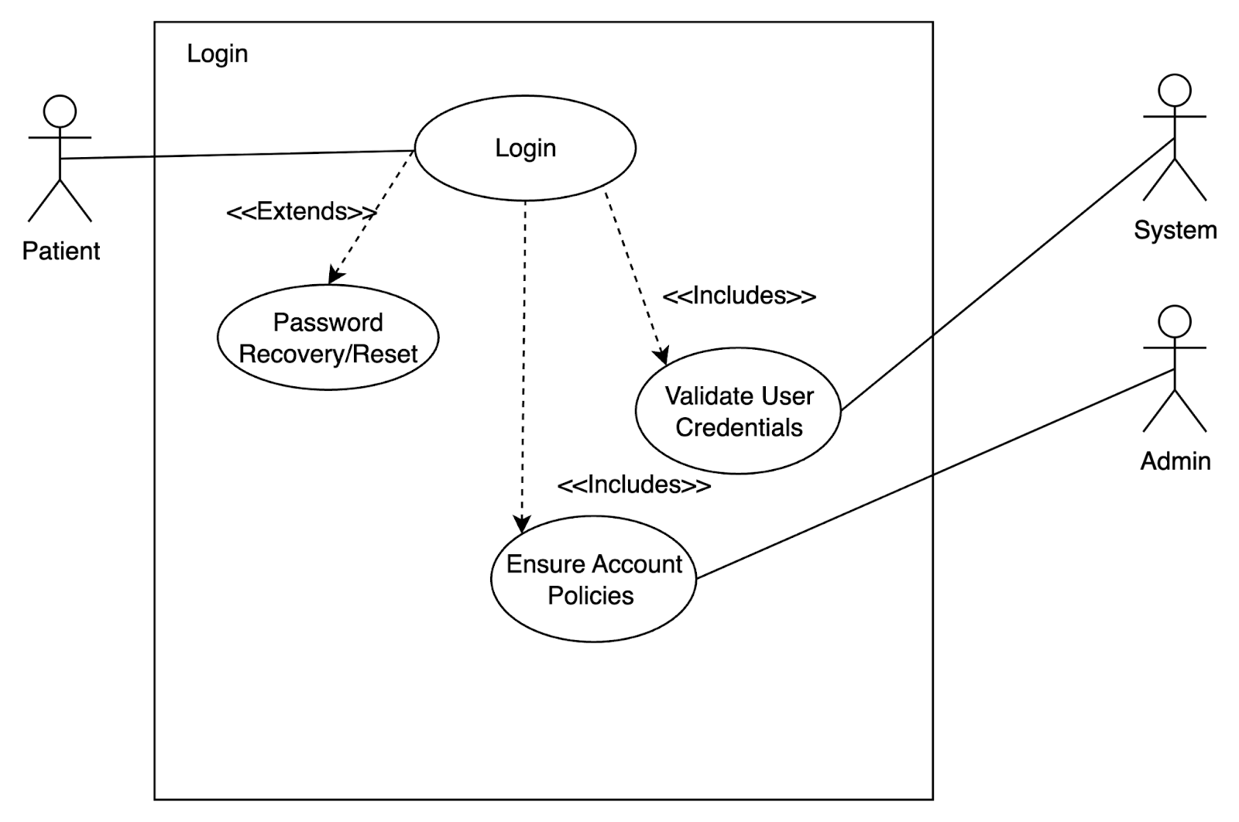
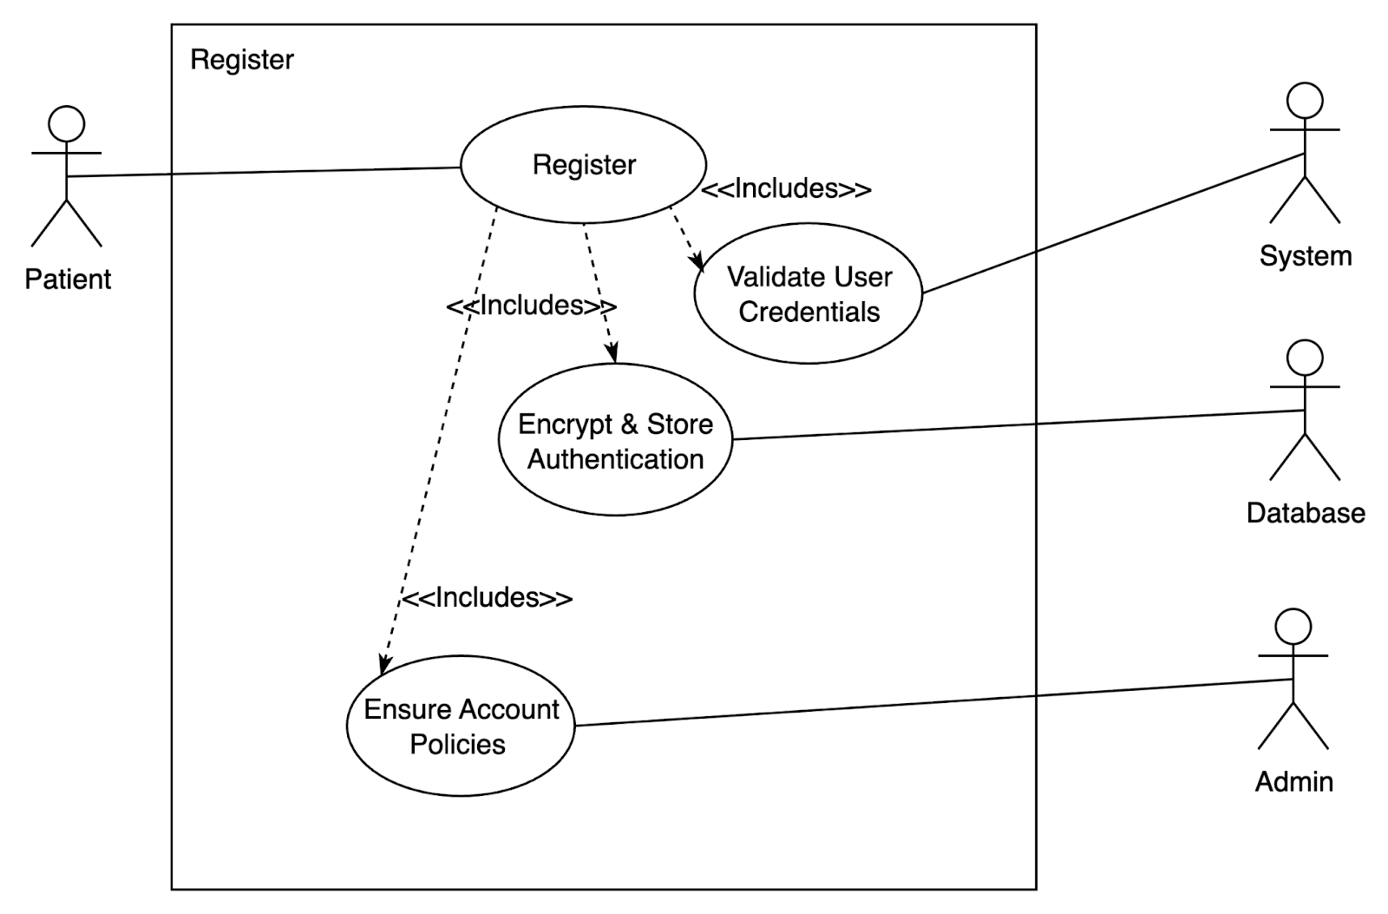
Login/Register

Group 1

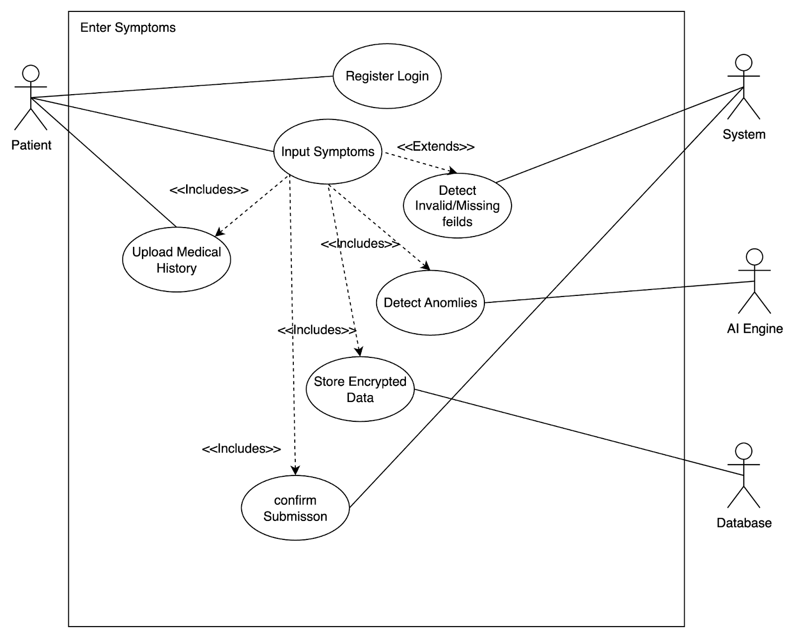
Enter Symptoms

Generate Prediction
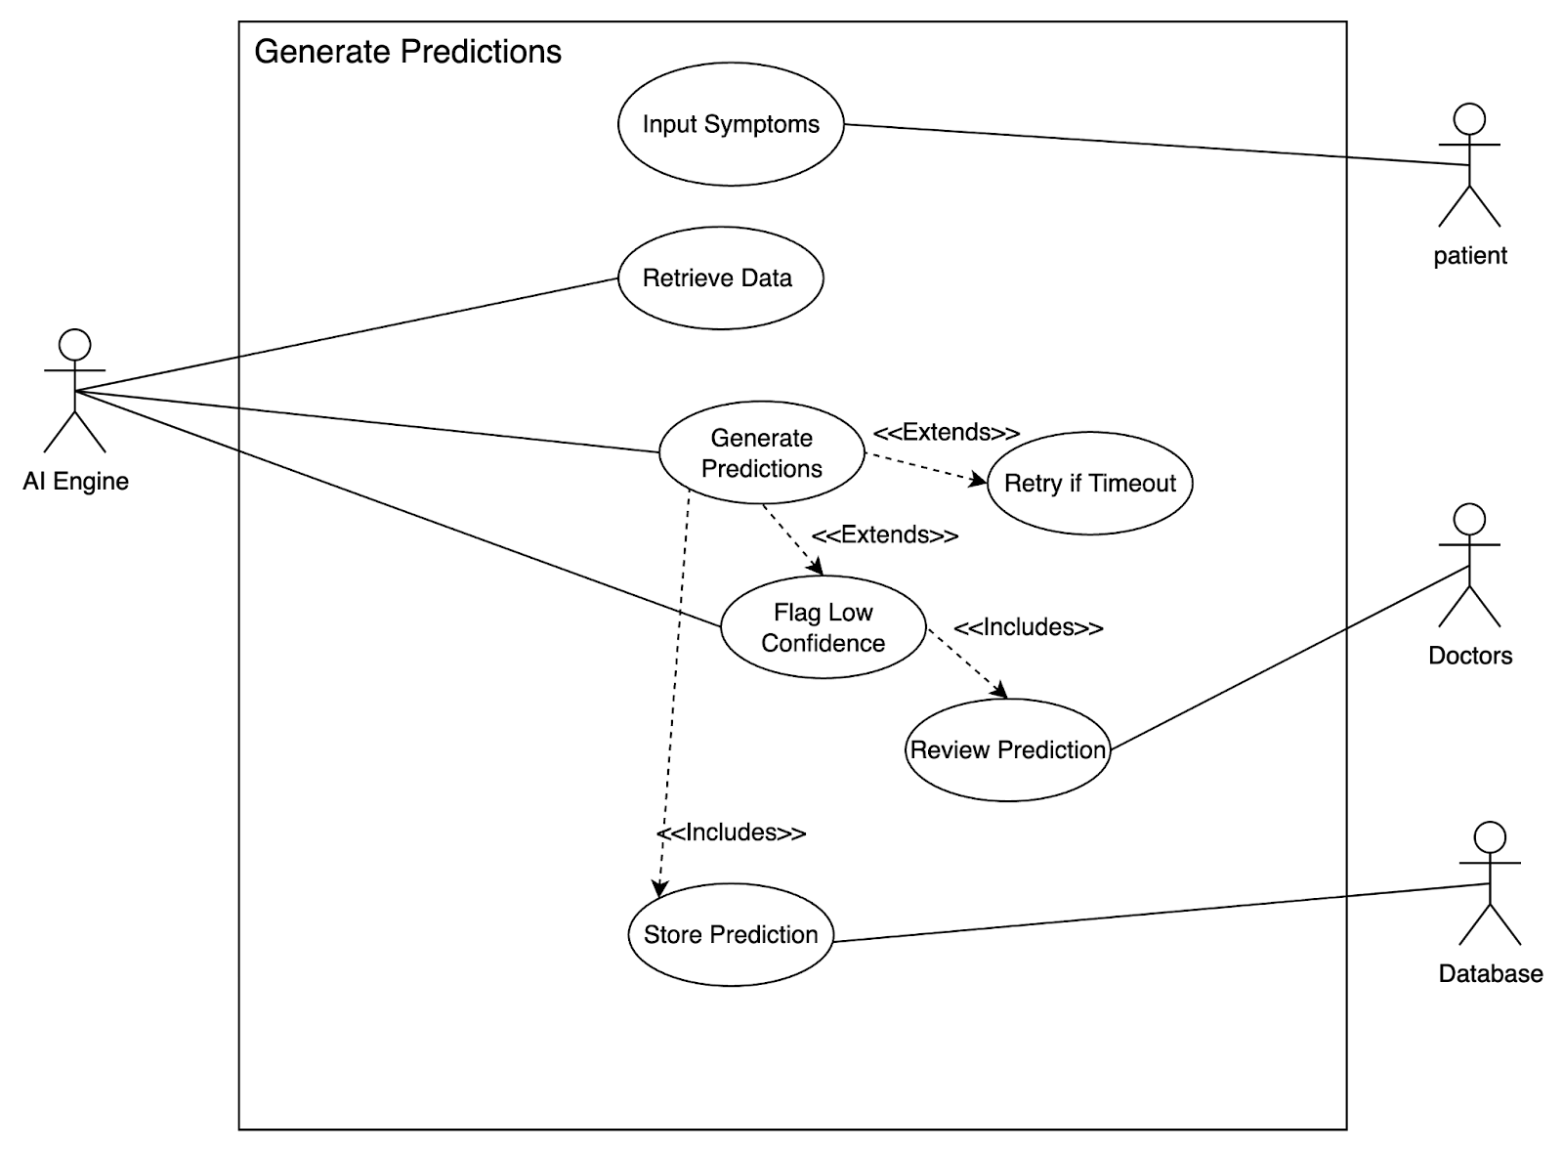

Group 1

View Patient Reports
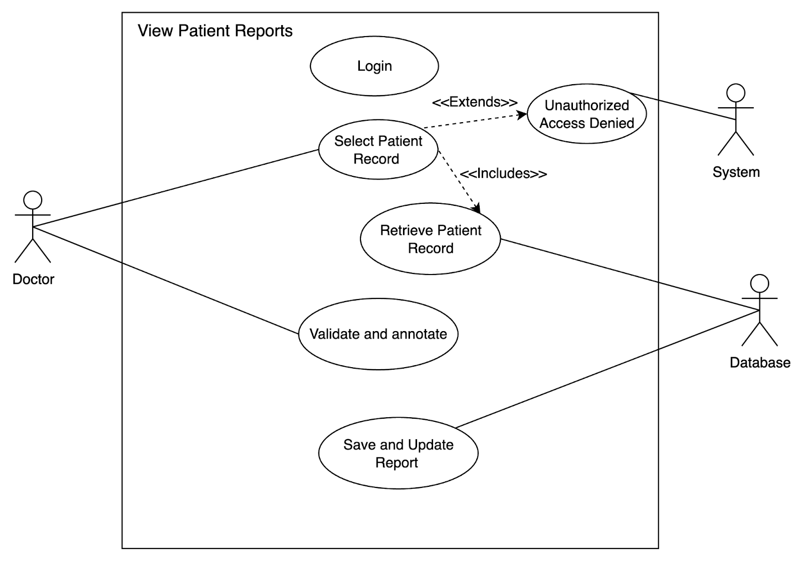

Store Health Records
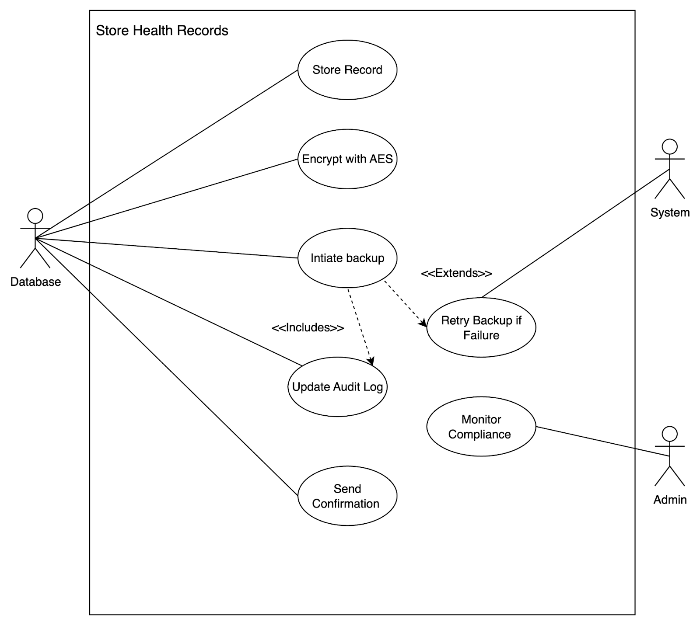

Group 1

Manage Compliance
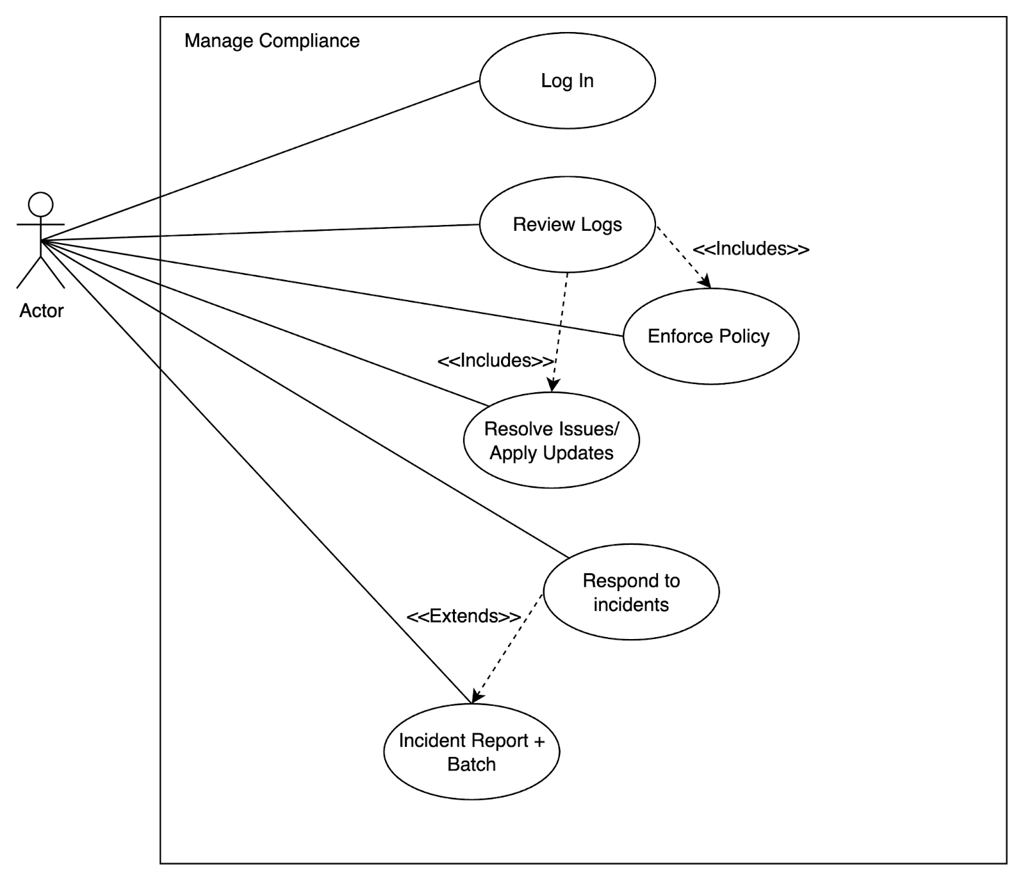
Manage User Accounts

Group 1

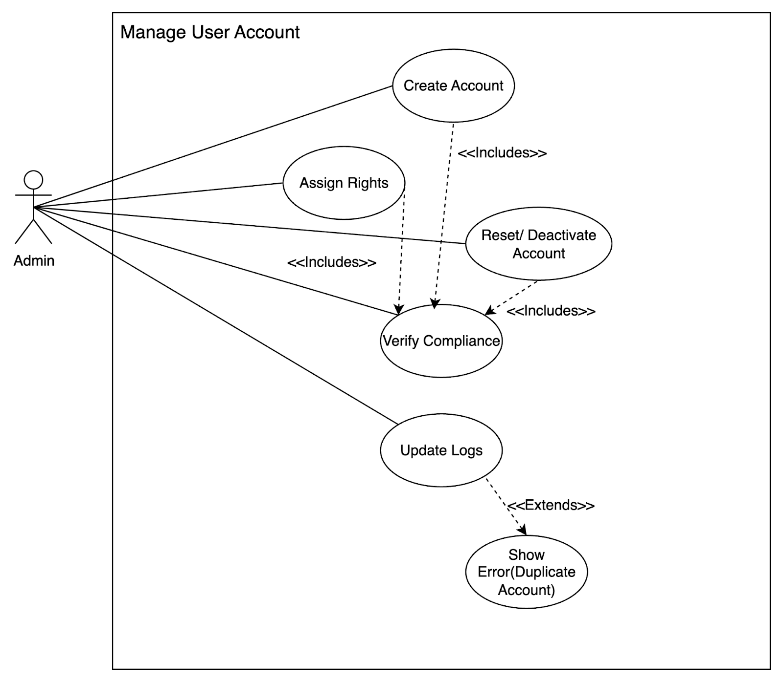

Scenario Textual Descriptions (STD)

STD01: Register/Login (UC01)

Field | Description
Scope & Description | Patient registers or logs into the system securely.
Primary Actor | Patient
Stakeholders & Interests | Patient: wants secure access.  System: must validate and encrypt credentials.  Admin: ensures compliance.
Precondition | Patient has device + internet connection.
Trigger | Patient selects “Register” or “Login.”

Group 1

Main Scenario Steps | - (R01) Patient provides login details.  - System validates input.  - (R25) DB retrieves/creates account record.  - (R33) Admin ensures account policies.  - Patient enters dashboard.
Postcondition | Patient logged in successfully.
Extensions | Invalid login → retry prompt. Forgotten password → recovery option.

STD02: Enter Symptoms (UC02)

Field | Description
Scope & Description | Patient inputs symptoms and medical history.
Primary Actor | Patient
Stakeholders & Interests | Patient: easy input.  Doctor: depends on reliable data.  System: secure storage.
Precondition | Patient is logged in (UC01).
Trigger | Patient selects “Enter Symptoms.”
Main Scenario Steps | - (R02) Patient inputs symptoms.  - (R03) Uploads history.  - (R22) AI detects anomalies.  - (R25, R26) DB stores encrypted data.  - System confirms submission.
Postcondition | Symptoms stored in DB for analysis.
Extensions | Missing/invalid fields → correction prompt.

STD03: Generate Prediction (UC03)

Field | Description
Scope & Description | AI Engine analyzes patient data and generates predictions.
Primary Actor | AI Engine

Group 1

Stakeholders & Interests | Patient: wants timely results. Doctor: reviews for accuracy. System: ensures compliance.
Precondition | Symptoms stored in DB (UC02).
Trigger | Patient submits data for analysis.
Main Scenario Steps | - (R17) AI retrieves data.  - (R18, R19) Processes input and generates predictions.  - (R23) Flags low-confidence cases.  - (R20) Sends results to UI.  - (R25) Stores prediction in DB.
Postcondition | Predictions displayed + stored.
Extensions | Timeout → retry. Low confidence → doctor review.

STD04: View Patient Reports (UC04)

Field | Description
Scope & Description | Doctor reviews patient records and AI predictions.
Primary Actor | Doctor
Stakeholders & Interests | Doctor: complete and accurate data.  Patient: expects reliable interpretation.
Precondition | Doctor logged in (UC01).
Trigger | Doctor selects patient record.
Main Scenario Steps | - (R09) Doctor logs in.  - (R10) Requests file.  - (R25, R28) DB retrieves record.

Group 1

- (R11, R12) Doctor validates/annotates.
- System saves updates.
Postcondition | Report updated and stored.
Extensions | Unauthorized access → denied.

STD05: Store Health Records (UC05)

Field | Description
Scope & Description | Database stores encrypted health data.
Primary Actor | Database
Stakeholders & Interests | Patient: data privacy.  Doctor: reliable retrieval.  Admin: compliance.
Precondition | New data submitted by patient or AI.
Trigger | System sends data to DB.
Main Scenario Steps | - (R25) DB stores record.  - (R26) Encrypts with AES-256.  - (R27) Backup initiated.  - (R29) Audit log updated.  - Confirmation returned.
Postcondition | Data securely stored.
Extensions | Backup failure → retry.

STD06: Manage Compliance (UC06)

Field | Description
Scope & Description | Admin oversees compliance and audits.
Primary Actor | Admin
Stakeholders & Interests | Admin: ensures regulations.  Users: trust system protection.
Precondition | Admin authenticated.
Trigger | Admin selects compliance dashboard.

Group 1

Main Scenario Steps | - (R33) Admin logs in.  - (R35, R36) Reviews logs.  - (R37) Enforces policies.  - (R38–R40) Resolves issues, applies updates.  - (R41) Responds to incidents.
Postcondition | Compliance maintained.
Extensions | Breach detected → incident report + patch.

STD07: Manage User Accounts (UC07)

Field | Description
Scope & Description | Admin creates, modifies, or deactivates accounts.
Primary Actor | Admin
Stakeholders & Interests | Admin: manages accounts.  Users: expect security.
Precondition | Admin authenticated.
Trigger | Admin opens user management panel.
Main Scenario Steps | - (R33) Create account.  - (R34) Assign rights.  - (R35, R37) Verify compliance.  - Reset or deactivate accounts.  - (R36, R39) Update logs.
Postcondition | Accounts updated.
Extensions | Duplicate account → error prompt.

Activity Diagrams (AD)

AD01: Register/Login (UC01)

Group 1

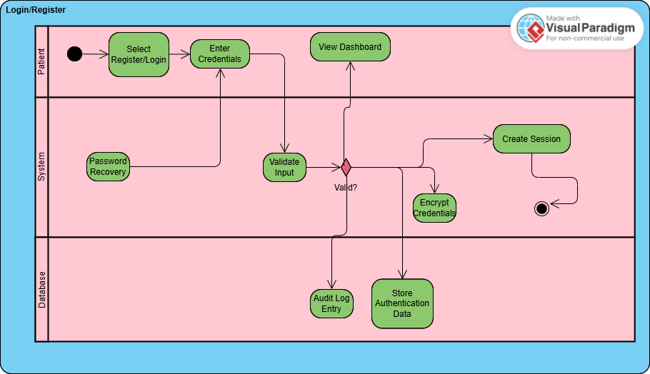

AD02: Enter Symptoms (UC02)

Group 1

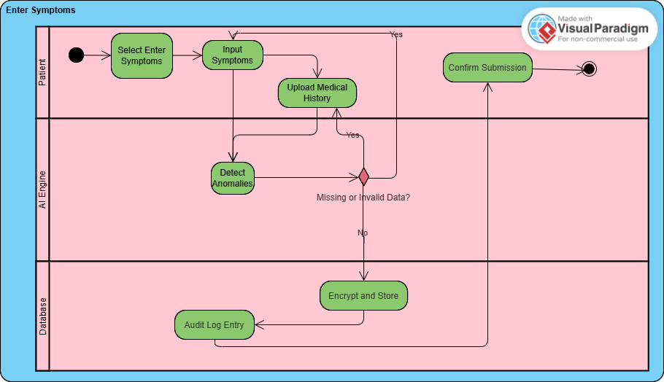

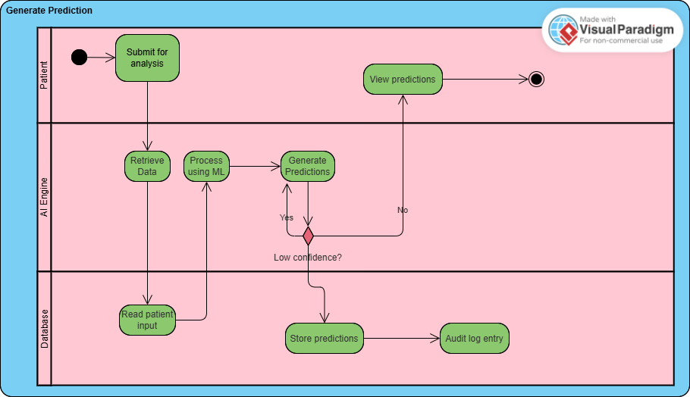
AD03: Generate Prediction (UC03)

AD04: View Patient Reports (UC04)

Group 1

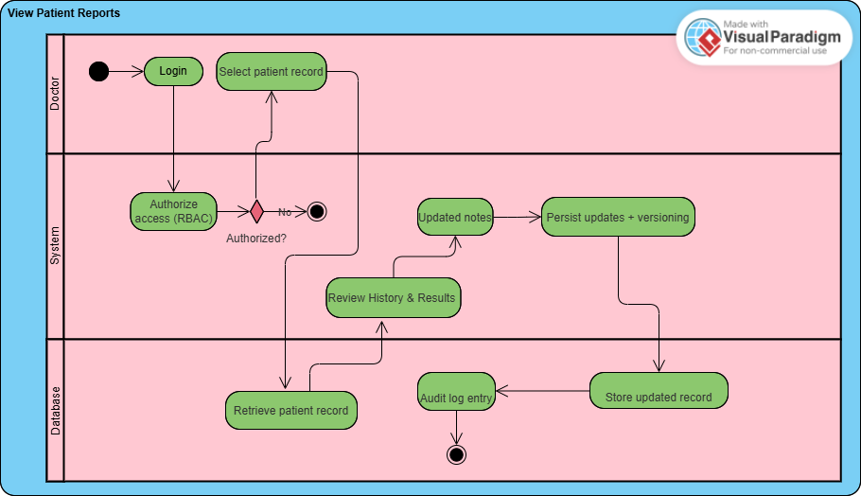

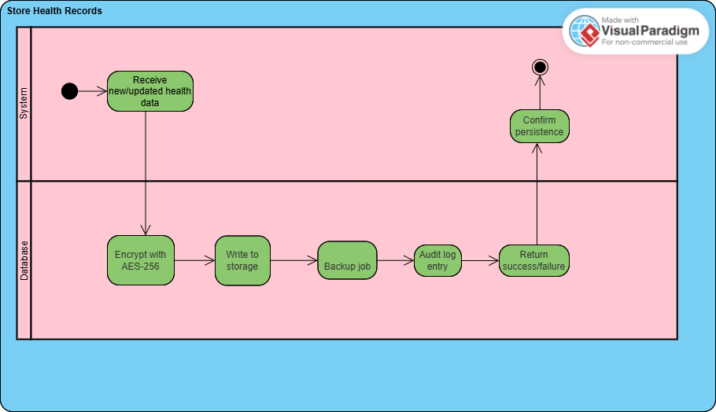
AD05: Store Health Records (UC05)

AD06: Manage Compliance (UC06)

Group 1

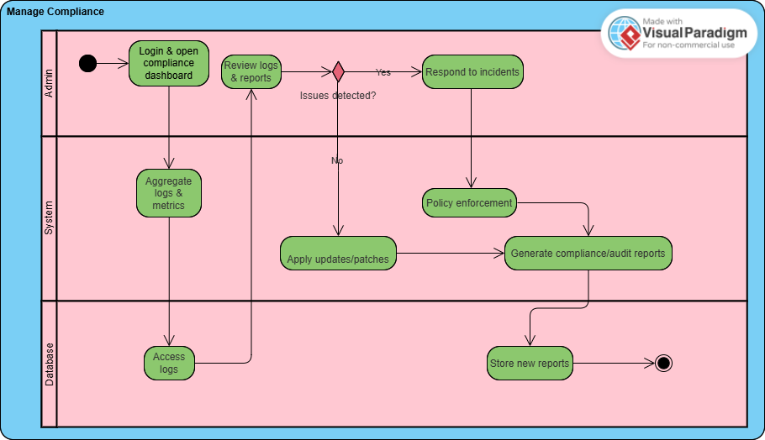

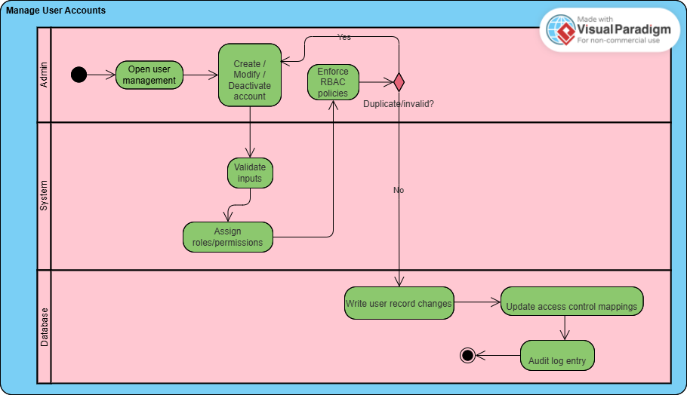
AD07: Manage User Accounts (UC07)

Traceability (initial)

Group 1

FR | Description | UC | STD | AD | R / NFR / A
FR | Patients can | UC01 | STD01 | AD01 | R01, R08, R09,
01 | register/login securely |  |  |  | R25, R33, R45,
 |  |  |  |  | R46 / NFR03,
 |  |  |  |  | NFR04, NFR06 /
 |  |  |  |  | A01, A02, A06
FR | Patients input | UC02 | STD02 | AD02 | R02, R03, R06,
02 | symptoms for AI |  |  |  | R07, R22, R25 /
 | analysis |  |  |  | NFR01, NFR04 /
 |  |  |  |  | A01, A03
FR | Abnormal reading alerts | UC03 | STD03 | AD03 | R06, R23 / NFR01
03 | to patients |  |  |  | / A01
FR | Patients review AI | UC03 | STD03 | AD03 | R04, R20, R23 /
04 | predictions |  |  |  | NFR01 / A07
FR | Patients update or | UC02 | STD02 | AD02 | R07, R25 / NFR01
05 | correct previous data |  |  |  | / A03
FR | Doctors view and edit | UC04 | STD04 | AD04 | R09–R13, R25,
06 | patient reports |  |  |  | R28, R32 /
 |  |  |  |  | NFR03, NFR02 /
 |  |  |  |  | A04, A05
FR | Doctors annotate | UC04 | STD04 | AD04 | R11, R12, R25 /
07 | predictions with notes |  |  |  | NFR03 / A04
FR | Alert doctors on | UC03, | STD03, | AD03, | R14, R23, R25 /
08 | low-confidence | UC04 | STD04 | AD04 | NFR01 / A04,
 | predictions |  |  |  | A07
FR | Maintain longitudinal | UC04, | STD04, | AD04, | R09, R13, R25,
09 | patient data for trends | UC05 | STD05 | AD05 | R32 / NFR02 /
 |  |  |  |  | A05
FR | Doctors report incorrect | UC04, | STD04, | AD04, | R14, R38 / NFR02
10 | predictions / issues | UC06 | STD06 | AD06 | / A04
FR | Generate possible | UC03 | STD03 | AD03 | R17–R20, R23 /
11 | disease predictions |  |  |  | NFR01, NFR05 /
 |  |  |  |  | A03, A07
FR | Continuously learn and | UC03 | STD03 | AD03 | R18, R21 / NFR01
12 | refine predictions |  |  |  | / A03
FR | Detect anomalies or | UC02 | STD02 | AD02 | R22, R25 / NFR01
13 | incomplete data |  |  |  | / A03

Group 1

FR | Flag low-confidence | UC03 | STD03 | AD03 | R23, R11, R14 /
14 | predictions for review |  |  |  | NFR01 / A04,
 |  |  |  |  | A07
FR | Ensure prediction | UC03 | STD03 | AD03 | R18, R24 /
15 | response < 2 s |  |  |  | NFR01, NFR05 /
 |  |  |  |  | A01, A05
FR | Store patient data | UC05 | STD05 | AD05 | R25–R29, R32 /
16 | securely |  |  |  | NFR03, NFR06 /
 |  |  |  |  | A05, A06
FR | Apply AES-256 | UC05 | STD05 | AD05 | R26, R25 /
17 | encryption to PHI |  |  |  | NFR03, NFR06 /
 |  |  |  |  | A06
FR | Record DB operations | UC05, | STD05, | AD05, | R29, R35, R36 /
18 | in audit log | UC06 | STD06 | AD06 | NFR03, NFR06 /
 |  |  |  |  | A06
FR | Perform automated | UC05 | STD05 | AD05 | R27, R31, R39 /
19 | backups and recovery |  |  |  | NFR02 / A05,
 |  |  |  |  | A09
FR | Retrieve and deliver | UC04, | STD04, | AD04, | R25, R32 / NFR01
20 | data to front-end users | UC05 | STD05 | AD05 | / A05
FR | Admin | UC01, | STD01, | AD01, | R33, R34 / NFR03
21 | create/modify/deactivat | UC07 | STD07 | AD07 | / A08
 | e accounts
FR | Assign role-based | UC07 | STD07 | AD07 | R34, R28, R50 /
22 | access rights |  |  |  | NFR03 / A08
FR | Monitor HIPAA/PHIPA | UC06 | STD06 | AD06 | R35–R37 / NFR03
23 | compliance |  |  |  | / A06
FR | Conduct audits of | UC06 | STD06 | AD06 | R36, R29 /
24 | system activity |  |  |  | NFR03, NFR02 /
 |  |  |  |  | A06
FR | Generate compliance | UC06 | STD06 | AD06 | R36, R41, R29 /
25 | and audit reports |  |  |  | NFR03, NFR02 /
 |  |  |  |  | A09
FR | Apply patches, updates, | UC06 | STD06 | AD06 | R39, R40, R41 /
26 | and upgrades |  |  |  | NFR02 / A09
FR | Validate and route | UC01– | STD01 | AD01– | R43, R44 / NFR03
27 | incoming requests | UC07 | –STD0 | AD07 | / A03
 |  |  | 7

Group 1

FR | Manage session control | UC01, | STD01, | AD01, | R45, R46 / NFR03
28 | and tokens | UC07 | STD07 | AD07 | / A01
FR | Synchronize front-end | UC02, | STD02, | AD02– | R43, R47 / NFR02
29 | and back-end data | UC03, | STD03, | AD05 | / A05
 |  | UC05 | STD05
FR | Handle errors and show | UC01– | STD01 | AD01– | R48 / NFR03 /
30 | safe messages | UC07 | –STD0 | AD07 | A01
 |  |  | 7
FR | Log transactions and | UC05, | STD05 | AD05– | R49 / NFR03,
31 | data exchanges | UC06, | –STD0 | AD07 | NFR06 / A06
 |  | UC07 | 7
FR | Enforce access control | UC01, | STD01, | AD01, | R50, R28 / NFR03
32 | policies | UC04, | STD04, | AD04, | / A08
 |  | UC07 | STD07 | AD07
FR | Maintain uptime via | UC06, | STD06, | AD06, | R39, R51 / NFR02
33 | failover mechanisms | UC07 | STD07 | AD07 | / A05, A09

Group 1

42

Group 1

CarePath: An Online Disease/Healthcare System Phase 2
CPS731 Group 1

Veezish Ahmad (501080184)

Jessica Morcos (501093695)

Barbod Salehiporva (501120154)

Group 1

Table of Contents

Phase-II: System Design
  - Apply Fixes on Phase-I
  - Class Diagram (initial)
  - Discuss and Apply selected Design Pattern(s)
  - Class Diagram (update)
  - Updated Sequence Diagrams (USD)
  - Traceability (update)

Group 1

Apply Fixes on Phase-I

Section | Type of Fix | Description of Corrections
1.4 Functional Requirements (FR) | Traceability consistency | Added missing cross-links between FRs and related UCs, STDs, ADs, Rs, NFRs, and As. Ensured all FRs have at least one corresponding Responsibility (R) and Use Case (UC). Added system-level FRs (FR27–FR33) with correct references to R43–R52.
 | Clarity and coverage | Rewrote traceability cells so that each FR now accurately references all components involved (e.g., FR08 now includes UC03 & UC04; FR19 includes NFR02 & A05). Ensured doctor-, database-, and admin-related FRs properly link to R and NFR tables. Ensured Database FRs were not written like NFRs.
1.5  Non-Functional Requirements  (NFR) | Cross-table alignment | Fixed missing and incomplete mappings (e.g., NFR02 → R39–R41). Linked NFR01 to all latency-related FRs and NFR06 to encryption FRs (FR16–FR17). Included missing responsibilities (R26, R29, R45–R50).
 | Performance and compliance | Mapped NFR05 to all scalability FRs (FR11, FR15, FR33) and system-level responsibilities (R24, R30, R52).
1.6 Assumptions (A) | Expanded relational mapping | Each assumption now directly links to at least  one FR, NFR, UC, and relevant R. Added proper compliance mapping (A06 ↔ HIPAA/PHIPA FRs). Clarified operational dependencies (A05 ↔ FR19, FR33, R27, R39).
 | Consistency fixes | Unified structure so every A# uses the same identifier format; ensured A08/A09 reference project and uptime-related FRs.
1.7  Responsibilities (R) | Full backward linkage | Rebuilt all traceability columns to show two-way relationships between Rs and corresponding FRs, UCs, STDs, ADs, and NFRs. Added missing entries for Admin (R35–R41) and System (R43–R52).

Group 1

 | System integration fixes | System-level responsibilities (R43–R52) were reconnected to FR27–FR33 and the appropriate UCs and ADs for routing, error handling, and scaling.
1.8 Use Cases (UC) | Expanded traceability coverage | Each UC now maps to its STDs, ADs, and all related FRs, Rs, NFRs, and As. Added missing system responsibilities and included A-links (contextual assumptions) for clarity.
 | Cross-validation | Ensured that UCs correspond correctly with STDs and ADs (e.g., UC03 ↔ STD03 ↔ AD03).  Included cross-links for Admin operations (UC06, UC07).
1.12 Traceability Matrix (Final) | Full matrix restructured | Created complete forward and backward traceability from FR → UC → STD → AD → R/NFR/A. Added all missing cross-references and ensured that every FR appears at least once in each dimension.
 | Consistency across tables | Standardized all identifiers (FR##, UC##, STD##, AD##, R##, NFR##, A##). Verified all  references match their definitions in prior sections.

The traceability structure was systematically corrected to ensure end-to-end alignment between requirements, responsibilities, use cases, and design artifacts.
All tables were cross-verified to remove missing, redundant, or inconsistent references. Functional Requirements (FRs) were expanded to include their corresponding UCs, STDs, ADs, Rs, NFRs, and As, ensuring every functional element can be traced both forward (toward implementation) and backward (toward its origin).
Non-Functional Requirements (NFRs) were connected to relevant performance, compliance, and encryption responsibilities, while Assumptions (A) were mapped to the exact technical or behavioral conditions they depend upon.
Responsibilities (R) were unified across actors and components, and the System responsibilities (R43–R52) were newly connected to the internal operational FRs (FR27–FR33).
Finally, the comprehensive Traceability Matrix (Section 1.12) was rebuilt to show complete linkage between requirements, design diagrams, roles, and compliance obligations, resulting in a coherent and auditable Phase 1 document that satisfies both structural and
academic traceability standards.

Group 1

Class Diagram (initial)
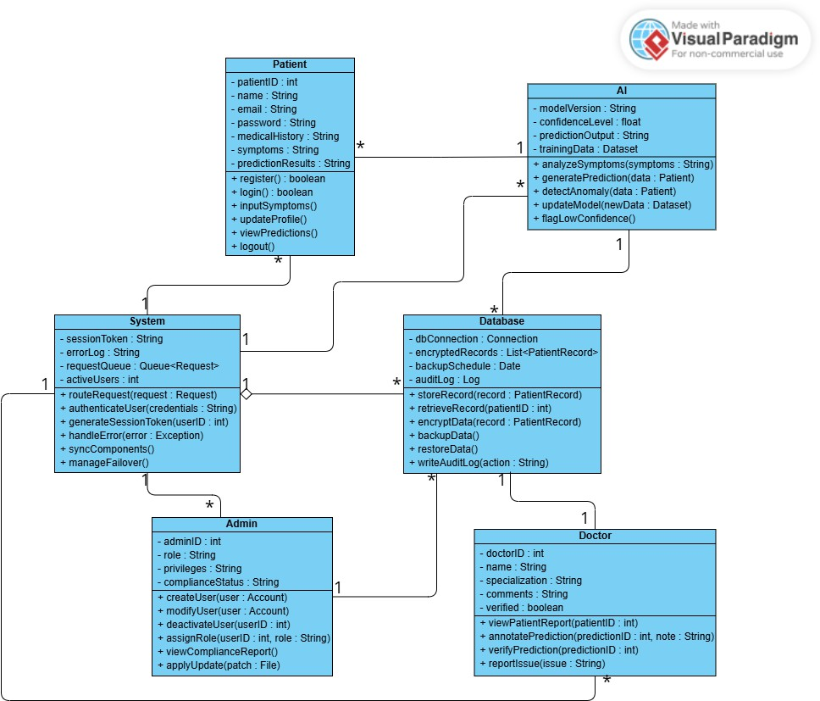

Group 1

Discuss and Apply selected Design Pattern(s)
    - GRASP Controller – split today’s “System” into use-case controllers

      - Why: a controller is the first object after the UI that receives a system event and delegates the work to domain experts; you can use one “facade” controller for the whole system or a small controller per use case. Keeping it thin avoids a bloated god-class and supports low coupling/high cohesion.

      - How in the model: keep System as a facade and add specific controllers that call into the existing classes:

        - AuthController → login/session (FR27–FR28).

        - SymptomController → validates & routes symptom submissions (FR27, FR29).

        - PredictionController → orchestrates AI predictions/flagging (ties UC03 to AI/DB).

        - RecordsController → fetch/store patient records (FR20).

        - ComplianceController → audits/compliance operations (FR23–FR26).
    - MVC (Model–View–Controller) – make the UI independent of the domain model
      - Why: the model (the Patient/Doctor/AI/Database classes) should not depend on GUI details; controllers handle input and views subscribe to model changes. This lets you swap web/mobile UIs and have multiple views stay in sync via a propagation/dependency mechanism.
      - How in the model: treat the new use-case controllers above as the MVC “C”; “views” are the UI screens; the current classes remain the MVC “M”.
    - GRASP Information Expert – put behavior where the data lives
      - Why: assign each responsibility to the class that has the information to fulfill it; this preserves encapsulation, lowers coupling, and increases cohesion.
      - How in the model:

        - Database owns encryption/backup/audit because it has the data & facilities (FR16–FR19). Keep encryptData(), backupData(), and writeAuditLog() here.

        - AI keeps analyzeSymptoms(), generatePrediction(), flagLowConfidence() since it has the model/metrics. (Matches UC03

Group 1

responsibilities listed for the system.)

        - Doctor validates/annotates predictions because they hold the clinical knowledge (FR06–FR10).

    - GRASP Creator – make the class that aggregates/uses another class create it

      - Why: A should create B if A contains/records/closely uses B or has the init data for B. This separates creation from use while keeping coupling low.

      - How in the model (introduce small value objects):

        - Patient creates SymptomEntry when entering symptoms.

        - AI creates Prediction (with confidenceLevel) when analyzing.

        - Doctor creates Annotation/Report entries when reviewing.

        - Database creates AuditLogEntry when storing/retrieving records (FR18).

        - AuthController creates SessionToken during login (FR28).

    - GRASP Low Coupling & High Cohesion – keep classes focused and independent
      - Why: fewer dependencies mean fewer ripple-effects; focused classes are easier to understand/reuse. The Controller guidance explicitly ties back to these two qualities.
      - How in the model:

        - Move errorLog/handleError() out of System into a small ErrorHandler (called by controllers); keep System/controllers delegating, not doing.

        - Keep Database focused on storage/security/audit (FR16–FR19) and avoid UI or workflow logic there.

What changes in the diagram
      - Add: AuthController, SymptomController, PredictionController, RecordsController, ComplianceController between UI and the current classes; they receive requests and forward to the right expert (per GRASP Controller).

      - Add light value objects (SymptomEntry, Prediction, Annotation, AuditLogEntry, SessionToken) and use Creator to show who instantiates them.

Group 1

      - Show MVC layering: UI → Controllers → Model (the existing classes). Keep dependencies one-way from UI to Model to allow multiple UIs and synchronized views.

Why these patterns fit the specs
      - FRs already say “validate and route all incoming user requests,” “manage session tokens,” and “sync back-end components,” which are textbook controller responsibilities (FR27–FR29).
      - Data-centric FRs around storage, encryption, audit, and backup belong to the
Database as the Information Expert (FR16–FR19).

      - Splitting controllers by use case prevents a bloated controller and keeps cohesion high while coupling low.

      - Adopting MVC decouples the UI from the model so you can evolve views independently and propagate updates across views.

Class Diagram Update
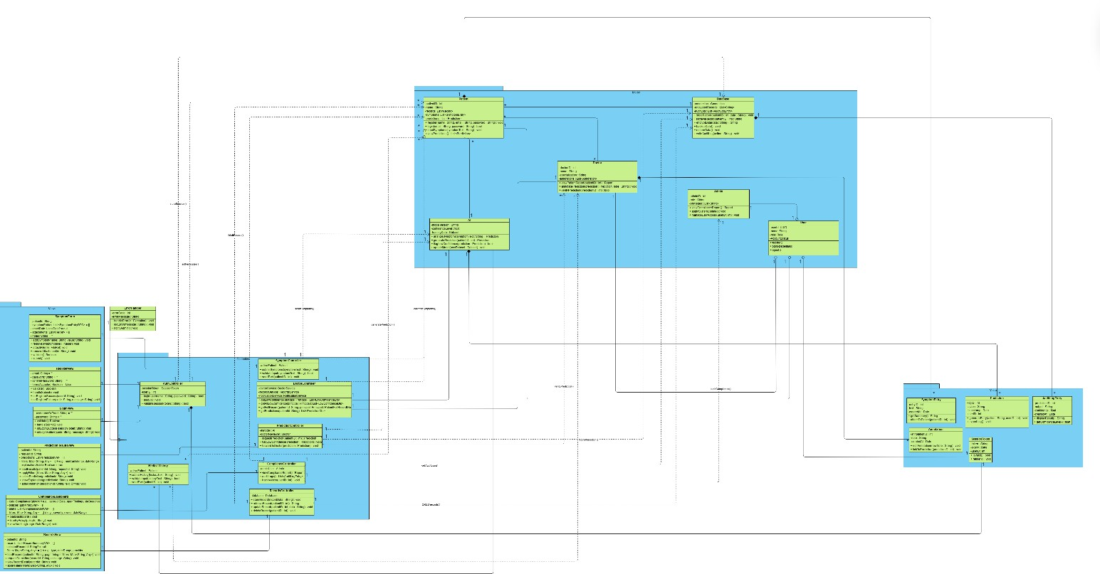

Group 1



1 Model
Patient
-patientID : int
-name : String
-records: List<Record>
-symptoms: List<SymptomEntry>
-predictions : List<Prediction>
+ register(name : String, email : String, password : String) : void
+ login(email : String, password : String) : bool
+ inputSymptoms(symptomText : String) : void
+ viewPredictions() : List<Prediction>
*
* *
* *
* 1
*
* *

Doctor
*
collectsSymptoms()
1
1
+ viewPatientReport(patientID : int) : Report
+ annotatePrediction(prediction : Prediction, note : String) : void
+ verifyPrediction(predictionID : int) : bool
-doctorID : int
-name : String
-specialization : String
-annotations : List<Annotation>

* 1
1
storeSession()

1
AI

1
-modelVersion : String
-confidenceLevel : float
-trainingData : Dataset
fetchRecord()
+ analyzeSymptoms(symptomText : String) : Prediction
+ generatePrediction(patientID : int) : Prediction
+ flagLowConfidence(prediction : Prediction) : bool
+ updateModel(newDataset : Dataset) : void
1

1
1

authenticates()

1
1
+ storeRecord(patientID : int, data : String) : void
+ retrieveRecord(patientID : int) : String
+ encryptData(data : String) : String
+ backupData() : void
+ restoreData() : void
+ writeAuditLog(action : String) : void
-connection : Connection
-encryptedRecords : List<String>
-auditLog : List<AuditLogEntry>
Database
1
1
1
1

Admin
-adminID : int
-role : String
-privileges : List<String>
1
+ viewComplianceReport() : Report
+ applySystemUpdate() : void
+ manageUserAccess(userID : int) : void
1
1
-userId: UUID
-name: String
-role: Role
-AccountStatus
User

+register()
+login(credentials)
+logout()
1 1 1

Views
-errorCode : int
-errorMessage : String
ErrorHandler
SymptomForm
- patientId: String
- symptomEntries: List<SymptomEntryDTO> = []
- onsetDate: LocalDate? = null
- attachments: List<FileRef> = []
- notes: String = ""
+ addSymptom(name: String, value: String): void
+ removeSymptom(index: Integer): void
+ attachFile(file: FileRef): void
+ removeAttachment(id: String): void
+ validate(): Boolean
+ submit(): void

1
+ handleError(e : Exception) : void
+ logError(message : String) : void
+ notifyAdmin() : void

1

Controllers
1
-activePatient : Patient
sendSymptoms()

1 1
SymptomController

generatePrediction()

1 1 1
+ validate(): Boolean
+ handleSubmit(): void
+ onRegisterSuccess(userId: String): void
+ onRegisterFailure(code: String, message: String): void
- email: String = ""
- password: String = ""
- confirmPassword: String = ""
- termsAccepted: Boolean = false
RegisterView
+ submitSymptoms(symptomText : String) : void
+ validateInput(symptomText : String) : bool
+ sendToAI(patientID : int) : void
1 1
-doctorService: DoctorService
-recordsService: RecordsService
-notificationService: NotificationService
-sessionToken : SessionToken
-userID : int
DoctorController
AuthController

1
+ getLowConfidence(principal: Principal): List<LowConfidenceDto>
+ getAllLowConfidence(principal: Principal): List<LowConfidenceDto>
+ getFullRecord(patientId: String, principal: Principal): PatientFullRecordDto
+ getPredictions(patientId: String): List<PredictionDto>
+ login(username : String, password : String) : bool
+ logout() : void
+ validateSession(token : String) : bool

1 1
LoginView
- usernameOrEmail: String = ""
- password: String = ""
+ validate(): Boolean
+ handleSubmit(): void
+ onLoginSuccess(sessionToken: String): void
+ onLoginFailure(code: String, message: String): void

1
1
PredictionController
1
-aiModel : AI
-doctorReviewer : Doctor
1 1
+ requestPrediction(patientID : int) : Prediction
+ flagLowConfidence(prediction : Prediction) : void
+ forwardToDoctor(prediction : Prediction) : void
1 1
PredictionResultsView
- patientId: String
- requestId: String
- predictions: List<PredictionVM> = []
- filters: Map<String, Any> = {} // e.g., minConfidence, dateRange
- explanationVisible: Boolean = true
+ loadResults(patientId: String, requestId: String): void
+ applyFilters(filters: Map<String, Any>): void
+ selectPrediction(predictionId: String): void
+ showExplanation(predictionId: String): void
+ addAnnotation(predictionId: String, text: String): void

1
* 1 1
ComplianceController

MedicalHistory
1
+ submitHistory(historyText : String) : void
+ validateInput(historyText : String) : bool
+ sendToAI(patientID : int) : void
-activePatient : Patient
+ viewComplianceReport() : Report
+ auditLogs() : List<AuditLogEntry>
+ trackAccess(userID : int) : void
-adminUser : Admin
1

* *
-database : Database
RecordsController
1
+ storeRecord(recordData : String) : void
+ retrieveRecord(patientID : int) : String
+ updateRecord(patientID : int, data : String) : void
+ deleteRecord(patientID : int) : void
ComplianceDashboard
- kpis: ComplianceKpisVM // e.g., lastAuditDate, openFindings, slaBreaches
- policies: List<PolicyVM> = []
- alerts: List<ComplianceAlertVM> = []
- filters: Map<String, Any> = {} // e.g., severity, owner, dateRange
+ loadDashboard(): void
+ filterByPolicy(policyId: String): void
+ viewAuditLog(range: DateRange): void

1
1
1

1
+ loadRecords(patientId: String, page: Integer, filters: Map<String, Any>): void
+ requestCorrection(recordId: String, message: String): void
+ viewRecordDetail(recordId: String): void
+ applyFilters(filters: Map<String, Any>): void
- patientId: String
- records: List<RecordSummaryVM> = []
- selectedRecordId: String? = null
- filters: Map<String, Any> = {} // e.g., type, dateRange, provider
RecordsView

getAuditLogs()

CRUD records()

verifyPrediction()

storePrediction()

auditCompliance()

Value
* * *

SymptomEntry
-entryID : int
-text : String
-createdAt : Date
+ getSummary() : String

-logID : int
-action : String
-timestamp : Date
-userID : int
Prediction
AuditLogEntry
-predictionID : int
-output : String
-confidence : float
-createdAt : Date

+ attachToPatient(patientID : int) : void
+ generateEntry(action : String, userID : int) : void
+ exportLog() : void
+ displayResult() : String
+ getConfidenceLevel() : float

Annotation
-annotationID : int
-note : String
* -createdAt : Date
+ editAnnotation(newNote : String) : void
+ linkToPrediction(predictionID : int) : void

SessionToken
-token : String
-expiry : Date
1 -userID : int
+ isValid() : bool
+ refresh() : void
1

Updated Sequence Diagrams (USD)

USD01
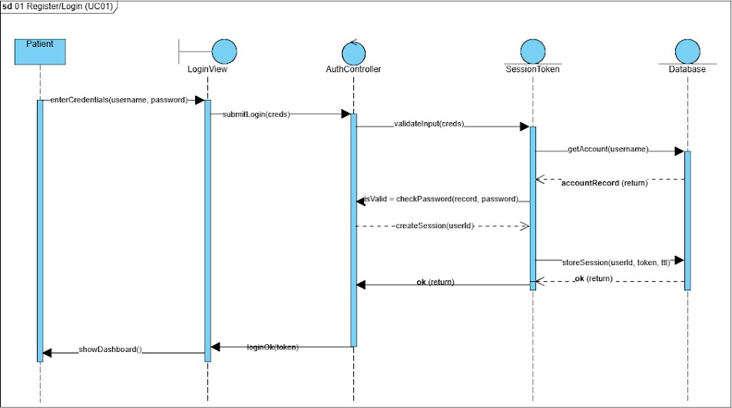

USD02
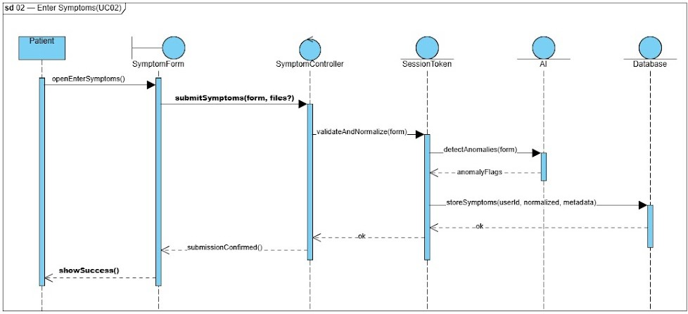

Group 1

USD03
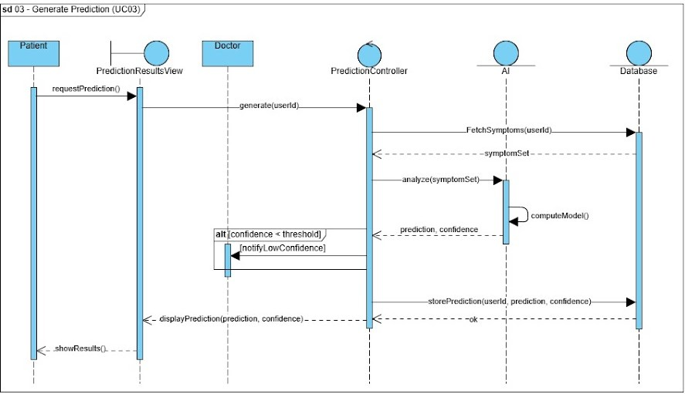
USD04
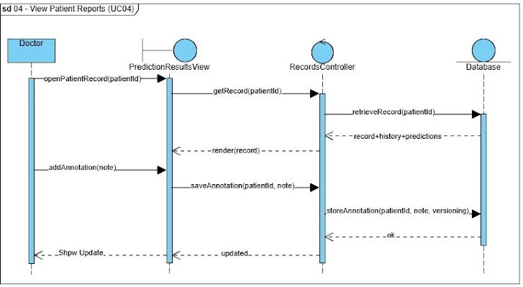

Group 1

USD05
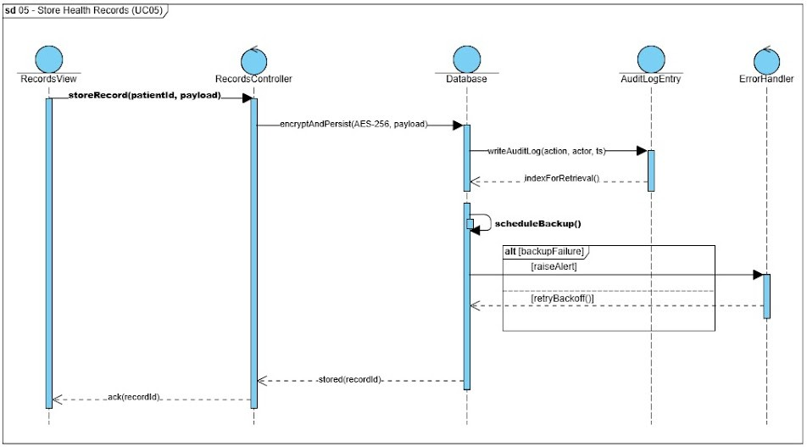
USD06
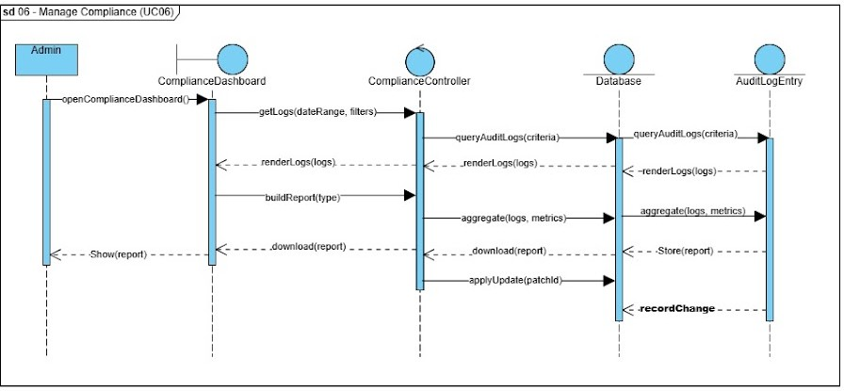

Group 1

USD07
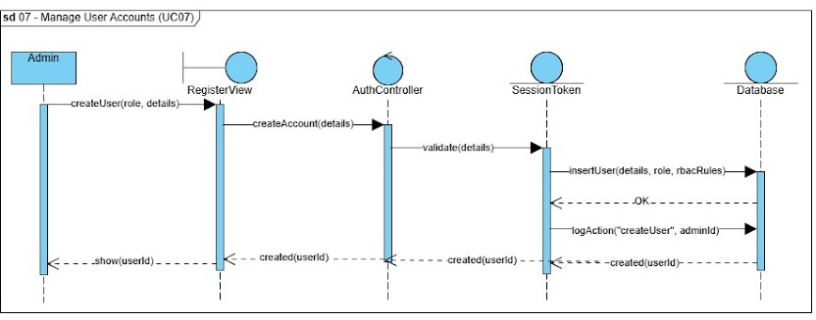
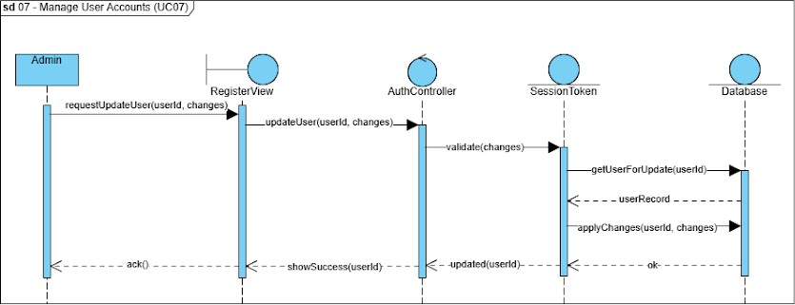

Group 1

Traceability (update)

FR | Description | UC | STD | AD | SD / USD | R / NFR / A
FR01 | Patients can register/login securely | UC01 | STD01 | AD01 | SD01 / USD01 | R01, R08, R09, R25, R33, R45, R46 / NFR03, NFR04, NFR06  / A01, A02, A06
FR02 | Patients input symptoms for AI analysis | UC02 | STD02 | AD02 | SD02 / USD02 | R02, R03, R06, R07, R22, R25 / NFR01, NFR04  / A01, A03
FR03 | System sends abnormal reading alerts to patients | UC03 | STD03 | AD03 | SD03 / USD03 | R06, R23 / NFR01 / A01
FR04 | Patients review AI predictions | UC03 | STD03 | AD03 | SD03 / USD03 | R04, R20, R23 / NFR01 / A07
FR05 | Patients update or correct previous data | UC02 | STD02 | AD02 | SD02 / USD02 | R07, R25 / NFR01 / A03
FR06 | Doctors view and edit patient | UC04 | STD04 | AD04 | SD04 / USD04 | R09–R13, R25, R28, R32 / NFR03, NFR02
FR07 | Doctors annotate  predictions with notes | UC04 | STD04 | AD04 | SD04 / USD04 | R11, R12, R25 / NFR03 / A04

Group 1

 | reports |  |  |  |  | / A04, A05
FR08 | Alert doctors on low-confidence predictions | UC03, UC04 | STD03, STD04 | AD03, AD04 | SD03–SD04  / USD03–US D04 | R14, R23, R25 / NFR01 / A04, A07
FR09 | Maintain longitudinal patient data for trends | UC04, UC05 | STD04, STD05 | AD04, AD05 | SD04–SD05  / USD04–US D05 | R09, R13, R25, R32 / NFR02 / A05
FR10 | Doctors report incorrect predictions or issues | UC04, UC06 | STD04, STD06 | AD04, AD06 | SD04–SD06  / USD04–US D06 | R14, R38 / NFR02 / A04
FR11 | Generate  possible disease predictions | UC03 | STD03 | AD03 | SD03 / USD03 | R17–R20, R23 / NFR01, NFR05  / A03, A07
FR12 | Continuously learn and refine predictions | UC03 | STD03 | AD03 | SD03 / USD03 | R18, R21 / NFR01 / A03
FR13 | Detect anomalies or  incomplete data | UC02 | STD02 | AD02 | SD02 / USD02 | R22, R25 / NFR01 / A03
FR14 | Flag  low-confidence predictions for review | UC03 | STD03 | AD03 | SD03 / USD03 | R23, R11, R14 / NFR01 / A04, A07
FR15 | Ensure prediction | UC03 | STD03 | AD03 | SD03 / USD03 | R18, R24 / NFR01, NFR05

Group 1

 | response < 2 s |  |  |  |  | / A01, A05
FR16 | Store patient data securely | UC05 | STD05 | AD05 | SD05 / USD05 | R25–R29, R32 / NFR03, NFR06  / A05, A06
FR17 | Apply AES-256 encryption to  PHI | UC05 | STD05 | AD05 | SD05 / USD05 | R26, R25 / NFR03, NFR06  / A06
FR18 | Record DB operations in audit log | UC05, UC06 | STD05, STD06 | AD05, AD06 | SD05–SD06  / USD05–US D06 | R29, R35, R36 / NFR03, NFR06  / A06
FR19 | Perform automated backups and recovery | UC05 | STD05 | AD05 | SD05 / USD05 | R27, R31, R39 / NFR02 / A05, A09
FR20 | Retrieve and deliver data to  front-end users | UC04, UC05 | STD04, STD05 | AD04, AD05 | SD04–SD05  / USD04–US D05 | R25, R32 / NFR01 / A05
FR21 | Admin create, modify,  deactivate accounts | UC01, UC07 | STD01, STD07 | AD01, AD07 | SD01, SD07  / USD01, USD07 | R33, R34 / NFR03 / A08
FR22 | Assign role-based  access rights | UC07 | STD07 | AD07 | SD07 / USD07 | R34, R28, R50 / NFR03 / A08
FR23 | Monitor HIPAA/PHIPA | UC06 | STD06 | AD06 | SD06 / USD06 | R35–R37 / NFR03 / A06

Group 1

 | compliance
FR24 | Conduct audits of system activity | UC06 | STD06 | AD06 | SD06 / USD06 | R36, R29 / NFR03, NFR02  / A06
FR25 | Generate  compliance and audit reports | UC06 | STD06 | AD06 | SD06 / USD06 | R36, R41, R29 / NFR03, NFR02  / A09
FR26 | Apply patches, updates, and upgrades | UC06 | STD06 | AD06 | SD06 / USD06 | R39, R40, R41 / NFR02 / A09
FR27 | Validate and  route incoming requests | UC01– UC07 | STD01– STD07 | AD01– AD07 | SD01–SD07  / USD01–US D07 | R43, R44 / NFR03 / A03
FR28 | Manage session control and tokens | UC01, UC07 | STD01, STD07 | AD01, AD07 | SD01, SD07  / USD01, USD07 | R45, R46 / NFR03 / A01
FR29 | Synchronize front-end and back-end data | UC02– UC05 | STD02– STD05 | AD02– AD05 | SD02–SD05  / USD02–US D05 | R43, R47 / NFR02 / A05
FR30 | Handle errors and show safe messages | UC01– UC07 | STD01– STD07 | AD01– AD07 | SD01–SD07  / USD01–US D07 | R48 / NFR03 / A01
FR31 | Log transactions and data exchanges | UC05– UC07 | STD05– STD07 | AD05– AD07 | SD05–SD07  / USD05–US | R49 / NFR03, NFR06 / A06

Group 1

 |  |  |  |  | D07
FR32 | Enforce access control policies | UC01, UC04, UC07 | STD01, STD04, STD07 | AD01, AD04, AD07 | SD01, SD04, SD07  / USD01, USD04, USD07 | R50, R28 / NFR03 / A08
FR33 | Maintain uptime via failover  mechanisms | UC06, UC07 | STD06, STD07 | AD06, AD07 | SD06–SD07  / USD06–US D07 | R39, R51 / NFR02 / A05, A09

Group 1

CarePath: An Online Disease/Healthcare System Phase 3/4
CPS731 Group 1

Veezish Ahmad (501080184)

Jessica Morcos (501093695)

Barbod Salehiporva (501120154)

Table of Contents

Phase-III & IV: System Implementation & Testing
  - Implementation of System Objects (coding)
  - Implementation of System UIs (coding)
  - Test Plan & Test Cases with Sample Results

Phase 3: System Implementation

Implementation of System Objects (coding)

The implementation of system objects follows a layered, MVC-inspired architecture where domain models, services, and controllers are clearly separated to reduce coupling and improve maintainability. Core entities such as Patient, Doctor, Prediction, Annotation, and AuditLogEntry are implemented as persistent model classes that map directly to database tables and encapsulate the main business data needed by the system. Controllers such as AuthController, PredictionController, and ComplianceController expose this logic through REST endpoints. This structure allowed us to implement each object with focused responsibilities, reusable methods, and clear links back to the functional requirements and use cases defined in Phases 1 and 2.

AI Implementation Overview

The AI component was implemented using a modular service layer that keeps all prediction logic separate from the controllers and UI. We created an AiClient interface and a concrete XaiClient implementation, which sends symptom text and tags to the AI model and returns a prediction with its confidence score and explanation. The AI service coordinates this process, validates inputs, and flags low-confidence predictions for doctor review. By wrapping AI outputs into structured domain objects, the system integrates predictions smoothly into patient records and doctor workflows while remaining flexible and easy to maintain.
In future iterations, the system can be enhanced both in terms of AI capability and overall functionality. On the AI side, we could introduce model versioning and A/B testing to compare different models and continuously improve prediction accuracy, as well as add active-learning workflows where doctors’ corrections are fed back to retrain or fine-tune the model. The platform could also integrate multi-modal inputs (e.g., structured questionnaire data, lab values, or wearable data) instead of relying only on free-text symptoms and tags.
From a usability and workflow perspective, we could add richer analytics dashboards for doctors and admins (e.g., trends across populations, model performance over time),
patient-facing education content based on predictions, and more granular notification settings. Finally, implementing role-based configuration (e.g., customizable risk thresholds,
specialty-specific AI prompts, and clinic-level settings) would make the system more adaptable to different clinical environments and use cases.

# | Object / Class (Layer) | Implementation Summary | Key Methods / Fields (examples) | Related FR(s) /  UC(s)

SO01 | Patient  (Model) | JPA entity representing a patient with links to symptoms, predictions, and records stored in the DB. | id, patientId, user, symptoms, predictions, records | FR02, FR04, FR05, FR16, FR20; UC02, UC03, UC04, UC05
SO02 | Doctor  (Model) | Encapsulates doctor profile and responsibilities for reviewing and annotating AI predictions. | id, name, specialization, annotations, viewPatientReport(), annotatePrediction() | FR06–F R10, FR15; UC03, UC04
SO3 | Admin  (Model) | Represents Admin user with privileges for user management, compliance, and system updates. | role, privileges, viewComplianceReport(  ), applySystemUpdate(), manageUserAccess() | FR21–F R26, FR23–F R25; UC06, UC07
SO4 | AI / AiClient  / XaiClient  (Model) | AI abstraction and concrete client for analyzing symptom text + tags and returning prediction label & confidence, decoupled from UI and controllers. | AiClient.analyzeSympt oms(text,tags), XaiClient.analyzeSymp toms(...), AI.generatePrediction (),  AI.flagLowConfidence(  ) | FR11, FR14, FR15; UC03 (AI  analysis  +  low-con fidence flagging  )
SO5 | SymptomEnt ry (Value) | Records each symptom submission (text + createdAt, tags) and links it to a patient and later predictions. | entryId, text, createdAt, getSummary(), attachToPatient() | FR02, FR11, FR16, FR20; UC02, UC03

SO6 | Prediction  (Value) | Stores AI prediction output, including label, confidence, and timestamps for auditability and doctor review. | predictionId, output/label, confidence, createdAt, getConfidenceLevel(), displayResult() | FR04, FR11, FR15, FR31; UC03, UC04
SO7 | AuditLogEnt ry (Value) | Captures DB and system operations (create/read/update/d elete) for audit logs and compliance reporting. | id, action, timestamp, userId, exportLog() | FR18, FR23–F R25, FR31; UC05, UC06
SO8 | Annotation  (Value) | Represents doctor annotations or notes on predictions used for explainability and clinical corrections. | annotationId, note, createdAt, editAnnotation(), linkToPrediction() | FR06–F R10, FR15; UC03, UC04
SO9 | SessionToken  (Value) | Models authentication tokens used for session control and access management. | token, expiry, userId, isValid(), refresh() | FR28, FR30, FR32; UC01, UC07
SO10 | AuthControl ler (Controller) | Web controller for patient registration/login and issuing tokens. Validates requests and delegates to Auth/User services. | login(), signup(), logout(), uses SessionToken | FR01, FR27, FR28, FR30; UC01, UC07
SO11 | SymptomCo ntroller (Controller) | Receives symptom form submissions, validates input, and sends requests to AI  + DB. | submitSymptoms(), validateInput(), sendToAI() | FR02, FR11, FR27, FR29; UC02, UC03

SO12 | PredictionCo ntroller /  DoctorContr oller (Controller) | Handles doctor-facing endpoints for predictions,  low-confidence queue, reports, and trends. | getPredictions(), getLowConfidenceRepor ts(), getAllReports() | FR04, FR06–F R10, FR15, FR20, FR29; UC03, UC04
SO13 | RecordsCont roller (Controller) | Provides endpoints for retrieving and aggregating patient history, predictions, and annotations. | getPredictionsWithAnn otations(), getHistory(), uses RecordsService | FR04, FR05, FR16–F R20, FR29; UC04, UC05
SO14 | Compliance Controller (Controller) | Admin endpoints for managing users, system health, and audit logs. | listUsers(), getUser(), systemHealth(), getAuditLogs(), createUser() | FR21–F R26, FR23–F R25, FR31; UC06, UC07
SO15 | ErrorHandle r (Controller) | Centralizes exception handling and error logging, returning  user-friendly messages to the UI. | handleError(), logError(), notifyAdmin() | FR30, FR33; UC01– UC07

AiClient.java package org.hsdd.ai; import java.util.List;
public interface AiClient {

// description = free-text symptoms
// tags = extra keywords (can be empty list)
Result analyze(String description, List<String> tags);

record Result(String label, double confidence) {}
}

XaiClient.java

package org.hsdd.ai;

import com.fasterxml.jackson.core.JsonProcessingException; import com.fasterxml.jackson.databind.JsonNode;
import com.fasterxml.jackson.databind.ObjectMapper; import org.springframework.beans.factory.annotation.Value; import org.springframework.context.annotation.Primary; import org.springframework.http.*;
import org.springframework.stereotype.Component; import org.springframework.web.client.RestTemplate;

import java.util.HashMap; import java.util.List; import java.util.Map;

@Component @Primary
public class XaiClient implements AiClient {

private final RestTemplate restTemplate = new RestTemplate(); private final ObjectMapper objectMapper = new ObjectMapper();

private final String apiKey; private final String url; private final String model;

public XaiClient(
@Value("${xai.api-key}") String apiKey, @Value("${xai.url}") String url, @Value("${xai.model}") String model) {
this.apiKey = apiKey; this.url = url; this.model = model;
}

@Override
public Result analyze(String text, List<String> tags) { try {

// 1) Build messages
Map<String, Object> systemMsg = Map.of( "role", "system",
"content", """
You are a medical triage assistant.
You MUST ALWAYS answer ONLY with a JSON object:
{"label": "<short best-guess diagnosis>", "confidence": <number between 0

and 1>}

);

Never say "unknown", "needs_review", or similar.
Pick your BEST GUESS even if information is incomplete. """

String userContent = """ Symptoms description:
%s

Tags: %s

Respond ONLY with JSON like:
{"label": "migraine", "confidence": 0.91} """.formatted(text, tags);

Map<String, Object> userMsg = Map.of( "role", "user",
"content", userContent
);

// 2) Request body
Map<String, Object> body = new HashMap<>(); body.put("model", model);
body.put("stream", false); body.put("temperature", 0);
body.put("messages", List.of(systemMsg, userMsg));

// 3) Headers
HttpHeaders headers = new HttpHeaders(); headers.setContentType(MediaType.APPLICATION_JSON); headers.setBearerAuth(apiKey);

HttpEntity<Map<String, Object>> entity = new HttpEntity<>(body, headers);

// 4) Call Grok ResponseEntity<String> response =

restTemplate.postForEntity(url, entity, String.class);

// 5) Parse JSON generically (NO XaiChatResponse) JsonNode root = objectMapper.readTree(response.getBody()); JsonNode firstChoice = root.path("choices").get(0);
String content = firstChoice
.path("message")
.path("content")
.asText()
.trim();

// 6) Try to parse Grok's content as JSON { "label": ..., "confidence": ... } try {
JsonNode node = objectMapper.readTree(content); String label = node.path("label").asText();
double conf = node.path("confidence").asDouble(0.5);

if (label == null || label.isBlank()) { label = "model_response";
}

return new Result(label, conf);
} catch (JsonProcessingException e) {
// If Grok returns plain text instead of JSON, use that as label return new Result(content, 0.5);
}

} catch (Exception e) {
throw new RuntimeException("xAI call failed", e);
}
}
}

AI.java

package org.hsdd.model;

import com.fasterxml.jackson.core.type.TypeReference; import com.fasterxml.jackson.databind.ObjectMapper; import org.hsdd.ai.AiClient;
import org.hsdd.value.Prediction; import org.hsdd.value.SymptomEntry;
import org.springframework.stereotype.Service;

import java.util.ArrayList; import java.util.List;

@Service
public class AI {
private final AiClient aiClient; public AI(AiClient aiClient) {
this.aiClient = aiClient;
}

/**
* Predict using the AI model WITHOUT saving.
*/
public Prediction predict(SymptomEntry symptom) {

// Extract tags
List<String> tags = new ArrayList<>(); try {
if (symptom.getTags() != null) { tags = new ObjectMapper()
.readValue(symptom.getTags(), new TypeReference<List<String>>() {});
}
} catch (Exception ignored) {}

// 🔥 AI CALL (Grok) — this stays exactly the same AiClient.Result result = aiClient.analyze(
symptom.getDescription(), tags
);

// Return prediction object — service layer will save it return new Prediction(
symptom.getPatientId(), symptom.getId(), result.label(), // AI label
result.confidence() // AI confidence
);
}
}

Admin.java

package org.hsdd.model; public class Admin {
private final User user;

public Admin(User user) { this.user = user;
}

public User getUser() { return user;
}

public Long getId() { return user.getId(); }
public String getUsername() { return user.getUsername(); } public String getEmail() { return user.getEmail(); }
}

Doctor.java

package org.hsdd.model;

import org.hsdd.dto.AllReportDto; import org.hsdd.dto.AnnotationDto;
import org.hsdd.dto.CreateAnnotationRequest; import org.hsdd.dto.IssueReportDto;
import org.hsdd.dto.LowConfidenceDto; import org.hsdd.dto.PatientFullRecordDto; import org.hsdd.dto.PredictionDto;
import org.hsdd.dto.PredictionWithAnnotationDto; import org.hsdd.dto.RecentPatientDto;
import org.hsdd.dto.ReportIssueRequest; import org.hsdd.dto.SymptomDto; import org.hsdd.dto.TrendDataDto;
import org.hsdd.dto.UpdateAnnotationRequest; import org.hsdd.service.DoctorService;
import org.hsdd.service.RecordsService; import java.util.List;
public class Doctor { private final User user;

private final DoctorService doctorService; private final RecordsService recordsService;

public Doctor(User user,
DoctorService doctorService, RecordsService recordsService) {
if (user == null) {
throw new IllegalArgumentException("User cannot be null");
}
this.user = user;
this.doctorService = doctorService; this.recordsService = recordsService;
}

//
// Basic info
//

public Long getId() { return user.getId();
}

public String getUsername() { return user.getUsername();
}

public String getEmail() { return user.getEmail();
}

public String getRole() { return user.getRole();
}

public boolean isActive() { return user.isActive();
}

public User getUser() { return user;
}

//
// UML-ish operations

//

public PatientFullRecordDto viewPatientRecord(String patientId) { List<PredictionDto> predictions =
doctorService.getPatientPredictions(patientId);

List<TrendDataDto> trends = doctorService.getPatientTrends(patientId);

return new PatientFullRecordDto( patientId,
predictions, trends
);
}

public List<SymptomDto> viewPatientSymptoms(String patientId) { return recordsService.listSymptoms(patientId);
}

public List<PredictionWithAnnotationDto> viewPredictionHistory(String patientId) { return recordsService.listPredictions(patientId);
}

//
// Annotations
//

public AnnotationDto annotatePrediction(CreateAnnotationRequest req) { return doctorService.createAnnotation(req, user.getUsername());
}

public AnnotationDto editAnnotation(Long annotationId, UpdateAnnotationRequest req) { return doctorService.updateAnnotation(annotationId, req, user.getUsername());
}

//
// Issue reports
//

public IssueReportDto reportIssue(ReportIssueRequest req) { return doctorService.reportIssue(req, user.getUsername());
}

//
// Low-confidence review queue
//

public List<LowConfidenceDto> getLowConfidenceQueue() {
// “review queue” – all low-confidence, not yet reviewed return doctorService.getAllLowConfidenceReports();
}

public List<LowConfidenceDto> getAllLowConfidenceReports() { return doctorService.getAllLowConfidenceReports();
}

public LowConfidenceDto getLowConfidenceDetails(Long predictionId) { return doctorService.getLowConfidenceReport(predictionId);
}

public void markPredictionReviewed(Long predictionId) { doctorService.markLowConfidenceReviewed(predictionId, user.getUsername());
}

public void markPredictionPending(Long predictionId) { doctorService.markLowConfidencePending(predictionId);
}

//
// Patients & reports
//

public List<RecentPatientDto> getRecentPatients() { return doctorService.getRecentPatients();
}

public List<RecentPatientDto> getAllPatients() { return doctorService.getAllPatients();
}

public List<AllReportDto> getAllReports() { return doctorService.getAllReports();

}
}

IssueReport.java
package org.hsdd.model; import jakarta.persistence.*;
import org.hsdd.value.Prediction; import java.time.LocalDateTime;

@Entity
@Table(name = "issue_reports") public class IssueReport {

@Id
@GeneratedValue(strategy = GenerationType.IDENTITY) private Long id;

//
// UML: IssueReport → Prediction (many-to-one)
//
@ManyToOne(optional = false)
@JoinColumn(name = "prediction_id", nullable = false) private Prediction prediction;

//
// UML: IssueReport → Doctor (User)
//
@ManyToOne(optional = false) @JoinColumn(name = "doctor_id", nullable = false) private User doctor;

@Lob
@Column(name = "issue_description", nullable = false) private String issueDescription;

@Column(name = "correct_label") private String correctLabel;

@Column(name = "created_at", nullable = false)
private LocalDateTime createdAt = LocalDateTime.now(); public IssueReport() {}

//
// Getters & Setters
//
public Long getId() { return id; }

public Prediction getPrediction() { return prediction; }
public void setPrediction(Prediction prediction) { this.prediction = prediction; }

public User getDoctor() { return doctor; }
public void setDoctor(User doctor) { this.doctor = doctor; }

public String getIssueDescription() { return issueDescription; }
public void setIssueDescription(String issueDescription) { this.issueDescription = issueDescription; }

public String getCorrectLabel() { return correctLabel; }
public void setCorrectLabel(String correctLabel) { this.correctLabel = correctLabel; }

public LocalDateTime getCreatedAt() { return createdAt; }
}

MedicalHistory.java

package org.hsdd.model;

import jakarta.persistence.*; import lombok.Getter;
import lombok.NoArgsConstructor; import lombok.Setter;
import java.time.Instant; @Entity
@Table(name = "medical_history", schema = "HSDD")
@Getter @Setter
@NoArgsConstructor
public class MedicalHistory {

@Id
@GeneratedValue(strategy = GenerationType.IDENTITY) private Long id;

@Column(name = "patient_id", length = 8, nullable = false)
private String patientId; // matches HSDD.medical_history.patient_id

@Column(name = "title", length = 100, nullable = false) private String title; // e.g. "Asthma"

@Column(name = "details", columnDefinition = "TEXT") private String details; // e.g. "uses inhaler daily"

@Column(name = "diagnosed_at", nullable = false, updatable = false, insertable = false)
private Instant diagnosedAt; // filled by DB DEFAULT CURRENT_TIMESTAMP
}

Patient.java
package org.hsdd.model; import jakarta.persistence.*;
import org.hsdd.value.Prediction; import org.hsdd.value.SymptomEntry;

import java.time.LocalDate; import java.util.List;

@Entity
@Table(name = "patients") public class Patient {

@Id
@GeneratedValue(strategy = GenerationType.IDENTITY) private Long id;

@OneToOne(optional = false) @JoinColumn(name = "user_id", unique = true) private User user;

@Column(name = "patient_id", nullable = false, unique = true, length = 8) private String patientId;

@Column(name="first_name", nullable=false, length=80) private String firstName;

@Column(name="last_name", nullable=false, length=80)

private String lastName;

@Column(name="date_of_birth") private LocalDate dateOfBirth;

@Column(name="phone", length=32) private String phone;

//
// UML REQUIREMENT: Patient 1 --- * Symptoms
// (no DB impact — mapped by patientId string)
//
@OneToMany(mappedBy = "patientId", fetch = FetchType.LAZY) private List<SymptomEntry> symptoms;

//
// UML REQUIREMENT: Patient 1 --- * Predictions
//
@OneToMany(mappedBy = "patientId", fetch = FetchType.LAZY) private List<Prediction> predictions;

// Getters / Setters
public Long getId() { return id; }
public void setId(Long id) { this.id = id; }

public User getUser() { return user; }
public void setUser(User user) { this.user = user; }

public String getPatientId() { return patientId; }
public void setPatientId(String patientId) { this.patientId = patientId; }

public String getFirstName() { return firstName; }
public void setFirstName(String firstName) { this.firstName = firstName; }

public String getLastName() { return lastName; }
public void setLastName(String lastName) { this.lastName = lastName; }

public LocalDate getDateOfBirth() { return dateOfBirth; }
public void setDateOfBirth(LocalDate dateOfBirth) { this.dateOfBirth = dateOfBirth; }

public String getPhone() { return phone; }
public void setPhone(String phone) { this.phone = phone; }

public List<SymptomEntry> getSymptoms() { return symptoms; }

public List<Prediction> getPredictions() { return predictions; }
}

User.java
package org.hsdd.model; import jakarta.persistence.*;
import org.hsdd.value.Prediction; import org.hsdd.model.IssueReport; import org.hsdd.value.Annotation;

import java.time.Instant; import java.util.List;

@Entity
@Table(name = "users") public class User {

@Id
@GeneratedValue(strategy = GenerationType.IDENTITY) private Long id;

@Column(nullable = false, unique = true, length = 64) private String username;

@Column(nullable = false, unique = true, length = 191) private String email;

@Column(name = "password_hash", nullable = false, length = 100) private String passwordHash;

@Column(name = "created_at", nullable = false) private Instant createdAt = Instant.now();

@Column(nullable = false, length = 20) private String role = "patient";

@Column(nullable = false) private boolean active = true;

//
// UML RELATIONSHIPS
//

// 1. User ↔ Patient (1–1)
@OneToOne(mappedBy = "user", fetch = FetchType.LAZY) private Patient patient;

// 2. User ↔ Predictions (doctor side) (1–*) @OneToMany(mappedBy = "doctor", fetch = FetchType.LAZY) private List<Prediction> doctorPredictions;

// 3. User ↔ IssueReports (doctor side) @OneToMany(mappedBy = "doctor", fetch = FetchType.LAZY) private List<IssueReport> issueReports;

// 4. User ↔ Annotations (doctor side) @OneToMany(mappedBy = "doctor", fetch = FetchType.LAZY) private List<Annotation> annotations;

//
// getters / setters
//

public Long getId() { return id; }
public void setId(Long id) { this.id = id; }

public String getUsername() { return username; }
public void setUsername(String username) { this.username = username; }

public String getEmail() { return email; }
public void setEmail(String email) { this.email = email; }

public String getPasswordHash() { return passwordHash; }
public void setPasswordHash(String passwordHash) { this.passwordHash = passwordHash; }

public Instant getCreatedAt() { return createdAt; }
public void setCreatedAt(Instant createdAt) { this.createdAt = createdAt; }

public String getRole() { return role; }
public void setRole(String role) { this.role = role; }

public boolean isActive() { return active; }
public void setActive(boolean active) { this.active = active; } public Patient getPatient() { return patient; }

public List<Prediction> getDoctorPredictions() { return doctorPredictions; } public List<IssueReport> getIssueReports() { return issueReports; }
public List<Annotation> getAnnotations() { return annotations; }
}
AuthController.java package org.hsdd.controller; import org.hsdd.dto.*;
import org.hsdd.model.Patient; import org.hsdd.service.*;
import org.springframework.http.*;
import org.springframework.web.bind.annotation.*;

@RestController @RequestMapping("/api/auth") public class AuthController {
private final UserService users; private final AuthService auth;

public AuthController(UserService users, AuthService auth) { this.users = users; this.auth = auth;
}

@PostMapping("/signup")
public ResponseEntity<?> signup(@RequestBody SignupRequest req){ Patient p = users.registerPatient(req);
String body = """
{"userId":%d,"patientId":"%s"} """.formatted(p.getUser().getId(), p.getPatientId());
return ResponseEntity.status(HttpStatus.CREATED).body(body);
}

@PostMapping("/login")
public AuthResponse login(@RequestBody LoginRequest req){ return auth.login(req);
}

@ExceptionHandler(RuntimeException.class)
public ResponseEntity<?> handleRuntimeException(RuntimeException ex) {

return ResponseEntity.status(HttpStatus.INTERNAL_SERVER_ERROR).body("error");
}

}
ComplianceController.java package org.hsdd.controller; import org.hsdd.dto.*;
import org.hsdd.service.AdminService; import org.hsdd.repo.UserRepository;
import org.springframework.http.ResponseEntity; import org.springframework.web.bind.annotation.*;

import java.util.HashMap; import java.util.Map;
import java.lang.management.ManagementFactory; import com.sun.management.OperatingSystemMXBean; import java.security.Principal;
import java.util.List;

@RestController @RequestMapping("/api/admin") public class ComplianceController {

private final AdminService adminService;
private final UserRepository userRepository; // ⭐ REQUIRED FOR activeUsers

public ComplianceController(AdminService adminService, UserRepository userRepository) {
this.adminService = adminService;
this.userRepository = userRepository; // ⭐ SAVE IT
}

// USERS

@GetMapping("/users")
public ResponseEntity<List<AdminUserDto>> listUsers() { return ResponseEntity.ok(adminService.listUsers());
}

@GetMapping("/users/{id}")
public ResponseEntity<AdminUserDto> getUser(@PathVariable Long id) {

return ResponseEntity.ok(adminService.getUser(id));
}

@PostMapping("/users")
public ResponseEntity<AdminUserDto> createUser( @RequestBody CreateUserRequest req, Principal principal
) {
String actor = principal != null ? principal.getName() : "admin"; return ResponseEntity.ok(adminService.createUser(req, actor));
}

@PutMapping("/users/{id}")
public ResponseEntity<AdminUserDto> updateUser( @PathVariable Long id,
@RequestBody UpdateUserRequest req, Principal principal
) {
String actor = principal != null ? principal.getName() : "admin"; return ResponseEntity.ok(adminService.updateUser(id, req, actor));
}

@DeleteMapping("/users/{id}")
public ResponseEntity<Void> deleteUser( @PathVariable Long id,
Principal principal
) {
String actor = principal != null ? principal.getName() : "admin"; adminService.deactivateUser(id, actor);
return ResponseEntity.noContent().build();
}

@PutMapping("/users/{id}/reactivate")
public ResponseEntity<AdminUserDto> reactivateUser( @PathVariable Long id,
Principal principal) {

String actor = principal != null ? principal.getName() : "system"; return ResponseEntity.ok(adminService.reactivateUser(id, actor));
}

// AUDIT

@GetMapping("/audit-logs")

public ResponseEntity<List<AuditLogDto>> listAuditLogs( @RequestParam(defaultValue = "100") int limit
) {
return ResponseEntity.ok(adminService.listAuditLogs(limit));
}

@GetMapping("/audit-logs/report")
public ResponseEntity<Map<String, Long>> auditSummary() { return ResponseEntity.ok(adminService.auditSummary());
}

@GetMapping("/audit-logs/recent")
public ResponseEntity<List<AuditLogDto>> recentAuditLogs() { return ResponseEntity.ok(
adminService.listAuditLogs(3) // last 3 logs
);
}

// SYSTEM HEALTH

@GetMapping("/system-health")
public ResponseEntity<Map<String, Object>> systemHealth() {

long uptimeMs = ManagementFactory.getRuntimeMXBean().getUptime(); double uptimePercent = Math.min(100, uptimeMs / 1000.0 / 3600.0);

long total = Runtime.getRuntime().totalMemory(); long free = Runtime.getRuntime().freeMemory(); long used = total - free;
double memoryPercent = (used * 100.0) / total;

OperatingSystemMXBean osBean =
(OperatingSystemMXBean) ManagementFactory.getOperatingSystemMXBean(); double cpuLoad = osBean.getSystemCpuLoad();
int cpuPercent = (cpuLoad < 0) ? 0 : (int) (cpuLoad * 100);

// ⭐ RESTORED — this was missing
long activeUsers = userRepository.countByActiveTrue();

Map<String, Object> result = new HashMap<>(); result.put("uptime", String.format("%.1f%%", uptimePercent));

result.put("cpuUsage", cpuPercent); result.put("memoryUsage", (int) memoryPercent);
result.put("activeUsers", activeUsers); // ⭐ NOW INCLUDED
result.put("lastBackup", "2025-11-11 23:45");

return ResponseEntity.ok(result);
}
}

DoctorController.java

package org.hsdd.controller;

import org.hsdd.dto.LowConfidenceDto; import org.hsdd.model.Doctor;
import org.hsdd.service.DoctorFactory;
import org.springframework.http.ResponseEntity; import org.springframework.web.bind.annotation.*;

import java.security.Principal; import java.util.List;

@RestController @RequestMapping("/api/doctor") public class DoctorController {

private final DoctorFactory doctorFactory;

public DoctorController(DoctorFactory doctorFactory) { this.doctorFactory = doctorFactory;
}

//
// LOW CONFIDENCE QUEUE (UML: Doctor → review queue)
//

@GetMapping("/low-confidence")
public ResponseEntity<List<LowConfidenceDto>> getLowConfidence(Principal principal) {

Doctor doctor = doctorFactory.fromUsername(principal.getName()); return ResponseEntity.ok(doctor.getLowConfidenceQueue());
}

@GetMapping("/low-confidence/all")
public ResponseEntity<List<LowConfidenceDto>> getAllLowConfidence(Principal principal) {

Doctor doctor = doctorFactory.fromUsername(principal.getName()); return ResponseEntity.ok(doctor.getAllLowConfidenceReports());
}

@GetMapping("/low-confidence/{id}")
public ResponseEntity<LowConfidenceDto> getSingleLowConfidence( @PathVariable Long id,
Principal principal
) {
Doctor doctor = doctorFactory.fromUsername(principal.getName()); return ResponseEntity.ok(doctor.getLowConfidenceDetails(id));
}

@PutMapping("/low-confidence/{id}/review")
public ResponseEntity<Void> markLowConfidenceReviewed( @PathVariable Long id,
Principal principal
) {
Doctor doctor = doctorFactory.fromUsername(principal.getName()); doctor.markPredictionReviewed(id);

return ResponseEntity.ok().build();
}

@PutMapping("/low-confidence/{id}/pending") public ResponseEntity<Void> markPending(
@PathVariable Long id, Principal principal
) {
Doctor doctor = doctorFactory.fromUsername(principal.getName()); doctor.markPredictionPending(id);

return ResponseEntity.ok().build();
}

// Optional alias your frontend still might call @GetMapping("/flagged")
public ResponseEntity<List<LowConfidenceDto>> getFlagged(Principal principal) { Doctor doctor = doctorFactory.fromUsername(principal.getName());

return ResponseEntity.ok(doctor.getLowConfidenceQueue());
}
}

MedicalHistoryController.java

package org.hsdd.controller;

import org.hsdd.model.MedicalHistory;
import org.hsdd.service.MedicalHistoryService; import org.springframework.http.HttpStatus; import org.springframework.http.ResponseEntity; import org.springframework.web.bind.annotation.*;
import org.springframework.web.multipart.MultipartFile;

import java.io.IOException; import java.util.List;

@RestController @RequestMapping("/api/history") public class MedicalHistoryController {

private final MedicalHistoryService historyService;

public MedicalHistoryController(MedicalHistoryService historyService) { this.historyService = historyService;
}

//
// 1) Upload
// @PostMapping("/upload")
public ResponseEntity<?> uploadHistory(
@RequestParam(value = "patientId", required = false) String patientId, @RequestParam(value = "file", required = false) MultipartFile file
) {
if (patientId == null || patientId.isBlank()) {
return ResponseEntity.badRequest().body("Missing patientId");
}
if (file == null || file.isEmpty()) {
return ResponseEntity.badRequest().body("Missing file");
}

try {

historyService.uploadHistoryFile(patientId, file); return ResponseEntity.ok().build();
} catch (IOException e) {
return ResponseEntity.status(HttpStatus.INTERNAL_SERVER_ERROR)
.body("Failed to upload: " + e.getMessage());
}
}

//
// 2) List
// @GetMapping
public ResponseEntity<?> listHistory(
@RequestParam(value = "patientId", required = false) String patientId
) {
if (patientId == null || patientId.isBlank()) {
return ResponseEntity.badRequest().body("Missing patientId");
}

try {
List<MedicalHistory> list = historyService.listHistory(patientId); return ResponseEntity.ok(list);
} catch (RuntimeException e) {
return ResponseEntity.status(HttpStatus.INTERNAL_SERVER_ERROR)
.body("Service error: " + e.getMessage());
}
}

//
// 3) Add entry
// @PostMapping("/add")
public ResponseEntity<?> addHistoryEntry(
@RequestParam(value = "patientId", required = false) String patientId, @RequestParam(value = "title", required = false) String title, @RequestParam(value = "details", required = false) String details
) {
if (patientId == null || patientId.isBlank()
|| title == null || title.isBlank()
|| details == null || details.isBlank()) {
return ResponseEntity.badRequest().body("Missing required fields");
}

try {

MedicalHistory entry = new MedicalHistory(); entry.setPatientId(patientId); entry.setTitle(title);
entry.setDetails(details);

MedicalHistory saved = historyService.save(entry); return ResponseEntity.ok(saved);

} catch (RuntimeException e) {
return ResponseEntity.status(HttpStatus.INTERNAL_SERVER_ERROR)
.body("Save failed: " + e.getMessage());
}
}
}
PredictionController.java package org.hsdd.controller; import org.hsdd.dto.*;
import org.hsdd.model.Doctor;
import org.hsdd.service.DoctorFactory; import org.hsdd.service.DoctorService; import org.hsdd.service.NotificationService; import org.hsdd.repo.UserRepository;
import org.springframework.http.ResponseEntity; import org.springframework.web.bind.annotation.*;

import java.security.Principal; import java.util.List;

@RestController @RequestMapping("/api/doctor") public class PredictionController {

private final DoctorService doctorService;
private final NotificationService notificationService; private final UserRepository users;
private final DoctorFactory doctorFactory;

public PredictionController( DoctorService doctorService,
NotificationService notificationService, UserRepository users,

DoctorFactory doctorFactory
) {
this.doctorService = doctorService; this.notificationService = notificationService; this.users = users;
this.doctorFactory = doctorFactory;
}

//
// PREDICTIONS
// @GetMapping("/patients/{patientId}/predictions")
public ResponseEntity<List<PredictionDto>> getPredictions(@PathVariable String patientId) {
return ResponseEntity.ok(doctorService.getPatientPredictions(patientId));
}

@GetMapping("/patients/{patientId}/trends")
public ResponseEntity<List<TrendDataDto>> getTrends(@PathVariable String patientId)
{
return ResponseEntity.ok(doctorService.getPatientTrends(patientId));
}

//
// ANNOTATIONS
// @GetMapping("/predictions/{predictionId}/annotations")
public ResponseEntity<List<AnnotationDto>> getAnnotations(@PathVariable Long predictionId) {
return ResponseEntity.ok(doctorService.getAnnotationsForPrediction(predictionId));
}

@PostMapping("/annotations")
public ResponseEntity<AnnotationDto> createAnnotation( @RequestBody CreateAnnotationRequest req, Principal principal
) {
Doctor doctor = doctorFactory.fromUsername(principal.getName()); return ResponseEntity.ok(doctor.annotatePrediction(req));
}

@PutMapping("/annotations/{id}")
public ResponseEntity<AnnotationDto> updateAnnotation( @PathVariable Long id,

@RequestBody UpdateAnnotationRequest req, Principal principal
) {
Doctor doctor = doctorFactory.fromUsername(principal.getName()); return ResponseEntity.ok(doctor.editAnnotation(id, req));
}

//
// ISSUE REPORTS
// @PostMapping("/issues")
public ResponseEntity<IssueReportDto> reportIssue( @RequestBody ReportIssueRequest req, Principal principal
) {
Doctor doctor = doctorFactory.fromUsername(principal.getName()); return ResponseEntity.ok(doctor.reportIssue(req));
}

//
// NOTIFICATIONS
// @GetMapping("/notifications")
public ResponseEntity<List<NotificationDto>> getUnread(Principal principal) { Long userId = users.findByUsername(principal.getName())
.orElseThrow(() -> new RuntimeException("User not found"))
.getId();

List<NotificationDto> dtos = notificationService
.getUnreadNotifications(userId)
.stream()
.map(n -> new NotificationDto( n.getId(), n.getPrediction().getId(), n.getMessage(), n.isReadFlag(), n.getCreatedAt()
))
.toList();

return ResponseEntity.ok(dtos);
}

@PostMapping("/notifications/{id}/read")

public ResponseEntity<Void> markRead( @PathVariable Long id,
Principal principal
) {
Long userId = users.findByUsername(principal.getName())
.orElseThrow(() -> new RuntimeException("User not found"))
.getId();

notificationService.markAsRead(id, userId); return ResponseEntity.ok().build();
}

@GetMapping("/predictions/{predictionId}/issues") public ResponseEntity<List<IssueReportDto>> getIssues(
@PathVariable Long predictionId
) {
return ResponseEntity.ok( doctorService.getIssuesForPrediction(predictionId)
);
}

@GetMapping("/recent-patients")
public ResponseEntity<List<RecentPatientDto>> getRecentPatients() { return ResponseEntity.ok(doctorService.getRecentPatients());
}

@GetMapping("/all-patients")
public ResponseEntity<List<RecentPatientDto>> getAllPatients() { return ResponseEntity.ok(doctorService.getAllPatients());
}

@GetMapping("/patient/{patientId}/full-record")
public ResponseEntity<PatientFullRecordDto> getFullRecord( @PathVariable String patientId,
Principal principal
) {
String username = (principal != null) ? principal.getName() : null;

Doctor doctor = doctorFactory.fromUsername(username); PatientFullRecordDto dto = doctor.viewPatientRecord(patientId);

return ResponseEntity.ok(dto);
}

@GetMapping("/reports")
public ResponseEntity<List<AllReportDto>> getAllReports(Principal principal) {

// Allow tests without principal
String username = (principal != null) ? principal.getName() : null;

Doctor doctor = doctorFactory.fromUsername(username); return ResponseEntity.ok(doctor.getAllReports());
}

}

RecordsController.java
package org.hsdd.controller; import org.hsdd.dto.PredictionDto;
import org.hsdd.dto.PredictionWithAnnotationDto; import org.hsdd.dto.SymptomDto;
import org.hsdd.service.RecordsService;
import org.springframework.http.ResponseEntity; import org.springframework.web.bind.annotation.*;

import java.util.List;

@RestController @RequestMapping("/api/records") public class RecordsController {

private final RecordsService records;

public RecordsController(RecordsService records) { this.records = records;
}

@GetMapping("/symptoms")
public ResponseEntity<List<SymptomDto>> listSymptoms(@RequestParam String patientId) {
// returns last 200 symptoms for this patientId
return ResponseEntity.ok(records.listSymptoms(patientId));
}

@GetMapping("/predictions")

public ResponseEntity<List<PredictionWithAnnotationDto>> listPredictions(@RequestParam String patientId) {
return ResponseEntity.ok(records.listPredictions(patientId));
}

}

SymptomController.java

package org.hsdd.controller;

import lombok.RequiredArgsConstructor; import org.hsdd.dto.SubmitSymptomRequest; import org.hsdd.dto.SubmitSymptomResponse; import org.hsdd.service.SymptomService;
import org.springframework.web.bind.annotation.*;

import jakarta.servlet.http.HttpServletRequest; import java.security.Principal;

@RestController @RequestMapping("/api/patient") @RequiredArgsConstructor public class SymptomController {
private final SymptomService symptomService; @PostMapping("/symptoms") // <-- plural matches your HTTP file
public SubmitSymptomResponse submit(@RequestBody SubmitSymptomRequest req,
Principal principal, HttpServletRequest http) {
// actor is the logged-in username; ip is caller IP
var actor = principal != null ? principal.getName() : "anonymous"; var ip = http.getRemoteAddr();
return symptomService.submit(req, actor, ip);
}
}

Annotation.java

package org.hsdd.value; import jakarta.persistence.*;

import org.hsdd.model.User; import java.time.LocalDateTime;
@Entity
@Table(name = "annotations") public class Annotation {

@Id
@GeneratedValue(strategy = GenerationType.IDENTITY) private Long id;

// Link to prediction @ManyToOne(optional = false) @JoinColumn(name = "prediction_id") private Prediction prediction;

// Link to doctor user (role = DOCTOR) @ManyToOne(optional = false) @JoinColumn(name = "doctor_id") private User doctor;

@Lob
@Column(nullable = false) private String notes;

@Column(name = "corrected_label") private String correctedLabel;

@Column(name = "created_at", nullable = false)
private LocalDateTime createdAt = LocalDateTime.now();

@Column(name = "updated_at", nullable = false)
private LocalDateTime updatedAt = LocalDateTime.now();

@PreUpdate
public void onUpdate() {
this.updatedAt = LocalDateTime.now();
}

public Annotation() {}

// Getters & setters
public Long getId() { return id; }

public Prediction getPrediction() { return prediction; }
public void setPrediction(Prediction prediction) { this.prediction = prediction; }

public User getDoctor() { return doctor; }
public void setDoctor(User doctor) { this.doctor = doctor; }

public String getNotes() { return notes; }
public void setNotes(String notes) { this.notes = notes; }

public String getCorrectedLabel() { return correctedLabel; }
public void setCorrectedLabel(String correctedLabel) { this.correctedLabel = correctedLabel; }

public LocalDateTime getCreatedAt() { return createdAt; } public LocalDateTime getUpdatedAt() { return updatedAt; }
}

AuditLogEntry.java

package org.hsdd.value;

import jakarta.persistence.*; import java.time.Instant;

@Entity @Table(name="audit_logs") public class AuditLogEntry {
@Id @GeneratedValue(strategy = GenerationType.IDENTITY) private Long id;

@Column(name="event_time", nullable=false) private Instant eventTime = Instant.now();

private String actor; // username or null @Column(name="event_type", nullable=false, length=50) private String eventType;

@Column(columnDefinition="TEXT") private String details;

@Column(name="ip_address", length=45) private String ipAddress;

public Long getId() { return id;

}

public void setId(Long id) { this.id = id;
}

public Instant getEventTime() { return eventTime;
}

public void setEventTime(Instant eventTime) { this.eventTime = eventTime;
}

public String getActor() { return actor;
}

public void setActor(String actor) { this.actor = actor;
}

public String getEventType() { return eventType;
}

public void setEventType(String eventType) { this.eventType = eventType;
}

public String getDetails() { return details;
}

public void setDetails(String details) { this.details = details;
}

public String getIpAddress() { return ipAddress;
}

public void setIpAddress(String ipAddress) { this.ipAddress = ipAddress;

}
}

Notification.java

package org.hsdd.value;

import jakarta.persistence.*; import org.hsdd.model.User;
import java.time.LocalDateTime; @Entity
@Table(name = "notifications")
public class Notification {

@Id
@GeneratedValue(strategy = GenerationType.IDENTITY) private Long id;

@ManyToOne(optional = false) @JoinColumn(name = "user_id") private User user;

@ManyToOne(optional = false) @JoinColumn(name = "prediction_id") private Prediction prediction;

@Column(nullable = false, length = 255) private String message;

@Column(name = "read_flag", nullable = false) private boolean readFlag = false;

@Column(name = "created_at", nullable = false)
private LocalDateTime createdAt = LocalDateTime.now(); public Notification() {}
// getters & setters
public Long getId() { return id; } public User getUser() { return user; }
public void setUser(User user) { this.user = user; }

public Prediction getPrediction() { return prediction; }
public void setPrediction(Prediction prediction) { this.prediction = prediction; }

public String getMessage() { return message; }
public void setMessage(String message) { this.message = message; }

public boolean isReadFlag() { return readFlag; }
public void setReadFlag(boolean readFlag) { this.readFlag = readFlag; }

public LocalDateTime getCreatedAt() { return createdAt; }
}

Prediction.java
package org.hsdd.value; import jakarta.persistence.*;
import org.hsdd.model.IssueReport; import org.hsdd.model.User;

import java.time.LocalDateTime; import java.util.ArrayList; import java.util.List;

@Entity
@Table(name = "predictions", schema = "HSDD") public class Prediction {

@Id
@GeneratedValue(strategy = GenerationType.IDENTITY) private Long id;

@Column(name = "patient_id", nullable = false, length = 8) private String patientId;

// Keep the primitive ID (NO DB CHANGES) @Column(name = "symptom_id", nullable = false) private Long symptomId;

// Link back to SymptomEntry @ManyToOne(fetch = FetchType.LAZY)
@JoinColumn(name = "symptom_id", insertable = false, updatable = false) private SymptomEntry symptomEntity;

@Column(name = "label", nullable = false) private String label;

@Column(name = "confidence", nullable = false) private double confidence;

@Column(name = "created_at", nullable = false) private LocalDateTime createdAt;

@Column(name = "reviewed", nullable = false) private boolean reviewed = false;

@OneToMany(mappedBy = "prediction", cascade = CascadeType.ALL, fetch = FetchType.LAZY)
private List<Annotation> annotations = new ArrayList<>();

@OneToMany(mappedBy = "prediction", cascade = CascadeType.ALL, fetch = FetchType.LAZY)
private List<IssueReport> issueReports = new ArrayList<>();

//
// Constructors
//
public Prediction() {}

public Prediction(String patientId, Long symptomId, String label, Double confidence) { this.patientId = patientId;
this.symptomId = symptomId; this.label = label; this.confidence = confidence;
this.createdAt = LocalDateTime.now();
}

//
// Getters / Setters
//
public Long getId() { return id; }

public void setId(Long id) { this.id = id; } public String getPatientId() { return patientId; }
public void setPatientId(String patientId) { this.patientId = patientId; }

@ManyToOne(fetch = FetchType.LAZY)
@JoinColumn(name = "doctor_id", insertable = false, updatable = false) private User doctor;

public User getDoctor() { return doctor;
}

public void setDoctor(User doctor) { this.doctor = doctor;
}

public Long getSymptomId() { return symptomId; }

public void setSymptomId(Long symptomId) { this.symptomId = symptomId; }

public SymptomEntry getSymptomEntity() { return symptomEntity;
}

public void setSymptomEntity(SymptomEntry symptomEntity) { this.symptomEntity = symptomEntity;
}

public String getLabel() { return label; }

public void setLabel(String label) { this.label = label; } public double getConfidence() { return confidence; }
public void setConfidence(double confidence) { this.confidence = confidence; } public LocalDateTime getCreatedAt() { return createdAt; }
public void setCreatedAt(LocalDateTime createdAt) { this.createdAt = createdAt; } public boolean isReviewed() { return reviewed; }
public void setReviewed(boolean reviewed) { this.reviewed = reviewed; }

public List<Annotation> getAnnotations() { return annotations; }

public void setAnnotations(List<Annotation> annotations) { this.annotations = annotations; }

public List<IssueReport> getIssueReports() { return issueReports; }

public void setIssueReports(List<IssueReport> issueReports) { this.issueReports = issueReports; }
}

SessionToken.java

package org.hsdd.value;

import java.time.LocalDateTime; public class SessionToken {
private final String token;
private final LocalDateTime createdAt = LocalDateTime.now(); private final long ttlMinutes = 60; // UML-only metadata

public SessionToken(String token) { this.token = token;
}

public String getToken() { return token; }
public LocalDateTime getCreatedAt() { return createdAt; } public boolean isExpired() {
return createdAt.plusMinutes(ttlMinutes)
.isBefore(LocalDateTime.now());
}
}
SymptomEntry.java package org.hsdd.value; import jakarta.persistence.*;
import java.time.LocalDateTime;

import java.util.ArrayList; import java.util.List;

@Entity
@Table(name = "symptoms", schema = "HSDD") public class SymptomEntry {

@Id
@GeneratedValue(strategy = GenerationType.IDENTITY) private Long id;

@Column(name = "patient_id", nullable = false) private String patientId;

@Lob
@Column(name = "description", nullable = false) private String description;

@Column(name = "tags", columnDefinition = "json") private String tags;

@Column(name = "submitted_at", nullable = false) private LocalDateTime submittedAt;

//
// ✔ UML Aggregation: SymptomEntity → Predictions
//
// This matches Prediction.symptomEntity (the ManyToOne side) @OneToMany(mappedBy = "symptomEntity", fetch = FetchType.LAZY) private List<Prediction> predictions = new ArrayList<>();

//
// Constructors
//
public SymptomEntry() {}

public SymptomEntry(String patientId, String text, String tagsJson) { this.patientId = patientId;
this.description = text; this.tags = tagsJson;
this.submittedAt = LocalDateTime.now();
}

//

// Getters / Setters
//
public Long getId() { return id; }

public void setId(Long id) { this.id = id; } public String getPatientId() { return patientId; }
public void setPatientId(String patientId) { this.patientId = patientId; } public String getDescription() { return description; }
public void setDescription(String description) { this.description = description; } public String getTags() { return tags; }
public void setTags(String tags) { this.tags = tags; }

public LocalDateTime getSubmittedAt() { return submittedAt; }

public void setSubmittedAt(LocalDateTime submittedAt) { this.submittedAt = submittedAt; }
public List<Prediction> getPredictions() { return predictions; } public void setPredictions(List<Prediction> predictions) {
this.predictions = predictions;
}
// Returns a truncated summary of the symptom description public String getSummary() {
if (description == null) { return "";
}
int limit = 80; // adjust if UML specifies a different limit return description.length() <= limit
? description
: description.substring(0, limit - 3) + "...";
}

// Attaches this symptom to a patient (UML operation) public void attachToPatient(String patientId) {
this.patientId = patientId;
}
}

Implementation of System UIs (coding)

The system user interfaces were implemented using a component-based front-end design, where each screen is built as a reusable view tied to specific actors and use cases. Key UI components, such as LoginView, RegisterView, SymptomForm, PredictionResultsView, RecordsView, DashboardDoctor, and DashboardAdmin, were coded to communicate with the backend via REST APIs exposed by the controllers. Each view is responsible for rendering form inputs, tables, and dashboards, handling basic validation, and then delegating all business logic to the server. This approach keeps UI logic thin and focused on user interaction (e.g., capturing symptom descriptions, reviewing low-confidence reports, viewing audit logs), while ensuring consistency in layout, navigation, and error messaging across patient, doctor, and admin flows.

# | UI Component (file) | Actor / Role | Implementation Summary | Main Endpoints / Controllers Used | Related FR(s) /  UC(s)
UI01 | LoginView.jsx | Patient / | Reusable login form | POST | FR01,
 |  | Doctor / Admin | (via AuthForm) that collects username/email + password and calls  backend auth API, | /api/auth/login  → AuthController. login() | FR27, FR28; UC01
 |  |  | then stores token and
 |  |  | redirects on success.

UI02 | RegisterView.jsx | Patient | Wraps AuthForm | POST | FR01,
 |  |  | in register mode to submit signup details (username, email, password, profile fields) and shows | /api/auth/signu p → AuthController. signup() | FR21, FR27; UC01
 |  |  | success / error
 |  |  | feedback.
UI03 | SymptomForm.js | Patient | Full-screen form for | POST  /api/patient/sy mptoms (or equivalent) →  SymptomControll er.submitSympto ms() | FR02,
 | x |  | entering symptom |  | FR11,
 |  |  | description and |  | FR29;
 |  |  | selecting tags; sends |  | UC02,
 |  |  | JSON payload to |  | UC03
 |  |  | backend and
 |  |  | displays success /
 |  |  | failure messages.
UI04 | PredictionResults | Patient | Lists AI predictions | GET  /api/records/pr edictions → RecordsControll er.getPredictio nsWithAnnotatio ns() | FR04,
 | View.jsx |  | with confidence, |  | FR11,
 |  |  | timestamps, filters, |  | FR15,
 |  |  | and explanation |  | FR20;
 |  |  | toggles; supports |  | UC03,
 |  |  | selecting a |  | UC04
 |  |  | prediction and
 |  |  | adding annotations.
UI05 | RecordsView.jsx / | Patient | Displays patient | GET  /api/records/hi story, POST  /api/records/co rrection → RecordsControll er | FR04,
 | RecordView.jsx |  | history records, with |  | FR05,
 |  |  | support for viewing |  | FR16–FR2
 |  |  | details and |  | 0; UC04,
 |  |  | requesting |  | UC05
 |  |  | corrections; connects
 |  |  | to records API.

UI06 | DashboardDoctor | Doctor | Doctor’s landing | GET | FR06–FR1
 | .jsx |  | dashboard: doctor notifications,  low-confidence reports, patient list, and quick links to  All Reports and | /api/doctor/not ifications, GET  /api/doctor/rep orts, GET  /api/doctor/fla | 0, FR15, FR23; UC03, UC04
 |  |  | Patients views. | gged →
 |  |  |  | PredictionContr
 |  |  |  | oller /
 |  |  |  | DoctorControlle
 |  |  |  | r
UI07 | DoctorNav.jsx | Doctor | Top navigation bar | Uses React Router links to routes that call PredictionContr oller /  RecordsControll er. | FR04,
 |  |  | used across doctor |  | FR06–FR1
 |  |  | screens for |  | 0; UC03,
 |  |  | navigation between |  | UC04
 |  |  | Low Confidence,
 |  |  | Flagged Report,
 |  |  | Patients, and All
 |  |  | Reports views.
UI08 | FlaggedReportPa | Doctor | UI for reviewing | GET | FR06–FR1
 | ge.jsx |  | flagged  low-confidence reports one by one, adding annotations, and marking each as reviewed. | /api/doctor/fla gged, POST  /api/doctor/fla gged/{id}/revie  w → | 0, FR15; UC03, UC04
 |  |  |  | PredictionContr
 |  |  |  | oller /
 |  |  |  | DoctorControlle
 |  |  |  | r

UI09 | DashboardAdmin | Admin | Admin dashboard | GET | FR21–FR2
 | .jsx |  | summarizing active users, system health, and recent audit logs; includes navigation cards for  user management, | /api/admin/audi t-logs/recent, GET  /api/admin/syst  em-health, GET | 6, FR23–FR2 5, FR31; UC06, UC07
 |  |  | logs, and settings. | /api/admin/audi
 |  |  |  | t-logs →
 |  |  |  | ComplianceContr
 |  |  |  | oller
UI10 | Logs / | Admin / | Unified page that | GET | FR18,
 | Notifications  View (All Logs / All Notifications) | Doctor / Patient | lists logs or notifications with timestamp and click-to-view behavior, including  empty-state | /api/admin/audi t-logs, GET  /api/doctor/not ifications, GET  /api/patient/no | FR23–FR2 5, FR31; UC05, UC06
 |  |  | messages and | tifications →
 |  |  | loading states. | ComplianceContr
 |  |  |  | oller /
 |  |  |  | PredictionContr
 |  |  |  | oller
UI11 | ProfilePage.jsx | All roles | Simple screen for | GET/PUT | FR01,
 |  |  | viewing/editing profile details, linked from  dashboards for | /api/users/me → UserController (or equivalent) | FR21, FR32; UC01,  UC07
 |  |  | account
 |  |  | maintenance.

RecordView.jsx

import { useState, useEffect } from "react"; import PatientNav from "./PatientNav";

export default function RecordView() { const [file, setFile] = useState(null);
const [uploadStatus, setUploadStatus] = useState("");

const [history, setHistory] = useState([]);

const token = localStorage.getItem("token");
const patientId = localStorage.getItem("patientId");

const fetchHistory = async () => { try {
const res = await fetch(
`http://localhost:8080/api/history?patientId=${patientId}`,
{
headers: { Authorization: `Bearer ${token}` },
}
);

if (!res.ok) {
setUploadStatus("Failed to load medical history."); return;
}

const data = await res.json(); setHistory(data);
} catch {
setUploadStatus("Server error.");
}
};

useEffect(() => { fetchHistory();
}, []);

const uploadFile = async (e) => { e.preventDefault();

if (!file) {
setUploadStatus("Select a file first."); return;
}

const formData = new FormData(); formData.append("patientId", patientId); formData.append("file", file);

const res = await fetch("http://localhost:8080/api/history/upload", { method: "POST",

body: formData,
headers: { Authorization: `Bearer ${token}` },
});

if (res.ok) {
setUploadStatus("Upload successful."); fetchHistory();
} else {
setUploadStatus("Upload failed.");
}
};

return (
<div className="min-h-screen bg-gray-100">
<header className="bg-[#b0372b] p-4">
<PatientNav activePage="Medical History" />
</header>

<div className="p-6 max-w-3xl mx-auto">
<h1 className="text-3xl font-bold mb-4">Medical History</h1>

{/* UPLOAD */}
<form onSubmit={uploadFile}
className="bg-white p-4 rounded border shadow mb-6"
>
<input type="file"
onChange={(e) => setFile(e.target.files[0])} className="mb-4"
/>
<button
className="bg-[#b0372b] text-white px-4 py-2 rounded" type="submit"
>
Upload
</button>
{uploadStatus && <p className="mt-2 text-gray-700">{uploadStatus}</p>}
</form>

{/* HISTORY LIST */}
<div className="bg-white p-6 rounded shadow border">
<h2 className="text-xl font-bold mb-4">Past Records</h2>
{history.length === 0 ? (

<p>No records found.</p>
) : (
<ul className="divide-y">
{history.map((h) => (
<li key={h.id} className="py-3">
<strong>{h.title}</strong>
<br />
<span className="text-gray-700">{h.details}</span>
<br />
<small className="text-gray-500">
{new Date(h.diagnosedAt).toLocaleDateString()}
</small>
</li>
))}
</ul>
)}
</div>
</div>
</div>
);
}

MessageDoctorPage.jsx

import PatientNav from "./PatientNav";

export default function MessageDoctorPage() { return (
<div className="min-h-screen bg-gray-100 flex flex-col">
<header className=" items-center justify-between mb-8 bg-[#b0372b] p-4 relative">
<PatientNav activePage="Message Doctor" />
</header>

<div className="m-6 ">

<h1 className="text-3xl font-bold mb-4">Message Doctor</h1>
<p className="text-gray-700 mb-6">
Send a secure message or attach your latest report for review by your physician.
</p>

<div className="bg-white border border-gray-300 rounded-lg p-6 max-w-xl shadow-sm">
<form className="flex flex-col gap-4">
<label className="font-medium">Subject</label>

<input type="text"
placeholder="E.g., Follow-up on last diagnosis" className="border border-gray-300 rounded-md p-2 focus:ring-2
focus:ring-[#b0372b]"
/>

<label className="font-medium">Message</label>
<textarea
placeholder="Type your message..." rows="4"
className="border border-gray-300 rounded-md p-2 resize-none focus:ring-2 focus:ring-[#b0372b]"
></textarea>

<button type="submit"
className="bg-[#b0372b] text-white rounded-md py-2 hover:bg-[#962b21] transition"
>
Send Message
</button>
</form>
</div>
</div>
</div>
);
}

PatientNav.jsx
import { Link } from "react-router-dom";

export default function PatientNav({ activePage }) { const navItems = [
{ label: "Enter Symptoms", path: "/patient/enter-symptoms" },
{ label: "View Predictions", path: "/patient/view-predictions" },
{ label: "Medical History", path: "/patient/medical-history" },

];

return (
<nav className="flex gap-6 h-10 text-white font-medium">
{navItems.map((item) => (
<Link

key={item.path} to={item.path}
className={`hover:underline ${
activePage === item.label ? "underline font-bold" : ""
}`}
>
{item.label}
</Link>
))}
<Link to="/" className="ml-auto text-white hover:underline">
← Dashboard
</Link>
</nav>
);
}

PredictionResultsView.jsx

import { useState, useEffect } from "react"; import PatientNav from "./PatientNav";

export default function PredictionResultsView() { const [predictions, setPredictions] = useState([]); const [error, setError] = useState("");

const token = localStorage.getItem("token");
const patientId = localStorage.getItem("patientId");

//
// Fetch Predictions From Backend
//
const fetchPredictions = async () => { try {
const res = await fetch(
`http://localhost:8080/api/records/predictions?patientId=${patientId}`,
{
headers: { Authorization: `Bearer ${token}` },
}
);

if (!res.ok) {
setError("Failed to load predictions."); return;
}

const data = await res.json(); console.log("BACKEND PREDICTIONS:", data);

// Map backend → UI
const mapped = data.map((p) => ({ id: p.id,
disease: p.correctedLabel || p.label, // doctor override applied confidence: Math.round(p.confidence * 100),
date: new Date(p.createdAt).toLocaleDateString(), doctor: p.doctorUsername || null,
notes: p.doctorNotes || "—",
}));

setPredictions(mapped);
} catch (err) { console.error(err);
setError("Server connection error.");
}
};

useEffect(() => { fetchPredictions();
}, []);

const latestPrediction = predictions[0] || {
disease: "No predictions yet", confidence: 0,
date: "-",
notes: "-", doctor: null,
};

return (
<div className="min-h-screen bg-gray-100 flex flex-col">
{/* NAVBAR */}
<header className="items-center justify-between mb-8 bg-[#b0372b] p-4">
<PatientNav activePage="Prediction Results" />
</header>

<div className="m-6">
<h1 className="text-3xl font-bold mb-4">Prediction Results</h1>
<p className="text-gray-700 mb-6">
Review your AI-generated health predictions based on your latest

symptom entries.
</p>

{/* ERROR */}
{error && <p className="text-red-600 mb-4">{error}</p>}

{/* LATEST PREDICTION CARD */}
<div className="bg-white border border-gray-300 rounded-lg p-6 max-w-xl shadow-sm mb-10">
<h2 className="font-semibold text-lg mb-2 text-gray-800"> Latest Prediction
</h2>

<p className="text-gray-900 text-xl font-bold mb-1">
{latestPrediction.disease}
</p>

<p
className={`text-sm font-semibold ${ latestPrediction.confidence >= 85
? "text-green-600"
: latestPrediction.confidence >= 70
? "text-yellow-600"
: "text-red-600"
}`}
>
Confidence: {latestPrediction.confidence}%
</p>

<p className="text-sm text-gray-500 mt-3"> Last Updated: {latestPrediction.date}
</p>

{latestPrediction.doctor && (
<p className="text-xs text-gray-500 mt-1">
Reviewed by <span className="font-semibold">{latestPrediction.doctor}</span>
</p>
)}

<p className="text-gray-700 mt-2">{latestPrediction.notes}</p>
</div>

{/* HISTORY TABLE */}

<div className="bg-white border border-gray-300 rounded-lg p-6 max-w-3xl shadow-sm">
<h2 className="text-xl font-semibold mb-4 text-gray-800"> Previous Predictions
</h2>

{predictions.length <= 1 ? (
<p className="text-gray-600">No previous predictions.</p>
) : (
<table className="w-full text-left border-collapse">
<thead>
<tr className="bg-gray-200 text-gray-700">
<th className="p-3">Date</th>
<th className="p-3">Prediction</th>
<th className="p-3">Confidence</th>
<th className="p-3">Doctor Notes</th>
</tr>
</thead>
<tbody>
{predictions.slice(1).map((p) => (
<tr key={p.id} className="border-b hover:bg-gray-50 transition">
<td className="p-3">{p.date}</td>

<td className="p-3 font-medium text-gray-800">
{p.disease}
{p.doctor && (
<span className="block text-xs text-gray-500"> Reviewed by <strong>{p.doctor}</strong>
</span>
)}
</td>

<td
className={`p-3 font-semibold ${ p.confidence >= 85
? "text-green-600"
: p.confidence >= 70
? "text-yellow-600"
: "text-red-600"
}`}
>
{p.confidence}%
</td>

<td className="p-3 text-sm text-gray-700">
{p.notes || "—"}
</td>
</tr>
))}
</tbody>
</table>
)}
</div>
</div>
</div>
);
}

SymptomForm.jsx

import { useState, useEffect } from "react"; import PatientNav from "./PatientNav"; import { submitSymptoms } from "../../api";

export default function SymptomForm() { const [text, setText] = useState(""); const [tags, setTags] = useState([]);
const [loading, setLoading] = useState(false); const [msg, setMsg] = useState("");

const token = localStorage.getItem("token");
const patientId = localStorage.getItem("patientId");

useEffect(() => {
console.log("🔥 SymptomForm loaded with:"); console.log("token:", token);
console.log("patientId:", patientId, "type:", typeof patientId);
}, []);

const TAG_OPTIONS = [ "fever",
"cough", "fatigue", "headache", "nausea",
"rash",

"shortness of breath",
];

const toggleTag = (tag) => { setTags((prev) =>
prev.includes(tag) ? prev.filter((t) => t !== tag) : [...prev, tag]
);
};

const handleSubmit = async (e) => { e.preventDefault(); setLoading(true);
setMsg("");

if (!token || !patientId) {
setMsg("❌ Missing authentication. Please log in again."); setLoading(false);
return;
}

try {
console.log("📡 Sending payload:", { patientId,
text, tags,
});
const res = await submitSymptoms(token, patientId, text, tags); console.log("🔥 FINAL BACKEND RESPONSE OBJECT:", res); setMsg("✅ Symptoms submitted successfully!");
setText("");
setTags([]);
} catch (err) {
console.error("🔥 ERROR IN SUBMISSION:", err); setMsg("❌ Could not submit symptoms.");
}

setLoading(false);
};

return (
<div className="min-h-screen bg-gray-100 flex flex-col">

<header className="items-center justify-between mb-8 bg-[#b0372b] p-4 relative">
<PatientNav activePage="Symptom Form" />
</header>

<div className="m-6">
<h1 className="text-3xl font-bold mb-4">Symptom Form</h1>

<p className="text-gray-700">
Log new or recurring symptoms to help your doctor track your health progress.
</p>

<div className="mt-6 bg-white border border-gray-300 rounded-lg p-6 shadow-sm max-w-xl">
<form className="flex flex-col gap-4" onSubmit={handleSubmit}>

<label className="font-medium">Describe your symptoms</label>
<textarea
placeholder="E.g., fever, cough, headache..."
className="border border-gray-300 rounded-md p-3 resize-none focus:ring-2 focus:ring-[#b0372b]"
rows="4" value={text}
onChange={(e) => setText(e.target.value)} required
/>

<div>
<label className="font-medium">Select matching symptoms</label>
<div className="grid grid-cols-2 gap-2 mt-2">
{TAG_OPTIONS.map((tag) => (
<label key={tag} className="flex items-center gap-2">
<input type="checkbox"
checked={tags.includes(tag)} onChange={() => toggleTag(tag)} className="w-4 h-4 text-[#b0372b]"
/>
<span className="text-gray-700 capitalize">{tag}</span>
</label>
))}
</div>
</div>

<button

type="submit"
className="bg-[#b0372b] text-white rounded-md py-2 hover:bg-[#962b21] transition"
disabled={loading}
>
{loading ? "Submitting..." : "Submit Symptoms"}
</button>

{msg && (
<p
className={`mt-2 text-sm ${
msg.startsWith("❌") ? "text-red-600" : "text-green-700"
}`}
>
{msg}
</p>
)}
</form>
</div>
</div>
</div>
);
}

DashboardAdmin.jsx

import { useState, useEffect } from "react";

import carepathLogo from "../assets/carepath-logo.svg"; import { Link } from "react-router-dom";
import DashboardCard from "./DashboardCard"; import userIcon from "../assets/user.svg";
import systemHealthIcon from "../assets/SystemHealth.svg"; import logsIcon from "../assets/Logs.svg";
import settingsIcon from "../assets/Settings.svg";

export default function DashboardAdmin() { const [language, setLanguage] = useState("en"); const [open, setOpen] = useState(false);
const t = (en, fr) => (language === "en" ? en : fr);

const [activeUsers, setActiveUsers] = useState(null);
const [systemStatus, setSystemStatus] = useState("Loading..."); const [logCount, setLogCount] = useState(null);

const [recentLogs, setRecentLogs] = useState([]);

// ======================================================
// LOGOUT FIX
// ======================================================
const handleLogout = () => {
// 👈 resets login state window.location.href = "/";
};

// ======================================================
// FETCH ALL DASHBOARD DATA
// ======================================================
useEffect(() => {
const token = localStorage.getItem("token"); if (!token) {
// If no token, force logout handleLogout();
return;
}

// Fetch recent logs fetch("http://localhost:8080/api/admin/audit-logs/recent", { headers: { Authorization: "Bearer " + token },
})
.then((res) => res.json())
.then((data) => {
const formatted = data.map((log) => {
const time = new Date(log.eventTime).toLocaleString("en-US");
return `${time} — ${log.eventType.replace(/_/g, " ")} — ${log.details}`;
});
setRecentLogs(formatted);
})
.catch((err) => console.error("Failed to load recent logs:", err));

// Fetch active users fetch("http://localhost:8080/api/admin/system-health", { headers: { Authorization: "Bearer " + token },
})
.then((res) => res.json())
.then((data) => { setActiveUsers(data.activeUsers); setSystemStatus("No Issues Detected");

});

// Fetch total audit log count fetch("http://localhost:8080/api/admin/audit-logs?limit=1000", { headers: { Authorization: "Bearer " + token },
})
.then((res) => res.json())
.then((logs) => { setLogCount(logs.length);
});
}, []);

// ======================================================
// RENDER
// ======================================================
return (
<div className="min-h-screen bg-gray-100 flex flex-col">
{/* Header */}
<header className="flex items-center justify-between bg-[#b0372b] p-4 relative">
<img src={carepathLogo} alt="CarePath" className="w-28" />

{/* Language Toggle */}
<button
onClick={() => setLanguage(language === "en" ? "fr" : "en")} className="absolute right-[13rem] top-6 text-xs text-white border border-white
rounded-full px-3 py-1 hover:bg-white hover:text-[#b0372b] transition"
>
{language === "en" ? "Français" : "English"}
</button>

{/* Account Dropdown */}
<div className="relative">
<button
onClick={() => setOpen(!open)}
className="text-white font-medium focus:outline-none"
>
{t("Account Settings ▾", "Paramètres du compte ▾")}
</button>

{open && (
<div className="absolute right-0 mt-2 w-48 bg-white text-black rounded-md shadow-lg border border-gray-200 z-10">
<Link to="/profile"

className="block px-4 py-2 hover:bg-gray-100" onClick={() => setOpen(false)}
>
{t("Profile", "Profil")}
</Link>

<hr className="border-gray-200" />

{/* LOGOUT */}
<button onClick={() => { setOpen(false); handleLogout();
}}
className="block w-full text-left px-4 py-2 text-red-600 hover:bg-gray-100"
>
{t("Logout", "Se déconnecter")}
</button>
</div>
)}
</div>
</header>

{/* Main Content */}
<main className="flex-1 px-10 py-8">
<h1 className="text-4xl font-bold mb-2">
{t("Welcome Back, Admin Jess", "Bon retour, Admin Jess")}
</h1>

<p className="mb-[5rem] text-gray-700">
{new Date().toLocaleDateString(language === "en" ? "en-US" : "fr-FR", { month: "long",
day: "numeric", year: "numeric",
})}
</p>

{/* Notifications Preview */}
<div className="bg-yellow-50 border border-yellow-300 rounded-xl p-5 mb-10 mx-[2rem] shadow-sm w-[40rem]">
<h2 className="font-semibold mb-3 text-yellow-900 flex items-center gap-2 text-lg">
<span>🔔</span> Recent Logs
</h2>

<ul className="space-y-2">
{recentLogs.length > 0 ? ( recentLogs.map((log, idx) => (
<li
key={idx}
className="bg-white border border-yellow-200 rounded-lg p-3 text-sm text-gray-800 shadow-sm hover:bg-gray-50 transition"
>
{log}
</li>
))
) : (
<li className="text-gray-600 text-sm">Loading recent logs...</li>
)}
</ul>

<p className="text-right text-xs mt-3">
<Link to="/notifications"
className="text-blue-600 hover:underline hover:text-blue-800 transition"
>
see all..
</Link>
</p>
</div>

{/* Dashboard Cards */}
<div className="grid grid-cols-2 max-w-5xl mx-[3rem]">
<DashboardCard to="/admin/manage-users"
title={t("Manage Users", "Gérer les utilisateurs")} subtitle={
activeUsers !== null ? `${activeUsers} Active Users` : "Loading..."
}
img={userIcon}
/>

<DashboardCard to="/admin/system-health"
title={t("System Health", "Santé du système")} subtitle={systemStatus} img={systemHealthIcon}
/>

<DashboardCard to="/admin/view-logs"
title={t("View Logs", "Voir les journaux")}
subtitle={logCount !== null ? `${logCount} Recent Events` : "Loading..."} img={logsIcon}
/>

<DashboardCard to="/admin/settings" title={t("Settings", "Paramètres")}
subtitle={t("Configure Application", "Configurer l'application")} img={settingsIcon}
/>
</div>
</main>
</div>
);
}

DashboardCard.jsx

import React from "react";
import PropTypes from "prop-types"; import { Link } from "react-router-dom";

function DashboardCard({ title, subtitle, to = "#", img }) { return (
<Link to={to}
className="bg-white border border-gray-300 rounded-xl p-4 m-3 text-left hover:shadow-md transition flex items-center justify-between h-[10rem]"
aria-label={title}
>
<div className="flex items-center gap-4">
{img && (
<img src={img}
alt={`${title} icon`}
className="w-[7rem] h-[8rem] rounded-md object-fit" loading="lazy"
/>
)}

<div>
<h3 className="font-medium">{title}</h3>
<p className="text-sm text-gray-600">{subtitle}</p>
</div>
</div>

<span className="text-right text-xl" aria-hidden>
→
</span>
</Link>
);
}

DashboardCard.propTypes = {
title: PropTypes.oneOfType([PropTypes.string, PropTypes.node]).isRequired, subtitle: PropTypes.oneOfType([PropTypes.string, PropTypes.node]),
to: PropTypes.string, img: PropTypes.string,
};

DashboardCard.defaultProps = { subtitle: "",
to: "#",
img: null,
};

export default React.memo(DashboardCard);

DashboardDoctor.jsx

import { useState, useEffect } from "react";

import carepathLogo from "../assets/carepath-logo.svg"; import { Link } from "react-router-dom";
import DashboardCard from "./DashboardCard";
import lowconfidence from "../assets/lowconfidenceReport.svg"; import Asset from "../assets/Asset 1.svg"
import reports from "../assets/All reports.svg"; import user from "../assets/user.svg";
import flagged from "../assets/Stock Image.svg";

export default function DashboardDoctor() { const [language, setLanguage] = useState("en");

const [open, setOpen] = useState(false); // 👈 missing before const [recentNotifications, setRecentNotifications] = useState([]);

const t = (en, fr) => (language === "en" ? en : fr);
// ======================================================
// LOGOUT FIX
// ======================================================
const handleLogout = () => {
// 👈 resets login state window.location.href = "/";
};
useEffect(() => {
const token = localStorage.getItem("token"); if (!token) return;

fetch("http://localhost:8080/api/doctor/notifications", { headers: { Authorization: "Bearer " + token }
})
.then(res => res.json())
.then(data => { setRecentNotifications(Array.isArray(data) ? data : []);
})
.catch(() => setRecentNotifications([]));
}, []);

return (
<div className="min-h-screen bg-gray-100 flex flex-col">
{/* Header */}
<header className="flex items-center justify-between bg-[#b0372b] p-4 relative">
<img src={carepathLogo} alt="CarePath" className="w-28" />

{/* 🌐 Language Toggle */}
<button
onClick={() => setLanguage(language === "en" ? "fr" : "en")} className="absolute right-[13rem] top-6 text-xs text-white border border-white
rounded-full px-3 py-1 hover:bg-white hover:text-[#b0372b] transition"
>
{language === "en" ? "Français" : "English"}
</button>

{/* ⚙ Account Settings Dropdown */}
<div className="relative">
<button

onClick={() => setOpen(!open)}
className="text-white font-medium focus:outline-none"
>
{t("Account Settings ▾", "Paramètres du compte ▾")}
</button>

{open && (
<div className="absolute right-0 mt-2 w-48 bg-white text-black rounded-md shadow-lg border border-gray-200 z-10">
<Link to="/profile"
className="block px-4 py-2 hover:bg-gray-100" onClick={() => setOpen(false)}
>
{t("Profile", "Profil")}
</Link>

<hr className="border-gray-200" />

<button onClick={() => { setOpen(false); handleLogout();
}}
className="block w-full text-left px-4 py-2 text-red-600 hover:bg-gray-100"
>
{t("Logout", "Se déconnecter")}
</button>
</div>
)}
</div>
</header>

{/* Main Content */}
<main className="flex-1 px-10 py-8">
<h1 className="text-4xl font-bold mb-2">
{t("Welcome Back, Dr Jess", "Bon retour, Dr Jess")}
</h1>
<p className="mb-[5rem] text-gray-700">
{new Date().toLocaleDateString(language === "en" ? "en-US" : "fr-FR", { month: "long",
day: "numeric", year: "numeric",

})}
</p>

{/* Notifications */}
<div className="bg-yellow-50 border border-yellow-300 rounded-xl p-5 mb-8 mx-[4rem] w-[28rem] shadow-sm">
<h2 className="font-semibold mb-3 text-yellow-900 flex items-center gap-2 text-lg">
<span>🔔</span> {t("Recent Notifications", "Notifications récentes")}
</h2>

<ul className="space-y-2">
{recentNotifications.length > 0 ? ( recentNotifications.slice(0, 2).map((n, i) => (
<li
key={i}
className="bg-white border border-yellow-200 rounded-lg p-3 text-sm text-gray-800 shadow-sm hover:bg-gray-50 transition"
>
{n.message}
<div className="text-[10px] text-gray-500 mt-1">
{new Date(n.createdAt).toLocaleString()}
</div>
</li>
))
) : (
<li className="text-gray-700 text-sm italic bg-white border border-yellow-200 rounded-lg p-3 shadow-sm">
{t("No new notifications — you're all caught up 🎉", "Aucune nouvelle
notification — vous êtes à jour 🎉")}
</li>
)}
</ul>

<p className="text-right text-xs mt-3">
<Link to="/notifications"
className="text-blue-600 hover:underline hover:text-blue-800 transition"
>
{t("see all..", "voir tout..")}
</Link>
</p>
</div>

{/* Cards */}
<div className="grid grid-cols-2 max-w-5xl mx-[3rem]">
<DashboardCard to="/doctor/low-confidence"
title={t("Low Confidence Reports", "Rapports à faible confiance")} subtitle={t("4 Reports Flagged", "4 rapports signalés")} img={lowconfidence}
/>
<DashboardCard to="/doctor/patients" title={t("Patients", "Patients")}
subtitle={t("Review recent reports", "Examiner les rapports récents")} img={Asset}
/>
<DashboardCard to="/doctor/all-reports"
title={t("All Reports", "Tous les rapports")}
subtitle={t("Review patient cases", "Examiner les cas des patients")} img={reports}
/>
<DashboardCard to="/doctor/flagged-report"
title={t("Flagged Report", "Rapport signalé")}
subtitle={t("Barbara Williams — Last Entry Oct 20, 2025", "Barbara Williams — Dernière entrée 20 octobre 2025")}
img={flagged}
/>
</div>

</main>
</div>
);
}

DashboardPatient.jsx

import { useState } from "react";
import carepathLogo from "../assets/carepath-logo.svg"; import { Link } from "react-router-dom";
import DashboardCard from "./DashboardCard";

// ✅ FIXED — IMPORT ALL ICONS PROPERLY

import enterIcon from "../assets/All reports.svg";
import viewIcon from "../assets/lowconfidenceReport.svg"; import historyIcon from "../assets/MedicalHistory.svg"; import messageIcon from "../assets/Message.svg";

export default function DashboardPatient() { const [language, setLanguage] = useState("en"); const [open, setOpen] = useState(false);
const t = (en, fr) => (language === "en" ? en : fr); const handleLogout = () => {
// 👈 resets login state
window.location.href = "/";
};

return (
<div className="min-h-screen bg-gray-100 flex flex-col">

{/* Header */}
<header className="flex items-center justify-between bg-[#b0372b] p-4 relative">
<img src={carepathLogo} alt="CarePath" className="w-28" />

{/* 🌐 Language Toggle */}
<button
onClick={() => setLanguage(language === "en" ? "fr" : "en")} className="absolute right-[13rem] top-6 text-xs text-white border border-white
rounded-full px-3 py-1 hover:bg-white hover:text-[#b0372b] transition"
>
{language === "en" ? "Français" : "English"}
</button>

{/* ⚙ Account Settings Dropdown */}
<div className="relative">
<button
onClick={() => setOpen(!open)}
className="text-white font-medium focus:outline-none"
>
{t("Account Settings ▾", "Paramètres du compte ▾")}
</button>

{open && (
<div className="absolute right-0 mt-2 w-48 bg-white text-black rounded-md shadow-lg border border-gray-200 z-10">
<Link

to="/profile"
className="block px-4 py-2 hover:bg-gray-100" onClick={() => setOpen(false)}
>
{t("Profile", "Profil")}
</Link>

<hr className="border-gray-200" />

<button onClick={() => { setOpen(false); handleLogout();
}}
className="block w-full text-left px-4 py-2 text-red-600 hover:bg-gray-100"
>
{t("Logout", "Se déconnecter")}
</button>
</div>
)}
</div>
</header>

{/* Main Content */}
<main className="flex-1 px-10 py-8">
<h1 className="text-4xl font-bold mb-2">
{t("Welcome Back, Jess", "Bon retour, Jess")}
</h1>
<p className="mb-[5rem] text-gray-700">
{new Date().toLocaleDateString( language === "en" ? "en-US" : "fr-FR",
{ month: "long", day: "numeric", year: "numeric" }
)}
</p>

{/* Patient Dashboard Cards */}
<div className="grid grid-cols-2 max-w-5xl mx-[3rem]">
<DashboardCard to="/patient/enter-symptoms"
title={t("Enter Symptoms", "Entrer les symptômes")}
subtitle={t("Add new symptoms", "Ajouter de nouveaux symptômes")} img={enterIcon} // FIXED

/>

<DashboardCard to="/patient/view-predictions"
title={t("View Predictions", "Voir les prédictions")}
subtitle={t("View past and recent predictions", "Voir les prédictions récentes et passées")}
img={viewIcon} // FIXED
/>

<DashboardCard to="/patient/medical-history"
title={t("Medical History", "Historique médical")} subtitle={t("Access your records", "Accéder à vos dossiers")} img={historyIcon} // FIXED
/>

</div>
</main>

{/* Footer */}
<footer className="text-center text-xs py-4 text-gray-600">
{t(
"privacy policy · about · contact · CarePath Inc.",
"politique de confidentialité · à propos · contact · CarePath Inc."
)}
</footer>
</div>
);
}

InputField.jsx

export default function InputField({ label,
type = "text", name, placeholder, value, onChange, autoComplete
}) {
return (

<div className="flex flex-col w-full mb-3">
<label className="text-sm font-medium mb-1">{label}</label>
<input type={type} name={name} value={value}
onChange={onChange} placeholder={placeholder} autoComplete={autoComplete}
className="w-full border border-gray-300 rounded-md px-3 py-[10px] text-sm text-gray-800
focus:outline-none focus:ring-2 focus:ring-black focus:border-black placeholder:text-gray-400 appearance-none"
/>
</div>
);
}

LoginView.jsx

import AuthForm from "./AuthForm";

export default function LoginView() { return <AuthForm mode="login" />;
}

NotificationView.jsx

// src/components/NotificationView.jsx import { Link } from "react-router-dom"; import { useState, useEffect } from "react";

export default function NotificationView({ userRole }) { const [items, setItems] = useState([]);
const [loading, setLoading] = useState(true); const [error, setError] = useState("");

const title =
userRole === "admin"
? "System Logs"
: userRole === "doctor"
? "All Notifications"
: "Your Notifications";

useEffect(() => {
const token = localStorage.getItem("token"); setLoading(true);
setError("");

//
// ADMIN → audit logs
//
if (userRole === "admin") { if (!token) { setError("Missing token"); setLoading(false);
return;
}

fetch("http://localhost:8080/api/admin/audit-logs/recent", { headers: { Authorization: `Bearer ${token}` },
})
.then((res) => {
if (!res.ok) throw new Error("Failed to load logs"); return res.json();
})
.then((data) => {
const formatted = data.map((log) => ({ id: log.id,
text: `${new Date(log.eventTime).toLocaleString( "en-US"
)} — ${log.eventType.replace(/_/g, " ")} — ${log.details}`,
}));
setItems(formatted);
})
.catch((err) => setError(err.message))
.finally(() => setLoading(false));

return;
}

//
// DOCTOR → real notifications
//
if (userRole === "doctor") { if (!token) { setError("Missing token"); setLoading(false);

return;
}

fetch("http://localhost:8080/api/doctor/notifications", { headers: { Authorization: `Bearer ${token}` },
})
.then((res) => {
if (res.status === 403) {
throw new Error("Forbidden – doctor role required.");
}
if (!res.ok) throw new Error("Failed to load notifications"); return res.json();
})
.then((data) => {
const formatted = data.map((n) => ({ id: n.id,
predictionId: n.predictionId, text: n.message,
createdAt: n.createdAt
? new Date(n.createdAt).toLocaleString("en-US")
: "",
read: n.readFlag,
}));
setItems(formatted);
})
.catch((err) => setError(err.message))
.finally(() => setLoading(false));

return;
}

//
// PATIENT / default
//
const defaultNotifications = [
{ id: 1, text: "Doctor reviewed your last report" },
{ id: 2, text: "New pattern detected in your data" },
{ id: 3, text: "AI model updated for improved accuracy" },
];
setItems(defaultNotifications); setLoading(false);
}, [userRole]);

//

// Doctor click → mark as read
//
const handleClickNotification = (item) => { if (userRole !== "doctor") return;

const token = localStorage.getItem("token"); if (!token) return;

fetch(`http://localhost:8080/api/doctor/notifications/${item.id}/read`, { method: "POST",
headers: { Authorization: `Bearer ${token}` },
})
.then((res) => {
if (!res.ok) throw new Error("Failed to mark notification as read");
// remove from list locally
setItems((prev) => prev.filter((n) => n.id !== item.id));
})
.catch((err) => console.error("Mark read failed:", err));
};

//
// Render
//
if (loading) { return (
<div className="min-h-screen bg-gray-100 flex flex-col">
<header className="flex justify-between items-center bg-[#b0372b] text-white p-4 shadow-md">
<h1 className="text-lg font-semibold">{title}</h1>
<Link to="/"
className="text-white border border-white px-3 py-1 rounded-full hover:bg-white hover:text-[#b0372b] transition"
>
← Back to Dashboard
</Link>
</header>
<main className="flex-1 p-8">
<p className="text-gray-700">Loading…</p>
</main>
</div>
);
}

return (
<div className="min-h-screen bg-gray-100 flex flex-col">
{/* Navigation Bar */}
<header className="flex justify-between items-center bg-[#b0372b] text-white p-4 shadow-md">
<h1 className="text-lg font-semibold">{title}</h1>
<Link to="/"
className="text-white border border-white px-3 py-1 rounded-full hover:bg-white hover:text-[#b0372b] transition"
>
← Back to Dashboard
</Link>
</header>

<main className="flex-1 p-8">
<h2 className="text-2xl font-bold mb-4">
All Recent {userRole === "admin" ? "Logs" : "Notifications"}
</h2>

{error && (
<p className="text-red-600 mb-4 text-sm">
{error}
</p>
)}

<ul className="space-y-3">
{items.map((item) => (
<li
key={item.id}
onClick={() => handleClickNotification(item)}
className={`bg-white border border-gray-300 rounded-lg p-4 hover:shadow-md transition text-gray-700 ${
userRole === "doctor"
? "cursor-pointer hover:border-[#b0372b]"
: ""
}`}
>
<div className="flex justify-between items-center">
<span>{item.text}</span>
{item.createdAt && (
<span className="text-xs text-gray-500 ml-3">
{item.createdAt}
</span>

)}
</div>
</li>
))}

{items.length === 0 && !error && (
<li className="text-gray-500 text-sm">No notifications to show.</li>
)}
</ul>
</main>
</div>
);
}

ProfilePage.jsx

import { Link } from "react-router-dom";

export default function ProfilePage() { return (
<div className="min-h-screen bg-gray-100 p-8">
<Link to="/" className="text-blue-600 hover:underline">← Back to Dashboard</Link>
<h1 className="text-3xl font-bold mb-4">Profile</h1>
<p className="text-gray-700">Display and edit personal information here.</p>
</div>
);
}

RegisterView.jsx
import AuthForm from "./AuthForm";

export default function RegisterView() { return <AuthForm mode="register" />;
}

AllReportsPage.jsx

// src/components/doctor/AllReportsPage.jsx import { useState, useEffect } from "react"; import DoctorNav from "./DoctorNav";
import { useNavigate } from "react-router-dom";

export default function AllReportsPage() { const [reports, setReports] = useState([]);
const [filteredReports, setFilteredReports] = useState([]); const [filterDisease, setFilterDisease] = useState("all"); const [sortOrder, setSortOrder] = useState("newest"); const [loading, setLoading] = useState(true);
const [error, setError] = useState(""); const navigate = useNavigate();
// 🔄 Fetch all reports on mount (same style as RecentPatients & LowConfidence)
useEffect(() => {
const token = localStorage.getItem("token");

if (!token) {
console.error("No token found — forcing logout"); window.location.href = "/";
return;
}

setLoading(true); setError("");

fetch("http://localhost:8080/api/doctor/reports", { headers: {
"Content-Type": "application/json", Authorization: `Bearer ${token}`,
},
})
.then((res) => {
if (res.status === 403) {
throw new Error("Forbidden — doctor role required or bad token");
}
if (!res.ok) {
throw new Error("Failed to fetch reports");
}
return res.json();
})
.then((data) => {
// data: List<AllReportDto>
// { id, patientName, patientId, disease, confidence, createdAt, doctor }

const normalized = data.map((r) => ({ id: r.id,
patientName: r.patientName, disease: r.disease,

// backend confidence is 0–1, show as % confidence: Math.round((r.confidence ?? 0) * 100),
date: r.createdAt ? new Date(r.createdAt).toLocaleDateString() : "—", doctor: r.doctor || "—",
}));

setReports(normalized); setFilteredReports(sortReports(normalized, sortOrder));
})
.catch((err) => {
console.error("Error fetching reports:", err); setError(err.message || "Unexpected error");
})
.finally(() => setLoading(false));
// eslint-disable-next-line react-hooks/exhaustive-deps
}, []);

// 🔁 Sort helper (newest/oldest) – works on normalized "date" field const sortReports = (data, order) => {
return [...data].sort((a, b) => {
const dateA = a.date === "—" ? 0 : new Date(a.date).getTime(); const dateB = b.date === "—" ? 0 : new Date(b.date).getTime(); return order === "newest" ? dateB - dateA : dateA - dateB;
});
};

// 🧮 Filter + Sort Logic
const handleFilterDisease = (value) => { setFilterDisease(value);
const filtered = value === "all"
? reports
: reports.filter((r) => r.disease.toLowerCase().includes(value.toLowerCase())
);
setFilteredReports(sortReports(filtered, sortOrder));
};

const handleSortChange = (order) => { setSortOrder(order);
setFilteredReports((current) => sortReports(current, order));
};

const handleViewDetails = (id) => {

// Placeholder — in future can route to /doctor/report/:id alert(`Viewing details for report ID: ${id} (placeholder action)`);
};

return (
<div className="min-h-screen bg-gray-100 flex flex-col">
{/* 🧭 Doctor Navbar */}
<header className="items-center justify-between mb-8 bg-[#b0372b] p-4 relative">
<DoctorNav activePage="All Reports" />
</header>

{/* 🩺 Page Content */}
<div className="m-6">
<h1 className="text-3xl font-bold mb-4">All Reports</h1>
<p className="text-gray-700 mb-6">
Browse and filter all diagnostic reports submitted across the CarePath system.
</p>

{loading && (
<div className="mb-4 text-gray-600">Loading reports…</div>
)}

{error && (
<div className="mb-4 text-red-600 font-medium">{error}</div>
)}

{/* 🔹 Filter + Sort Controls */}
<div className="flex flex-wrap items-center justify-between mb-6 gap-4">
<div className="flex items-center space-x-3">
<label className="font-medium text-gray-700"> Filter by Diagnosis:
</label>
<select value={filterDisease}
onChange={(e) => handleFilterDisease(e.target.value)} className="border border-gray-300 rounded px-3 py-1 focus:ring
focus:ring-[#b0372b]"
>
<option value="all">All</option>
<option value="Influenza">Influenza (Flu)</option>
<option value="Asthma">Asthma</option>
<option value="Hypertension">Hypertension</option>
<option value="Pneumonia">Pneumonia</option>

</select>
</div>

<div className="flex items-center space-x-3">
<label className="font-medium text-gray-700">Sort by Date:</label>
<select value={sortOrder}
onChange={(e) => handleSortChange(e.target.value)} className="border border-gray-300 rounded px-3 py-1 focus:ring
focus:ring-[#b0372b]"
>
<option value="newest">Newest to Oldest</option>
<option value="oldest">Oldest to Newest</option>
</select>
</div>
</div>

{/* 📋 Reports Table */}
<div className="bg-white rounded-lg shadow-lg p-6">
<h2 className="text-2xl font-semibold mb-4">Diagnostic Reports</h2>

{filteredReports.length === 0 && !loading ? (
<p className="text-gray-500">No reports found.</p>
) : (
<table className="w-full text-left border-collapse">
<thead>
<tr className="bg-gray-200 text-gray-700">
<th className="p-3">Date</th>
<th className="p-3">Patient</th>
<th className="p-3">Diagnosis</th>
<th className="p-3">Confidence</th>
<th className="p-3">Doctor</th>
<th className="p-3">Actions</th>
</tr>
</thead>
<tbody>
{filteredReports.map((r) => (
<tr
key={r.id}
className="border-b hover:bg-gray-50 transition"
>
<td className="p-3">{r.date}</td>
<td className="p-3 font-medium text-gray-800">
{r.patientName}

transition"
</td>
<td className="p-3">{r.disease}</td>
<td
className={`p-3 font-semibold ${ r.confidence >= 85
? "text-green-600"
: r.confidence >= 70
? "text-yellow-600"
: "text-red-600"
}`}
>
{r.confidence}%
</td>
<td className="p-3">{r.doctor}</td>
<td className="p-3">
<button
onClick={() => navigate(`/doctor/report/${r.id}`)}
className="px-3 py-1 bg-[#b0372b] text-white rounded hover:bg-[#992c23]

>
View Details
</button>

</td>
</tr>
))}
</tbody>
</table>
)}
</div>

</div>
</div>
);
}

ComplicationsView.jsx

// src/components/doctor/ComplicationsView.jsx import { useState, useEffect } from "react"; import DoctorNav from "./DoctorNav";

export default function ComplicationsView() {

const [reports, setReports] = useState([]); const [loading, setLoading] = useState(true); const [error, setError] = useState("");
// 🔄 Fetch low-confidence reports on mount useEffect(() => {
const token = localStorage.getItem("token");

if (!token) {
console.error("No token found — forcing logout"); window.location.href = "/";
return;
}

setLoading(true); setError("");

fetch("http://localhost:8080/api/doctor/low-confidence", { headers: {
"Content-Type": "application/json", Authorization: `Bearer ${token}`,
},
})
.then((res) => {
if (res.status === 403) {
throw new Error("Forbidden — doctor role required or bad token");
}
if (!res.ok) {
throw new Error("Failed to fetch low-confidence reports");
}
return res.json();
})
.then((data) => {
// data is List<LowConfidenceDto>
// { id, patientName, patientId, predictedDisease, confidence, submittedOn, status } setReports(data);
})
.catch((err) => {
console.error("Error fetching low-confidence reports:", err); setError(err.message || "Unexpected error");
})
.finally(() => setLoading(false));
}, []);

// ✅ Mark a report as reviewed (PUT backend + update UI) const handleMarkReviewed = async (id) => {
const token = localStorage.getItem("token");

if (!token) { window.location.href = "/"; return;
}

try {
const res = await fetch(
`http://localhost:8080/api/doctor/low-confidence/${id}/review`,
{
method: "PUT", headers: {
Authorization: `Bearer ${token}`,
},
}
);

if (!res.ok) {
throw new Error("Failed to mark report as reviewed");
}

// Update local state setReports((prev) => prev.map((r) =>
r.id === id ? { ...r, status: "Reviewed" } : r
)
);
} catch (err) {
console.error("Error marking report reviewed:", err); alert("Could not mark as reviewed. Please try again.");
}
};

return (
<div className="min-h-screen bg-gray-100 flex flex-col">
{/* 🩺 Doctor Navbar */}
<header className="items-center justify-between mb-8 bg-[#b0372b] p-4 relative">
<DoctorNav activePage="Low Confidence" />
</header>

<div className="m-6">

<h1 className="text-3xl font-bold mb-4">Low Confidence Reports</h1>
<p className="text-gray-700 mb-6">
Review reports automatically flagged by the AI engine for low confidence. Confirm or correct predictions to improve model accuracy.
</p>

{loading && (
<div className="mb-4 text-gray-600">Loading flagged reports…</div>
)}

{error && (
<div className="mb-4 text-red-600 font-medium">
{error}
</div>
)}

{/* 🧾 Reports Table */}
<div className="bg-white rounded-lg shadow-lg p-6">
<h2 className="text-2xl font-semibold mb-4">Flagged Predictions</h2>

{reports.length === 0 && !loading ? (
<p className="text-gray-500">No low-confidence reports found.</p>
) : (
<table className="w-full text-left border-collapse">
<thead>
<tr className="bg-gray-200 text-gray-700">
<th className="p-3">Patient</th>
<th className="p-3">Predicted Disease</th>
<th className="p-3">Confidence</th>
<th className="p-3">Submitted On</th>
<th className="p-3">Status</th>
<th className="p-3">Actions</th>
</tr>
</thead>
<tbody>
{reports.map((report) => {
// backend sends confidence as 0–1 double; show as %
const confidencePct = Math.round(report.confidence * 100);

return (
<tr
key={report.id}
className="border-b hover:bg-gray-50 transition"
>

<td className="p-3">{report.patientName}</td>
<td className="p-3">{report.predictedDisease}</td>
<td
className={`p-3 font-semibold ${ report.confidence < 0.5
? "text-red-600"
: "text-yellow-600"
}`}
>
{confidencePct}%
</td>
<td className="p-3">
{report.submittedOn
? new Date(report.submittedOn).toLocaleString()
: "—"}
</td>
<td
className={`p-3 font-medium ${ report.status === "Reviewed"
? "text-green-600"
: "text-blue-600"
}`}
>
{report.status}
</td>
<td className="p-3">
{report.status === "Pending Review" ? (
<button
onClick={() => handleMarkReviewed(report.id)} className="px-3 py-1 bg-[#b0372b] text-white rounded
hover:bg-[#992c23] transition"
>
Mark Reviewed
</button>
) : (
<span className="text-gray-500 text-sm italic">
- Done
</span>
)}
</td>
</tr>
);
})}
</tbody>

</table>
)}
</div>

</div>
</div>
);
}

DoctorNav.jsx

import { Link } from "react-router-dom";

export default function DoctorNav({ activePage }) { const navItems = [
{ label: "Low Confidence", path: "/doctor/low-confidence" },
{ label: "Flagged Report", path: "/doctor/flagged-report" },
{ label: "Patients", path: "/doctor/patients" },
{ label: "All Reports", path: "/doctor/all-reports" },

];

return (
<nav className="flex gap-6 h-10 text-white font-medium">
{navItems.map((item) => (
<Link key={item.path} to={item.path}
className={`hover:underline ${
activePage === item.label ? "underline font-bold" : ""
}`}
>
{item.label}
</Link>
))}
<Link to="/doctor/dashboard" className="ml-auto text-white hover:underline">
← Dashboard
</Link>
</nav>
);
}

FlaggedReportPage.jsx

import { useEffect, useState } from "react"; import DoctorNav from "./DoctorNav";
import { ChevronLeft, ChevronRight } from "lucide-react";

export default function FlaggedReportPage() {
const [flaggedReports, setFlaggedReports] = useState([]); const [currentIndex, setCurrentIndex] = useState(0);

const [annotations, setAnnotations] = useState([]); const [notes, setNotes] = useState("");
const [correctedLabel, setCorrectedLabel] = useState("");
const [reviewStatus, setReviewStatus] = useState("Pending Review");

const [loading, setLoading] = useState(true);
const [loadingDetails, setLoadingDetails] = useState(false); const [error, setError] = useState("");

const token = localStorage.getItem("token");

//
// 1. Load all low-confidence (flagged) reports
//
useEffect(() => { if (!token) {
window.location.href = "/"; return;
}

setLoading(true); setError("");

fetch("http://localhost:8080/api/doctor/flagged", { headers: {
Authorization: `Bearer ${token}`,
},
})
.then((res) => {
if (res.status === 403) {
throw new Error("Forbidden – doctor role required or bad token.");
}
if (!res.ok) throw new Error("Failed to load flagged reports."); return res.json();

})
.then((data) => {
const normalized = data.map((r) => ({ id: r.id,
patientName: r.patientName, patientId: r.patientId, predictedDisease: r.predictedDisease,
confidence: Math.round((r.confidence ?? 0) * 100), submittedOn: r.submittedOn
? new Date(r.submittedOn).toLocaleString()
: "—",
symptomDescription: r.symptomDescription ?? "—", // << ADDED status: r.status || "Pending Review",
}));

setFlaggedReports(normalized); if (normalized.length > 0) {
setReviewStatus(normalized[0].status || "Pending Review");
}
})
.catch((err) => setError(err.message))
.finally(() => setLoading(false));
}, [token]);

const currentReport =
flaggedReports.length > 0 ? flaggedReports[currentIndex] : null;

//
// 2. Load annotations whenever report changes
//
useEffect(() => {
if (!currentReport || !token) { setAnnotations([]);
return;
}
setLoadingDetails(true); fetch(
`http://localhost:8080/api/doctor/predictions/${currentReport.id}/annotations`,
{
headers: {

Authorization: `Bearer ${token}`,
},
}
)
.then((res) => {
if (!res.ok) throw new Error("Failed to load annotations."); return res.json();
})
.then((data) => setAnnotations(data))
.catch((err) => console.error("Error loading annotations:", err))
.finally(() => setLoadingDetails(false));
}, [currentReport, token]);

//
// Helpers
//
const resetForm = () => { setNotes(""); setCorrectedLabel("");
setReviewStatus(currentReport?.status || "Pending Review");
};

const handleNext = () => {
if (currentIndex < flaggedReports.length - 1) { setCurrentIndex((idx) => idx + 1); resetForm();
} else {
alert("All flagged reports have been reviewed.");
}
};

const handlePrev = () => { if (currentIndex > 0) {
setCurrentIndex((idx) => idx - 1); resetForm();
}
};

const handleSubmitReview = async (e) => { e.preventDefault();
if (!currentReport || !token) return; const predictionId = currentReport.id;

try {
// (a) Save annotation if present
if (notes.trim() || correctedLabel.trim()) { const resAnno = await fetch(
"http://localhost:8080/api/doctor/annotations",
{
method: "POST", headers: {
"Content-Type": "application/json", Authorization: `Bearer ${token}`,
},
body: JSON.stringify({ predictionId,
notes: notes.trim(),
correctedLabel: correctedLabel.trim() || null,
}),
}
);

if (!resAnno.ok) throw new Error("Failed to save annotation");

const newAnno = await resAnno.json(); setAnnotations((prev) => [...prev, newAnno]);
}

// (b) Update backend status
const isReviewed = reviewStatus === "Reviewed";

const endpoint = isReviewed
? `/api/doctor/low-confidence/${predictionId}/review`
: `/api/doctor/low-confidence/${predictionId}/pending`;

const resStatus = await fetch(`http://localhost:8080${endpoint}`, { method: "PUT",
headers: { Authorization: `Bearer ${token}` },
});

if (!resStatus.ok) throw new Error("Failed to update review status");

// (c) UI updates if (isReviewed) {
const updated = flaggedReports.filter((r) => r.id !== predictionId); setFlaggedReports(updated);

if (currentIndex < updated.length) { setCurrentIndex(currentIndex);
} else { setCurrentIndex(updated.length - 1);
}

alert("Report marked as Reviewed and removed from flagged list.");
} else { setFlaggedReports((prev) => prev.map((r, idx) =>
idx === currentIndex ? { ...r, status: reviewStatus } : r
)
);

alert("Review saved. Report remains flagged."); handleNext();
}

setNotes(""); setCorrectedLabel("");
} catch (err) {
alert(err.message || "There was a problem saving your review.");
}
};

//
// Render
//
if (loading) { return (
<div className="min-h-screen bg-gray-100">
<header className="bg-[#b0372b] p-4">
<DoctorNav activePage="Flagged Report" />
</header>
<div className="m-6 text-gray-700">Loading flagged reports…</div>
</div>
);
}

if (error) { return (
<div className="min-h-screen bg-gray-100">
<header className="bg-[#b0372b] p-4">
<DoctorNav activePage="Flagged Report" />

</header>
<div className="m-6 text-red-600">{error}</div>
</div>
);
}

if (!currentReport) { return (
<div className="min-h-screen bg-gray-100">
<header className="bg-[#b0372b] p-4">
<DoctorNav activePage="Flagged Report" />
</header>
<div className="m-6 text-gray-700">No flagged reports found.</div>
</div>
);
}

return (
<div className="min-h-screen bg-gray-100 flex flex-col">
<header className="items-center justify-between mb-8 bg-[#b0372b] p-4 relative">
<DoctorNav activePage="Flagged Report" />
</header>

<div className="m-6">
<h1 className="text-3xl font-bold mb-4">Flagged Reports</h1>
<p className="text-gray-700 mb-6">
Review and verify all AI-flagged reports for low confidence or inconsistencies. Use the arrows to move between flagged cases.
</p>

{/* 🩺 Report Navigation Header */}
<div className="flex items-center justify-between mb-4">
<button onClick={handlePrev}
disabled={currentIndex === 0}
className={`flex items-center gap-1 px-3 py-2 rounded-md ${ currentIndex === 0
? "bg-gray-300 text-gray-500 cursor-not-allowed"
: "bg-[#b0372b] text-white hover:bg-[#992c23]"
}`}
>
<ChevronLeft size={18} /> Previous
</button>

<p className="text-gray-700 font-medium">
Report {currentIndex + 1} of {flaggedReports.length}
</p>

<button onClick={handleNext}
disabled={currentIndex === flaggedReports.length - 1} className={`flex items-center gap-1 px-3 py-2 rounded-md ${ currentIndex === flaggedReports.length - 1
? "bg-gray-300 text-gray-500 cursor-not-allowed"
: "bg-[#b0372b] text-white hover:bg-[#992c23]"
}`}
>
Next <ChevronRight size={18} />
</button>
</div>

{/* 🧾 Current Flagged Report */}
<div className="bg-white rounded-lg shadow-lg p-6 max-w-4xl border border-gray-200">
<h2 className="text-2xl font-semibold mb-4">
{currentReport.patientName}'s Flagged Report
</h2>

<div className="grid grid-cols-1 sm:grid-cols-2 gap-4 mb-4">
<p>
<strong>Predicted Disease:</strong>{" "}
{currentReport.predictedDisease}
</p>

<p>
<strong>Confidence:</strong>{" "}
<span
className={`font-semibold ${ currentReport.confidence < 50
? "text-red-600"
: "text-yellow-600"
}`}
>
{currentReport.confidence}%
</span>
</p>

<p>

<strong>Submitted On:</strong> {currentReport.submittedOn}
</p>

<p>
<strong>Status:</strong> {reviewStatus}
</p>

{/* 🆕 Symptoms added EXACTLY as requested */}
<p className="col-span-2">
<strong>Symptoms:</strong> {currentReport.symptomDescription}
</p>
</div>

{/* Existing annotations */}
<div className="mb-6">
<p className="font-medium mb-2">Existing Doctor Annotations:</p>
{loadingDetails && (
<p className="text-gray-500 text-sm">Loading annotations…</p>
)}
{!loadingDetails && annotations.length === 0 && (
<p className="text-gray-500 text-sm">No annotations yet.</p>
)}
{!loadingDetails && annotations.map((a) => (
<div key={a.id}
className="border border-gray-200 rounded p-3 mb-2 text-sm"
>
<p>
<strong>Doctor:</strong> {a.doctorUsername ?? a.doctor}
</p>
<p>
<strong>Notes:</strong> {a.notes}
</p>
<p>
<strong>Corrected Label:</strong>{" "}
{a.correctedLabel || "—"}
</p>
</div>
))}
</div>

{/* ✏ Review / new annotation */}
<form onSubmit={handleSubmitReview} className="space-y-4">

<div>
<label className="font-medium text-gray-800"> Doctor Comments:
</label>
<textarea value={notes}
onChange={(e) => setNotes(e.target.value)} placeholder="Write your observations or corrections..."
className="w-full border border-gray-300 rounded-lg p-3 mt-2 focus:ring focus:ring-[#b0372b]"
rows={4}
/>
</div>

<div>
<label className="font-medium text-gray-800"> Corrected Diagnosis (optional):
</label>
<input value={correctedLabel}
onChange={(e) => setCorrectedLabel(e.target.value)} placeholder="e.g., Mild Flu"
className="w-full border border-gray-300 rounded-lg p-2 mt-2 focus:ring focus:ring-[#b0372b]"
/>
</div>

<div className="flex flex-wrap items-center gap-3 mt-2">
<label className="font-medium text-gray-800">Mark as:</label>
<select value={reviewStatus}
onChange={(e) => setReviewStatus(e.target.value)} className="border border-gray-300 rounded px-3 py-2 focus:ring
focus:ring-[#b0372b]"
>
<option>Pending Review</option>
<option>Reviewed</option>
</select>
</div>

<button type="submit"
className="bg-[#b0372b] text-white px-6 py-2 rounded hover:bg-[#992c23] transition"

>
Submit &amp; Next
</button>
</form>
</div>
</div>
</div>
);
}

PatientRecordPage.jsx

import { useState, useEffect } from "react";
import { useParams, useNavigate } from "react-router-dom"; import DoctorNav from "./DoctorNav";

export default function PatientRecordPage() { const { patientId } = useParams();
const navigate = useNavigate();

const [record, setRecord] = useState(null); const [loading, setLoading] = useState(true);

const [history, setHistory] = useState([]); const [newTitle, setNewTitle] = useState("");
const [newDetails, setNewDetails] = useState(""); const token = localStorage.getItem("token");
//
// Load predictions + trends
//
useEffect(() => { if (!token) {
navigate("/"); return;
}

async function loadRecord() { try {
const res = await fetch(
`http://localhost:8080/api/doctor/patient/${patientId}/full-record`,
{
headers: {

"Content-Type": "application/json", Authorization: `Bearer ${token}`,
},
}
);
if (!res.ok) throw new Error("Failed to load patient record"); const data = await res.json();
setRecord(data);
} catch (err) { console.error(err);
} finally { setLoading(false);
}
}

loadRecord();
}, [patientId, token, navigate]);

//
// Load Medical History
//
useEffect(() => { if (!token) return;

fetch(`http://localhost:8080/api/history?patientId=${patientId}`, { headers: { Authorization: `Bearer ${token}` },
})
.then((res) => res.json())
.then((data) => setHistory(data))
.catch((err) => console.error("Error loading history:", err));
}, [patientId, token]);

//
// Add medical-history entry
//
async function handleAddHistory() {
if (!newTitle.trim() || !newDetails.trim()) { alert("Please fill in all fields");
return;
}

const formData = new FormData();

formData.append("patientId", patientId); formData.append("title", newTitle.trim()); formData.append("details", newDetails.trim());

const res = await fetch("http://localhost:8080/api/history/add", { method: "POST",
headers: { Authorization: `Bearer ${token}` }, body: formData,
});

if (!res.ok) {
alert("Failed to add medical history entry"); return;
}

const added = await res.json(); setHistory((prev) => [added, ...prev]);

setNewTitle(""); setNewDetails("");
}

//
// Rendering
//
if (loading) { return (
<div className="min-h-screen bg-gray-100 flex items-center justify-center text-lg"> Loading patient record…
</div>
);
}

if (!record) { return (
<div className="min-h-screen bg-gray-100 flex items-center justify-center text-lg"> Failed to load patient record.
</div>
);
}

return (
<div className="min-h-screen bg-gray-100">
{/* NAVBAR */}

<header className="items-center justify-between mb-8 bg-[#b0372b] p-4 relative">
<DoctorNav activePage="Patient Record" />
</header>

<div className="m-6">
<button
onClick={() => navigate("/doctor/patients")}
className="px-4 py-2 mb-4 bg-gray-300 text-gray-800 rounded hover:bg-gray-400"
>
← Back to Patients
</button>

<h1 className="text-3xl font-bold mb-2">Patient Record</h1>
<p className="text-gray-600 mb-6">Patient ID: {patientId}</p>

{/* Predictions */}
<div className="bg-white shadow-lg rounded-lg p-6 mb-8">
<h2 className="text-2xl font-semibold mb-4">Predictions History</h2>

{record.predictions.length === 0 ? (
<p className="text-gray-500">No prediction history available.</p>
) : (
<table className="w-full text-left border-collapse">
<thead>
<tr className="bg-gray-200 text-gray-700">
<th className="p-3">ID</th>
<th className="p-3">Symptom ID</th>
<th className="p-3">Label</th>
<th className="p-3">Confidence</th>
<th className="p-3">Date</th>
</tr>
</thead>
<tbody>
{record.predictions.map((p) => (
<tr key={p.id} className="border-b hover:bg-gray-50 transition">
<td className="p-3">{p.id}</td>
<td className="p-3">{p.symptomId}</td>
<td className="p-3">{p.label}</td>
<td className="p-3">{(p.confidence * 100).toFixed(1)}%</td>
<td className="p-3">
{new Date(p.createdAt).toLocaleString()}
</td>
</tr>
))}

</tbody>
</table>
)}
</div>

{/* Medical History */}
<div className="bg-white shadow-lg rounded-lg p-6 mb-6">
<h2 className="text-2xl font-semibold mb-4">Medical History</h2>

{history.length === 0 ? (
<p className="text-gray-500">No medical history available.</p>
) : (
<ul className="space-y-3">
{history.map((h) => (
<li key={h.id} className="border border-gray-200 rounded p-3">
<p className="font-semibold">{h.title}</p>
<p className="text-gray-700">{h.details}</p>
</li>
))}
</ul>
)}
</div>

{/* Add new history */}
<div className="bg-white shadow-lg rounded-lg p-6 mb-8">
<h3 className="text-xl font-semibold mb-2"> Add New Medical History Entry
</h3>

<input type="text"
placeholder="Title (e.g., Allergy, Surgery)" className="w-full border p-2 rounded mb-2" value={newTitle}
onChange={(e) => setNewTitle(e.target.value)}
/>

<textarea rows="3"
placeholder="Details…"
className="w-full border p-2 rounded mb-2" value={newDetails}
onChange={(e) => setNewDetails(e.target.value)}
/>

<button onClick={handleAddHistory}
className="bg-[#b0372b] text-white px-4 py-2 rounded hover:bg-[#992c23]"
>
Add Entry
</button>
</div>

{/* Trends */}
<div className="bg-white shadow-lg rounded-lg p-6">
<h2 className="text-2xl font-semibold mb-4">Diagnosis Trends</h2>

{record.trends.length === 0 ? (
<p className="text-gray-500">No trend data available.</p>
) : (
<ul className="list-disc ml-6">
{record.trends.map((t, index) => (
<li key={index} className="text-gray-700 mb-1">
<strong>{t.label}</strong>: {t.count}{" "}
{t.count === 1 ? "occurrence" : "occurrences"}
</li>
))}
</ul>
)}
</div>
</div>
</div>
);
}

PatientsPage.jsx

import { useState, useEffect } from "react"; import DoctorNav from "./DoctorNav";
import { useNavigate } from "react-router-dom";

export default function RecentPatientsPage() { const [patients, setPatients] = useState([]);
const [sortOrder, setSortOrder] = useState("newest"); const navigate = useNavigate();

useEffect(() => {
const token = localStorage.getItem("token");

if (!token) { window.location.href = "/"; return;
}

fetch("http://localhost:8080/api/doctor/all-patients", { headers: {
"Content-Type": "application/json", Authorization: `Bearer ${token}`,
},
})
.then((res) => {
if (res.status === 403) throw new Error("Forbidden"); if (!res.ok) throw new Error("Failed to fetch patients"); return res.json();
})
.then((data) => {
const formatted = data.map((p) => { const raw =
p.lastVisit !== null && p.lastVisit !== "No visits yet"
? new Date(p.lastVisit)
: null;

return {
...p,
lastVisitRaw: raw,
lastVisit: raw ? raw.toLocaleString() : "No visits yet", doctorNotes: p.doctorNotes || "—",
};
});

setPatients(formatted); sortPatients(sortOrder, formatted);
})
.catch((err) => console.error("Error fetching patients:", err));
}, []);

const sortPatients = (order, list = patients) => { const sorted = [...list].sort((a, b) => {
const aVal = a.lastVisitRaw; const bVal = b.lastVisitRaw;

// If NO visits → always bottom

if (!aVal && !bVal) return 0; if (!aVal) return 1;
if (!bVal) return -1;

return order === "newest" ? bVal - aVal : aVal - bVal;
});

setPatients(sorted);
};

const handleSortChange = (e) => { const order = e.target.value; setSortOrder(order); sortPatients(order);
};

const handleViewRecord = (patientId) => { navigate(`/doctor/patient/${patientId}/record`);
};

return (
<div className="min-h-screen bg-gray-100 flex flex-col">
<header className="items-center justify-between mb-8 bg-[#b0372b] p-4 relative">
<DoctorNav activePage="Patients" />
</header>

<div className="m-6">
<h1 className="text-3xl font-bold mb-4">Patients</h1>

<div className="flex justify-end mb-4">
<label className="mr-3 font-medium text-gray-700">Sort by Date:</label>
<select value={sortOrder}
onChange={handleSortChange}
className="border border-gray-300 rounded px-3 py-1 focus:ring focus:ring-[#b0372b]"
>
<option value="newest">Newest to Oldest</option>
<option value="oldest">Oldest to Newest</option>
</select>
</div>

<div className="bg-white rounded-lg shadow-lg p-6">
<table className="w-full text-left border-collapse">

<thead>
<tr className="bg-gray-200 text-gray-700">
<th className="p-3">Patient Name</th>
<th className="p-3">Age</th>
<th className="p-3">Last Visit</th>
<th className="p-3">Diagnosis</th>
<th className="p-3">Doctor Notes</th>
<th className="p-3">Actions</th>
</tr>
</thead>

<tbody>
{patients.map((p, index) => (
<tr key={index} className="border-b hover:bg-gray-50 transition">
<td className="p-3 font-medium text-gray-800">{p.name}</td>
<td className="p-3">{p.age ?? "—"}</td>
<td className="p-3">{p.lastVisit}</td>
<td className="p-3">{p.lastDiagnosis}</td>
<td className="p-3 text-sm text-gray-600">{p.doctorNotes}</td>
<td className="p-3">
<button
onClick={() => handleViewRecord(p.patientId)}
className="px-3 py-1 bg-[#b0372b] text-white rounded hover:bg-[#992c23]

transition"

>
View Record
</button>
</td>

</tr>
))}

{patients.length === 0 && (
<tr>
<td
colSpan="6"
className="text-center p-6 text-gray-500 text-lg"
>
No patients found.
</td>
</tr>
)}
</tbody>
</table>
</div>

</div>
</div>
);
}

ReportDetailsPage.jsx

import { useEffect, useState } from "react"; import { useParams } from "react-router-dom"; import DoctorNav from "./DoctorNav";

export default function ReportDetailsPage() { const { reportId } = useParams();

const [report, setReport] = useState(null);
const [annotations, setAnnotations] = useState([]); const [issues, setIssues] = useState([]);

const [notes, setNotes] = useState("");
const [correctedLabel, setCorrectedLabel] = useState("");

// ⭐ NEW
const [reviewStatus, setReviewStatus] = useState("Pending Review");

const [loading, setLoading] = useState(true); const [error, setError] = useState("");

//
// FETCH REPORT + ITS ANNOTATIONS + ISSUES
//
useEffect(() => {
const token = localStorage.getItem("token"); if (!token) return window.location.href = "/";
setLoading(true);
Promise.all([
fetch(`http://localhost:8080/api/doctor/reports`, {
headers: { Authorization: `Bearer ${token}` }
}).then(res => res.json()),

fetch(`http://localhost:8080/api/doctor/predictions/${reportId}/annotations`, { headers: { Authorization: `Bearer ${token}` }
}).then(res => res.json()),

fetch(`http://localhost:8080/api/doctor/predictions/${reportId}/issues`, { headers: { Authorization: `Bearer ${token}` }
}).then(res => res.json()),
])
.then(([allReports, annos, issues]) => {
const r = allReports.find(r => r.id == reportId); if (!r) throw new Error("Report not found");

setReport(r); setAnnotations(annos); setIssues(issues);
// ⭐ Load correct current status setReviewStatus(r.status || "Pending Review");
})
.catch(err => setError(err.message))
.finally(() => setLoading(false));

}, [reportId]);

//
// CREATE ANNOTATION
//
const handleCreateAnnotation = () => {
const token = localStorage.getItem("token");

fetch("http://localhost:8080/api/doctor/annotations", { method: "POST",
headers: {
"Content-Type": "application/json", Authorization: `Bearer ${token}`
},
body: JSON.stringify({ predictionId: Number(reportId), notes,
correctedLabel
})
})
.then(res => res.json())
.then(newAnno => {
setAnnotations(prev => [...prev, newAnno]); setNotes("");
setCorrectedLabel("");

})
.catch(err => alert("Failed to add annotation: " + err.message));
};

//
// ⭐ NEW — UPDATE REVIEW STATUS
//
const handleUpdateStatus = async () => { const token = localStorage.getItem("token"); if (!token) return;

const endpoint =
reviewStatus === "Reviewed"
? `/api/doctor/low-confidence/${reportId}/review`
: `/api/doctor/low-confidence/${reportId}/pending`;

const res = await fetch(`http://localhost:8080${endpoint}`, { method: "PUT",
headers: { Authorization: `Bearer ${token}` }
});

if (!res.ok) {
alert("Failed to update review status"); return;
}

alert(
reviewStatus === "Reviewed"
? "Marked as Reviewed and removed from Flagged Reports."
: "Marked as Pending Review and added back to Flagged Reports."
);
};

//
// RENDER
//
if (loading) return <div className="p-8">Loading…</div>;
if (error) return <div className="p-8 text-red-600">{error}</div>;

return (
<div className="min-h-screen bg-gray-100 flex flex-col">
<header className="bg-[#b0372b] p-4">
<DoctorNav activePage="All Reports" />
</header>

<div className="m-6">
<h1 className="text-3xl font-bold mb-4">Report Details</h1>

{/* SUMMARY CARD */}
<div className="bg-white shadow p-6 rounded mb-6">
<h2 className="text-xl font-semibold mb-4">Summary</h2>

<p><strong>Patient:</strong> {report.patientName}</p>
<p><strong>Diagnosis:</strong> {report.disease}</p>
<p><strong>Confidence:</strong> {Math.round(report.confidence * 100)}%</p>
<p><strong>Date:</strong> {report.createdAt}</p>

{/* ⭐ NEW: STATUS TOGGLE */}
<div className="mt-4">
<label className="font-medium text-gray-800 mr-3">Review Status:</label>
<select value={reviewStatus}
onChange={(e) => setReviewStatus(e.target.value)} className="border border-gray-300 rounded px-3 py-2 focus:ring
focus:ring-[#b0372b]"
>
<option>Pending Review</option>
<option>Reviewed</option>
</select>

<button onClick={handleUpdateStatus}
className="ml-4 px-4 py-2 bg-[#b0372b] text-white rounded hover:bg-[#992c23]"
>
Save Status
</button>
</div>
</div>

{/* ANNOTATIONS */}
<div className="bg-white shadow p-6 rounded mb-6">
<h2 className="text-xl font-semibold mb-4">Doctor Annotations</h2>

{annotations.length === 0 && (
<p className="text-gray-500 mb-4">No annotations yet.</p>
)}

{annotations.map(a => (

<div key={a.id} className="border p-3 rounded mb-3">
<p><strong>Doctor:</strong> {a.doctor}</p>
<p><strong>Notes:</strong> {a.notes}</p>
<p><strong>Corrected Label:</strong> {a.correctedLabel ?? "—"}</p>
</div>
))}

<h3 className="font-semibold mt-6 mb-2">Add New Annotation</h3>
<textarea
className="border p-2 rounded w-full mb-2" placeholder="Notes"
value={notes}
onChange={e => setNotes(e.target.value)}
/>
<input
className="border p-2 rounded w-full mb-2" placeholder="Corrected Label" value={correctedLabel}
onChange={e => setCorrectedLabel(e.target.value)}
/>

<button onClick={handleCreateAnnotation}
className="px-4 py-2 bg-[#b0372b] text-white rounded hover:bg-[#992c23]"
>
Add Annotation
</button>
</div>

{/* ISSUES */}
<div className="bg-white shadow p-6 rounded">
<h2 className="text-xl font-semibold mb-4">Issue Reports</h2>

{issues.length === 0 ? (
<p className="text-gray-500">No issues reported.</p>
) : (
issues.map(i => (
<div key={i.id} className="border p-3 rounded mb-3">
<p><strong>Description:</strong> {i.issueDescription}</p>
<p><strong>Correct Label:</strong> {i.correctLabel}</p>
<p><strong>Submitted By:</strong> {i.doctor}</p>
</div>
))
)}

</div>
</div>
</div>
);
}

UserManagementPage.jsx

import { useState, useEffect } from "react"; import DoctorNav from "./DoctorNav";

export default function UserManagementPage() {
// 🧑‍⚕️ Dummy data representing medical staff and roles const [users, setUsers] = useState([
{
id: 1,
name: "Dr. Emily Carter", role: "Doctor",
department: "Pulmonology", accessLevel: "Full",
status: "Active",
},
{
id: 2,
name: "Nurse Michael Brown", role: "Nurse",
department: "Emergency", accessLevel: "Limited", status: "Active",
},
{
id: 3,
name: "Dr. Sarah Patel", role: "Doctor", department: "Cardiology", accessLevel: "Full", status: "Inactive",
},
{
id: 4,
name: "Technician John Lee", role: "Lab Technician", department: "Diagnostics", accessLevel: "Limited",

status: "Active",
},
]);

// 📡 Placeholder for backend integration (Spring Boot endpoint)
// useEffect(() => {
// fetch("http://localhost:8080/api/doctor/staff")
// .then((res) => res.json())
// .then((data) => setUsers(data))
// .catch((err) => console.error("Error fetching staff data:", err));
// }, []);

const handleToggleStatus = (id) => { setUsers(
users.map((u) => u.id === id
? { ...u, status: u.status === "Active" ? "Inactive" : "Active" }
: u
)
);
};

const handleChangeAccess = (id, newAccess) => { setUsers(
users.map((u) =>
u.id === id ? { ...u, accessLevel: newAccess } : u
)
);
};

return (
<div className="min-h-screen bg-gray-100 flex flex-col">
{/* 🩺 Doctor Navbar */}
<header className="items-center justify-between mb-8 bg-[#b0372b] p-4 relative">
<DoctorNav activePage="User Management" />
</header>

{/* 📋 Page Header */}
<div className="m-6">
<h1 className="text-3xl font-bold mb-4">User Management</h1>
<p className="text-gray-700 mb-6">
Manage medical staff and adjust access levels for the CarePath platform.
</p>

{/* 👩‍⚕️ Staff Management Table */}
<div className="bg-white rounded-lg shadow-lg p-6">
<h2 className="text-2xl font-semibold mb-4">Medical Staff Overview</h2>
<table className="w-full text-left border-collapse">
<thead>
<tr className="bg-gray-200 text-gray-700">
<th className="p-3">Name</th>
<th className="p-3">Role</th>
<th className="p-3">Department</th>
<th className="p-3">Access Level</th>
<th className="p-3">Status</th>
<th className="p-3">Actions</th>
</tr>
</thead>
<tbody>
{users.map((u) => (
<tr key={u.id} className="border-b hover:bg-gray-50 transition">
<td className="p-3 font-medium text-gray-800">{u.name}</td>
<td className="p-3">{u.role}</td>
<td className="p-3">{u.department}</td>
<td className="p-3">
<select value={u.accessLevel}
onChange={(e) => handleChangeAccess(u.id, e.target.value)} className="border border-gray-300 rounded px-2 py-1 focus:ring
focus:ring-[#b0372b]"
>
<option>Full</option>
<option>Limited</option>
</select>
</td>
<td
className={`p-3 font-semibold ${
u.status === "Active" ? "text-green-600" : "text-red-600"
}`}
>
{u.status}
</td>
<td className="p-3 space-x-2">
<button
onClick={() => handleToggleStatus(u.id)}
className="px-3 py-1 bg-[#b0372b] text-white rounded hover:bg-[#992c23]
transition"
>

Toggle Status
</button>
</td>
</tr>
))}
</tbody>
</table>
</div>

{/* ⚙ Backend Integration Placeholder */}
<div className="mt-10 p-4 bg-yellow-100 border border-yellow-300 rounded">
<p className="text-sm text-gray-800">
⚙ <strong>Backend Integration Placeholder:</strong>
Replace dummy staff data with Spring Boot API endpoints once available.
</p>
<ul className="list-disc ml-6 text-sm text-gray-700 mt-2">
<li><code>GET /api/doctor/staff</code> → Fetch medical staff</li>
<li><code>PUT /api/doctor/staff/:id/access</code> → Update access level</li>
<li><code>PUT /api/doctor/staff/:id/status</code> → Activate/deactivate staff</li>
<li><code>POST /api/doctor/staff</code> → Add new staff member (future)</li>
</ul>
</div>
</div>
</div>
);
}

AddUserPage.jsx

import { useState } from "react";
import { useNavigate } from "react-router-dom"; import AdminNav from "./AdminNav";
import { createUser } from "../../api";

export default function AddUserPage() { const navigate = useNavigate();

const [role, setRole] = useState("patient");

const [form, setForm] = useState({ username: "",
email: "",
password: "",
firstName: "",

lastName: "", dateOfBirth: "", phone: "",
});

const [error, setError] = useState(""); const [success, setSuccess] = useState("");

function handleChange(e) {
setForm({ ...form, [e.target.name]: e.target.value });
}

async function handleSubmit(e) { e.preventDefault();

try { setError("");
const payload = { ...form, role };

const result = await createUser(payload); setSuccess("User created successfully!");
setTimeout(() => { navigate("/admin/manage-users");
}, 1200);
} catch (err) {
setError("Failed to create user. Check fields and try again.");
}
}

return (
<div className="min-h-screen bg-gray-100 flex flex-col">
{/* Header */}
<header className="items-center justify-between mb-8 bg-[#b0372b] p-4 relative">
<AdminNav activePage="Manage Users" />
</header>

<div className="max-w-3xl w-xl mx-auto bg-white shadow rounded-lg p-10 mt-4 mb-10">
<button
onClick={() => navigate(-1)}
className="text-blue-600 hover:underline mb-4"
>

← Back to Manage Users
</button>

<h1 className="text-3xl font-bold mb-6">Add New User</h1>

{/* ERROR / SUCCESS */}
{error && (
<p className="bg-red-100 text-red-700 p-3 rounded mb-4">{error}</p>
)}
{success && (
<p className="bg-green-100 text-green-700 p-3 rounded mb-4">
{success}
</p>
)}

{/* ROLE TOGGLE */}
<div className="mb-6">
<label className="block text-gray-700 font-medium mb-2"> Select User Role
</label>

<div className="flex gap-4">
<button
className={`px-4 py-2 rounded border ${ role === "patient"
? "bg-[#b0372b] text-white"
: "bg-white border-gray-300"
}`}
onClick={() => setRole("patient")}
>
Patient
</button>

<button
className={`px-4 py-2 rounded border ${ role === "doctor"
? "bg-[#b0372b] text-white"
: "bg-white border-gray-300"
}`}
onClick={() => setRole("doctor")}
>
Doctor
</button>
</div>

</div>

{/* FORM */}
<form onSubmit={handleSubmit} className="space-y-5">
{/* Username */}
<div>
<label className="block text-gray-700 mb-1">Username</label>
<input name="username" value={form.username}
onChange={handleChange}
className="w-full border border-gray-300 rounded px-3 py-2" required
/>
</div>

{/* Email */}
<div>
<label className="block text-gray-700 mb-1">Email</label>
<input name="email" type="email" value={form.email}
onChange={handleChange}
className="w-full border border-gray-300 rounded px-3 py-2" required
/>
</div>

{/* Password */}
<div>
<label className="block text-gray-700 mb-1">Password</label>
<input name="password" type="password" value={form.password}
onChange={handleChange}
className="w-full border border-gray-300 rounded px-3 py-2" required
/>
</div>

{/* First Name */}
<div>

<label className="block text-gray-700 mb-1">First Name</label>
<input name="firstName" value={form.firstName}
onChange={handleChange}
className="w-full border border-gray-300 rounded px-3 py-2" required
/>
</div>

{/* Last Name */}
<div>
<label className="block text-gray-700 mb-1">Last Name</label>
<input name="lastName" value={form.lastName}
onChange={handleChange}
className="w-full border border-gray-300 rounded px-3 py-2" required
/>
</div>

{/* DOB */}
<div>
<label className="block text-gray-700 mb-1">Date of Birth</label>
<input type="date"
name="dateOfBirth" value={form.dateOfBirth} onChange={handleChange}
className="w-full border border-gray-300 rounded px-3 py-2" required
/>
</div>

{/* Phone */}
<div>
<label className="block text-gray-700 mb-1">Phone Number</label>
<input name="phone" value={form.phone}
onChange={handleChange}
className="w-full border border-gray-300 rounded px-3 py-2" required

/>
</div>

{/* SUBMIT BUTTON */}
<div className="mt-6">
<button type="submit"
className="px-6 py-2 bg-[#b0372b] text-white rounded hover:bg-[#992c23]"
>
Create User
</button>
</div>
</form>
</div>
</div>
);
}

AdminNav.jsx

import { Link } from "react-router-dom";

export default function AdminNav({ activePage }) { const navItems = [
{ label: "Manage Users", path: "/admin/manage-users" },
{ label: "System Health", path: "/admin/system-health" },
{ label: "View Logs", path: "/admin/view-logs" },
{ label: "Settings", path: "/admin/settings" },
];

return (
<nav className="flex gap-6 h-10 text-white font-medium">
{navItems.map((item) => (
<Link key={item.path} to={item.path}
className={`hover:underline ${
activePage === item.label ? "underline font-bold" : ""
}`}
>
{item.label}
</Link>
))}
<Link to="/" className="ml-auto right-0 text-white hover:underline">

← Dashboard
</Link>
</nav>
);
}

ManageUsersPage.jsx

import { useEffect, useState } from "react"; import { useNavigate } from "react-router-dom"; import AdminNav from "./AdminNav";

import { fetchUsers, deactivateUser, reactivateUser,
} from "../../api/";

export default function ManageUsersPage() { const [users, setUsers] = useState([]);
const [search, setSearch] = useState(""); const navigate = useNavigate();

// Load users from backend useEffect(() => { loadUsers();
}, []);

async function loadUsers() { const data = await fetchUsers(); setUsers(data);
}

async function handleDeactivate(id) { await deactivateUser(id); loadUsers();
}

async function handleReactivate(id) { await reactivateUser(id); loadUsers();
}

const filtered = users.filter((u) => {

const q = search.toLowerCase(); return (
u.username.toLowerCase().includes(q) ||
(u.firstName && u.firstName.toLowerCase().includes(q)) || (u.lastName && u.lastName.toLowerCase().includes(q)) || u.email.toLowerCase().includes(q) || String(u.userId).includes(q)
);
});

return (
<div className="min-h-screen bg-gray-100 flex flex-col">
{/* Header */}
<header className="items-center justify-between mb-8 bg-[#b0372b] p-4 relative">
<AdminNav activePage="Manage Users" />
</header>

<div className="m-6">
{/* Title */}
<h1 className="text-3xl font-bold mb-2">Manage Users</h1>
<p className="text-gray-700 mb-6">
The Admin can view, search, edit, deactivate, or reactivate users, assign roles, and monitor account activity.
</p>

{/* Top Bar */}
<div className="flex justify-between items-center mb-6">
{/* 🔍 Search */}
<input type="text"
placeholder="Search by name, email, or ID..." value={search}
onChange={(e) => setSearch(e.target.value)} className="border border-gray-300 rounded px-3 py-2 w-1/3"
/>

{/* ➕ Add User */}
<button
onClick={() => navigate("/admin/users/add")}
className="bg-[#b0372b] text-white px-4 py-2 rounded hover:bg-[#992c23] transition"
>
+ Add User
</button>

</div>

{/* User Table */}
<table className="w-full bg-white rounded-lg shadow">
<thead>
<tr className="bg-gray-200 text-left text-gray-700">
<th className="p-3">ID</th>
<th className="p-3">Name</th>
<th className="p-3">Role</th>
<th className="p-3">Email</th>
<th className="p-3">Status</th>
<th className="p-3 text-right">Actions</th>
</tr>
</thead>

<tbody>
{filtered.map((user) => (
<tr key={user.userId} className="border-b hover:bg-gray-50">
<td className="p-3">{user.userId}</td>

{/* Name */}
<td className="p-3">
{user.firstName ? (
<span>
{user.firstName} {user.lastName}
</span>
) : (
<span>{user.username}</span>
)}
</td>

{/* Role */}
<td className="p-3 capitalize">{user.role}</td>

{/* Email */}
<td className="p-3">{user.email}</td>

{/* Status */}
<td className="p-3">
{user.active ? (
<span className="text-green-700 font-medium">Active</span>
) : (
<span className="text-red-600 font-medium">Inactive</span>
)}

</td>

{/* Actions */}
<td className="p-3 text-right space-x-3">
{/* ✏ Edit */}
<button onClick={() =>
navigate(`/admin/user/${user.userId}`)
}
className="px-3 py-1 bg-blue-600 text-white rounded hover:bg-blue-700"
>
Edit
</button>

{/* 🔻 Deactivate / 🔺 Reactivate */}
{user.active ? (
<button
onClick={() => handleDeactivate(user.userId)}
className="px-3 py-1 bg-red-600 text-white rounded hover:bg-red-700"
>
Deactivate
</button>
) : (
<button
onClick={() => handleReactivate(user.userId)}
className="px-3 py-1 bg-green-600 text-white rounded hover:bg-green-700"
>
Reactivate
</button>
)}
</td>
</tr>
))}
</tbody>
</table>

</div>
</div>
);
}

SettingsPage.jsx

import { useState } from "react"; import AdminNav from "./AdminNav";

export default function SettingsPage() {
const tabs = ["General", "Security", "Integration", "Display"]; const [activeTab, setActiveTab] = useState("General");

const [settings, setSettings] = useState({
// General
systemMode: "Production", autoBackup: true, notifications: true,

// Security twoFactorAuth: false, passwordPolicy: "Strong", sessionTimeout: "30 min",
encryptionLevel: "AES-256",

// Integration aiEngine: "Active",
apiAccess: "Restricted", loggingService: "Cloud (AWS)",

// Display theme: "Light",
language: "English", dateFormat: "MM/DD/YYYY",
});

const handleToggle = (key) =>
setSettings({ ...settings, [key]: !settings[key] });

const handleChange = (key, value) => setSettings({ ...settings, [key]: value });

const handleSave = () => {
alert("Settings saved! (Frontend simulation only)");
};

return (
<div className="min-h-screen bg-gray-100 flex flex-col">
<header className="items-center justify-between mb-8 bg-[#b0372b] p-4 relative">
<AdminNav activePage="Settings" />

</header>

<div className="m-6">
<h1 className="text-3xl font-bold mb-4">Settings</h1>
<p className="text-gray-700 mb-6">
Configure system, security, integration, and display preferences.
</p>

{/* 🔹 Tab Navigation */}
<div className="flex flex-wrap gap-2 mb-6">
{tabs.map((tab) => (
<button key={tab}
onClick={() => setActiveTab(tab)}
className={`px-5 py-2 rounded-md font-medium ${ activeTab === tab
? "bg-[#b0372b] text-white"
: "bg-white text-gray-700 border"
} transition`}
>
{tab}
</button>
))}
</div>

{/* 🔸 Active Tab Content */}
<div className="bg-white rounded-lg shadow-lg p-6 max-w-3xl">
{activeTab === "General" && (
<Section title="General Settings">
<Toggle
label="Enable Notifications" checked={settings.notifications}
onChange={() => handleToggle("notifications")}
/>
<Toggle
label="Enable Auto Backup" checked={settings.autoBackup}
onChange={() => handleToggle("autoBackup")}
/>
<Select
label="System Mode" value={settings.systemMode}
options={["Production", "Maintenance", "Development"]} onChange={(v) => handleChange("systemMode", v)}

/>
</Section>
)}

{activeTab === "Security" && (
<Section title="Security Settings">
<Toggle
label="Two-Factor Authentication (2FA)" checked={settings.twoFactorAuth}
onChange={() => handleToggle("twoFactorAuth")}
/>
<Select
label="Password Policy" value={settings.passwordPolicy} options={["Basic", "Strong", "Strict"]}
onChange={(v) => handleChange("passwordPolicy", v)}
/>
<Select
label="Session Timeout" value={settings.sessionTimeout} options={["15 min", "30 min", "60 min"]}
onChange={(v) => handleChange("sessionTimeout", v)}
/>
<Select
label="Encryption Level" value={settings.encryptionLevel} options={["AES-128", "AES-256"]}
onChange={(v) => handleChange("encryptionLevel", v)}
/>
</Section>
)}

{activeTab === "Integration" && (
<Section title="Integration Settings">
<Select
label="AI Engine" value={settings.aiEngine} options={["Active", "Disabled"]}
onChange={(v) => handleChange("aiEngine", v)}
/>
<Select
label="API Access Mode" value={settings.apiAccess} options={["Internal", "Public", "Restricted"]}

onChange={(v) => handleChange("apiAccess", v)}
/>
<Select
label="Logging Service" value={settings.loggingService} options={["Local", "Cloud (AWS)"]}
onChange={(v) => handleChange("loggingService", v)}
/>
</Section>
)}

{activeTab === "Display" && (
<Section title="Display Settings">
<Select label="Theme"
value={settings.theme} options={["Light", "Dark"]}
onChange={(v) => handleChange("theme", v)}
/>
<Select label="Language"
value={settings.language} options={["English", "French"]}
onChange={(v) => handleChange("language", v)}
/>
<Select
label="Date Format" value={settings.dateFormat}
options={["MM/DD/YYYY", "DD/MM/YYYY"]}
onChange={(v) => handleChange("dateFormat", v)}
/>
</Section>
)}

{/* Save Button */}
<div className="text-right mt-6">
<button onClick={handleSave}
className="bg-[#b0372b] text-white px-6 py-2 rounded hover:bg-[#992c23] transition"
>
Save Settings
</button>
</div>

</div>

</div>
</div>
);
}

/* 🧩 Reusable Components */

function Section({ title, children }) { return (
<div className="mb-6">
<h2 className="text-xl font-semibold mb-4 text-gray-800">{title}</h2>
<div className="space-y-4">{children}</div>
</div>
);
}

function Toggle({ label, checked, onChange }) { return (
<div className="flex justify-between items-center">
<span className="text-gray-800 font-medium">{label}</span>
<input type="checkbox" checked={checked}
onChange={onChange}
className="w-5 h-5 accent-[#b0372b]"
/>
</div>
);
}

function Select({ label, value, options, onChange }) { return (
<div className="flex justify-between items-center">
<span className="text-gray-800 font-medium">{label}</span>
<select value={value}
onChange={(e) => onChange(e.target.value)}
className="border border-gray-300 rounded px-3 py-2 focus:outline-none focus:ring focus:ring-[#b0372b]"
>
{options.map((opt) => (
<option key={opt}>{opt}</option>

))}
</select>
</div>
);
}

SystemHealthPage.jsx

import { useState, useEffect } from "react"; import AdminNav from "./AdminNav";

export default function SystemHealthPage() {
const [systemData, setSystemData] = useState(null); const [error, setError] = useState("");

useEffect(() => {
const token = localStorage.getItem("token");

fetch("http://localhost:8080/api/admin/system-health", { headers: {
"Authorization": "Bearer " + token, "Content-Type": "application/json",
},
})
.then((res) => {
if (!res.ok) throw new Error("Failed"); return res.json();
})
.then((data) => {
console.log("System health received:", data); setSystemData(data);
})
.catch((err) => {
console.error("Error fetching system health:", err); setError("Failed to load system health.");
});
}, []);

if (error) return (
<div className="h-screen flex items-center justify-center text-red-600 text-xl">
{error}
</div>
);

if (!systemData) return (
<div className="h-screen flex items-center justify-center text-gray-500 text-xl"> Loading...
</div>
);

return (
<div className="min-h-screen bg-gray-100 flex flex-col">
<header className="items-center justify-between mb-8 bg-[#b0372b] p-4 relative">
<AdminNav activePage="System Health" />
</header>

<div className="m-6">
<h1 className="text-3xl font-bold mb-4">System Health</h1>

<div className="grid grid-cols-1 sm:grid-cols-2 lg:grid-cols-3 gap-6 mb-10">
<HealthCard title="Uptime" value={systemData.uptime} color="bg-green-100" />
<HealthCard title="CPU Usage" value={`${systemData.cpuUsage}%`} color="bg-blue-100" />
<HealthCard title="Memory Usage" value={`${systemData.memoryUsage}%`} color="bg-yellow-100" />
<HealthCard title="Active Users" value={systemData.activeUsers} color="bg-purple-100" />
<HealthCard title="Last Backup" value={systemData.lastBackup} color="bg-gray-100" />
</div>

</div>
</div>
);
}

function HealthCard({ title, value, color }) { return (
<div className={`p-6 rounded-lg shadow ${color}`}>
<h3 className="text-lg font-semibold mb-2 text-gray-800">{title}</h3>
<p className="text-2xl font-bold text-gray-900">{value}</p>
</div>
);
}

UserDetailPage.jsx

import { useEffect, useState } from "react";
import { useNavigate, useParams } from "react-router-dom"; import AdminNav from "./AdminNav";

import { fetchUser, updateUser, deactivateUser, reactivateUser,
} from "../../api";

export default function UserDetailPage() { const { id } = useParams();
const navigate = useNavigate();

const [loading, setLoading] = useState(true); const [user, setUser] = useState(null);
const [form, setForm] = useState({ email: "",
firstName: "",
lastName: "",
phone: "", dateOfBirth: "", active: true,
});

useEffect(() => { load();
}, [id]);

async function load() { setLoading(true);
const data = await fetchUser(id); setUser(data);

setForm({
email: data.email || "", firstName: data.firstName || "", lastName: data.lastName || "", phone: data.phone || "",
dateOfBirth: data.dateOfBirth || "", active: data.active,

});

setLoading(false);
}

function handleChange(e) {
setForm({ ...form, [e.target.name]: e.target.value });
}

async function handleSave() { await updateUser(id, form);
alert("User updated successfully!"); load();
}

async function handleDeactivate() { await deactivateUser(id); alert("User deactivated.");
load();
}

async function handleReactivate() { await reactivateUser(id); alert("User reactivated.");
load();
}
if (loading) return <div className="p-10 text-lg">Loading user...</div>; return (
<div className="min-h-screen bg-gray-100 flex flex-col">
{/* Header */}
<header className="items-center justify-between mb-8 bg-[#b0372b] p-4 relative">
<AdminNav activePage="Manage Users" />
</header>

<div className="max-w-3xl mx-auto w-xl bg-white shadow rounded-lg p-10 mt-4 mb-10">
<button
onClick={() => navigate(-1)}
className="text-blue-600 hover:underline mb-4"
>
← Back to Manage Users
</button>

<h1 className="text-3xl font-bold mb-4"> Edit User #{user.userId}
</h1>

<p className="text-gray-700 mb-6">
Role: <strong className="capitalize">{user.role}</strong>
</p>

{/* FORM */}
<div className="space-y-5">
{/* Email */}
<div>
<label className="block text-gray-700 mb-1">Email</label>
<input type="email" name="email"
value={form.email} onChange={handleChange}
className="w-full border border-gray-300 rounded px-3 py-2"
/>
</div>

{/* First Name */}
<div>
<label className="block text-gray-700 mb-1">First Name</label>
<input type="text"
name="firstName" value={form.firstName} onChange={handleChange}
className="w-full border border-gray-300 rounded px-3 py-2"
/>
</div>

{/* Last Name */}
<div>
<label className="block text-gray-700 mb-1">Last Name</label>
<input type="text"
name="lastName" value={form.lastName} onChange={handleChange}
className="w-full border border-gray-300 rounded px-3 py-2"

/>
</div>

{/* Phone */}
<div>
<label className="block text-gray-700 mb-1">Phone</label>
<input type="text" name="phone"
value={form.phone} onChange={handleChange}
className="w-full border border-gray-300 rounded px-3 py-2"
/>
</div>

{/* DOB */}
<div>
<label className="block text-gray-700 mb-1">Date of Birth</label>
<input type="date"
name="dateOfBirth" value={form.dateOfBirth} onChange={handleChange}
className="w-full border border-gray-300 rounded px-3 py-2"
/>
</div>

{/* Status */}
<div>
<label className="block text-gray-700 mb-1">Account Status</label>
<p className="font-medium">
{form.active ? (
<span className="text-green-700">Active</span>
) : (
<span className="text-red-600">Inactive</span>
)}
</p>
</div>
</div>

{/* ACTION BUTTONS */}
<div className="flex gap-4 mt-8">
{/* Save */}
<button

onClick={handleSave}
className="px-6 py-2 bg-blue-600 text-white rounded hover:bg-blue-700"
>
Save Changes
</button>

{/* Deactivate / Reactivate */}
{form.active ? (
<button onClick={handleDeactivate}
className="px-6 py-2 bg-red-600 text-white rounded hover:bg-red-700"
>
Deactivate
</button>
) : (
<button onClick={handleReactivate}
className="px-6 py-2 bg-green-600 text-white rounded hover:bg-green-700"
>
Reactivate
</button>
)}
</div>

{/* Metadata */}
<div className="mt-8 text-sm text-gray-600">
<p>Created At: {new Date(user.createdAt).toLocaleString()}</p>
{user.patientId && (
<p className="mt-1">Patient ID: {user.patientId}</p>
)}
</div>
</div>
</div>
);
}

ViewLogsPage.jsx

import { useState, useEffect } from "react"; import AdminNav from "./AdminNav"; import { fetchAuditLogs } from "../../api";

// Convert eventType → readable text function formatType(eventType) {

if (eventType.startsWith("ADMIN_CREATE")) return "Account"; if (eventType.startsWith("ADMIN_UPDATE")) return "Account";
if (eventType.startsWith("ADMIN_DEACTIVATE")) return "Account"; if (eventType.startsWith("ADMIN_REACTIVATE")) return "Account";

if (eventType.includes("LOGIN") || eventType.includes("SIGNUP")) return "Access";

return "System";
}

// Convert severity based on event function getSeverity(eventType) {
if (eventType.includes("DEACTIVATE")) return "Medium"; if (eventType.includes("REACTIVATE")) return "Low";
if (eventType.includes("UPDATE")) return "Low"; if (eventType.includes("CREATE")) return "Low";

return "Low"; // default
}

// Format timestamp nicely function formatDate(iso) { const d = new Date(iso);
return d.toLocaleString("en-US", { year: "numeric",
month: "2-digit",
day: "2-digit",
hour: "2-digit", minute: "2-digit",
});
}

export default function ViewLogsPage() { const [logs, setLogs] = useState([]); const [error, setError] = useState("");

useEffect(() => { fetchAuditLogs()
.then((data) => {
// Convert backend logs → UI logs const formatted = data.map((log) => ({ id: log.id,
timestamp: formatDate(log.eventTime),

user: log.actor,
action: log.eventType.replace(/_/g, " "), type: formatType(log.eventType), severity: getSeverity(log.eventType), details: log.details,
}));

setLogs(formatted);
})
.catch((err) => {
console.error("Error fetching logs:", err); setError("Failed to load logs");
});
}, []);

return (
<div className="min-h-screen bg-gray-100 flex flex-col">
{/* Navbar */}
<header className="items-center justify-between mb-8 bg-[#b0372b] p-4 relative">
<AdminNav activePage="View Logs" />
</header>

<div className="m-6">
<h1 className="text-3xl font-bold mb-4">View Logs</h1>

<p className="text-gray-700 mb-6">
Review recent activities, security events, and audit trails across the platform.
</p>

{error && (
<div className="mb-4 p-3 bg-red-100 text-red-700 rounded">
{error}
</div>
)}

{/* Logs Table */}
<div className="bg-white rounded-lg shadow-lg p-6">
<h2 className="text-2xl font-semibold mb-4">Recent Activity Logs</h2>

<table className="w-full text-left border-collapse">
<thead>
<tr className="bg-gray-200 text-gray-700">
<th className="p-3">Timestamp</th>
<th className="p-3">User</th>

<th className="p-3">Action</th>
<th className="p-3">Type</th>
<th className="p-3">Severity</th>
</tr>
</thead>

<tbody>
{logs.map((log) => (
<tr key={log.id} className="border-b hover:bg-gray-50 transition">
<td className="p-3">{log.timestamp}</td>
<td className="p-3">{log.user}</td>
<td className="p-3">
{log.action}
<div className="text-gray-500 text-xs mt-1">{log.details}</div>
</td>
<td className="p-3">{log.type}</td>

<td
className={`p-3 font-semibold ${ log.severity === "High"
? "text-red-600"
: log.severity === "Medium"
? "text-yellow-600"
: "text-green-600"
}`}
>
{log.severity}
</td>
</tr>
))}
</tbody>
</table>
</div>

{/* Placeholder removed since backend is now connected */}
</div>
</div>
);
}

Phase 4: Testing

4.1 Test Plan & Test Cases with Sample Results

To verify that the implemented functionality behaves as specified in the requirements, we developed a structured unit-test suite and organized the results into a test plan with detailed test cases. Using JUnit and MockMvc, we tested controllers such as AuthController, ComplianceController, DoctorController, PredictionController, RecordsController, SymptomController, and MedicalHistoryController, as well as service-level logic in AdminService and related components. For each test case, we defined the objective, inputs or setup (including mocked services and repositories), expected outputs or HTTP status codes, and then recorded the actual results after execution. This allowed us to confirm that success paths (e.g., valid sign-up, listing users, retrieving predictions) and failure paths (e.g., missing parameters, service exceptions) both behave correctly, providing traceability from test execution back to the functional requirements and use cases.

Test Plan

Test ID | Component (Class) | Unit Test Scenario | Input / Setup | Expected Behaviour (incl. HTTP  status / return) | Sample Actual Result / Status
UT-01 | ComplianceC | listUsers() | Mock | Response 200 OK with JSON array matching the mocked users; body size equals list size | Test assertion: HTTP 200, JSON  array length matches mocked list; PASS
 | ontrollerTe | returns list of | adminService
 | st | admin users | .listUsers()
 |  |  | to return a list of
 |  |  | AdminUserDto;
 |  |  | call GET
 |  |  | /api/admin/u
 |  |  | sers via
 |  |  | MockMvc
UT-02 | ComplianceC | recentAudit | Mock | Response 200 OK, JSON  array of size 3; verifies controller  hard-codes  limit = 3 | Received 3 entries,  status 200, body equals mocked list; PASS
 | ontrollerTe | Logs() returns | adminService
 | st | last 3 audit logs | .listAuditLo
 |  |  | gs(3) to return 3
 |  |  | AuditLogDto
 |  |  | entries; call GET
 |  |  | /api/admin/a
 |  |  | udit-logs/re
 |  |  | cent

UT-03 | ComplianceC ontrollerTe st | systemHealt h() returns system metrics and active user count | Mock userReposito ry.countByAc tiveTrue(); call GET  /api/admin/s ystem-health | Response 200 OK JSON with keys: uptime, cpuUsage, memoryUsag e,  activeUser s, lastBackup; activeUser s matches mocked count | JSON  contained all metrics,  activeU sers value  correct;  PASS
UT-04 | AuthControl lerTest | Signup returns 201 with user & patient IDs | Mock users.regist erPatient(Si gnupRequest) | Response 201 CREATED  with JSON string: | Status 201, body exactly matches

 |  |  | to return a Patient with user + patientId; POST  /api/auth/si gnup with valid JSON body | {"userId":  <id>,"pati entId":"<p id>"}; correct  IDs  interpolated | expected IDs; PASS
UT-05 | AuthControl lerTest | Login delegates to AuthService  .login() and returns token payload | Mock auth.login(L oginRequest)  to return  AuthResponse with token fields; POST  /api/auth/lo gin | Response 200 OK with JSON containing access token (and any other auth fields) that matches mocked  AuthRespon se | All fields match mocked response; PASS
UT-06 | AuthControl lerTest | Runtime exception handled by  @ExceptionH andler | Make controller throw RuntimeExcep tion inside test;  call endpoint and  let handleRuntim eException  run | Response 500 INTERNAL_S ERVER_ERR  OR, body  "error" | Got status 500 and body  "error" as expected; PASS
UT-07 | AdminServic eTest | listUsers() maps User entities to  AdminUserDt o | Mock userReposito ry.findAll()  with mixed roles;  call  adminService  .listUsers() | Returned list size equals repository list size; each dto has id/username/e mail/role correctly copied | All DTO fields matched entities; PASS
UT-08 | AdminServic eTest | deactivateU ser() | Mock userReposito ry.findById( | User’s active flag set to false, | User persisted inactive, audit log

 |  | deactivates and logs audit event | ) to return active user; call  deactivateUs er(id, actor) | saved; audit log entry recorded with event type like  USER_DEACT  IVATED and correct actor | called once; PASS
UT-09 | AdminServic eTest | reactivateU ser()  re-enables user  and logs audit event | Mock userReposito ry.findById(  ) to return  inactive user; call reactivateUs er(id, actor) | User active  = true after save; audit log entry with event type  USER_REACT  IVATED and actor | User active again, audit called; PASS
UT-10 | MedicalHist oryControll erTest | Upload history – happy path | Mock historyServi ce.uploadHis toryFile(pat ientId, file); POST  /api/history  /upload with valid patientId and non-empty file | Response 200 OK with empty body; service called once with exact arguments | Status 200, no body, Mockito verify passed; PASS
UT-11 | MedicalHist oryControll erTest | Upload history – missing patientId → 400 | POST  /api/history  /upload with patientId missing/blank and  any file | Response 400 BAD_REQUE  ST with body "Missing patientId" | Status 400, body string exactly  "Missin g patient Id";  PASS

UT-12 | MedicalHist oryControll erTest | Upload history – missing/empty file → 400 | POST  /api/history  /upload with valid patientId but file null or empty | Response 400 BAD_REQUE  ST with body "Missing file" | Status 400, error message matches; PASS
UT-13 | MedicalHist oryControll erTest | Upload history – IOException from service →  500 | Mock historyServi ce.uploadHis toryFile to  throw  IOException; POST  /api/history  /upload with valid inputs | Response 500 INTERNAL_S ERVER_ERR  OR with body starting "Failed to  upload:" | Received 500 and message starts with  "Failed to upload: "; PASS
UT-14 | MedicalHist oryControll erTest | List history – happy path returns list | Mock historyServi ce.listHisto ry(patientId  ) to return list of  MedicalHisto ry; GET  /api/history  ?patientId=.  .. | Response 200 OK, JSON  array equals mocked list | Size and content match; PASS
UT-15 | MedicalHist oryControll erTest | List history – missing patientId → 400 | GET  /api/history without patientId or blank param | Response 400 BAD_REQUE  ST with body "Missing patientId" | Status 400,  message correct; PASS
UT-16 | MedicalHist oryControll erTest | List history – service throws  → 500 | Mock historyServi ce.listHisto ry to throw | Response 500 INTERNAL_S ERVER_ERR  OR with body  "Service | Status 500,  message prefix "Servic

 |  |  | RuntimeExcep tion("boom"); GET  /api/history  ?patientId=.  .. | error: boom" | e error:"  ; PASS
UT-17 | MedicalHist oryControll erTest | Add entry – happy path saves and returns entity | Mock historyServi ce.save(entr y) to return  populated  MedicalHisto ry; POST  /api/history  /add with valid patientId, title, details | Response 200 OK, body contains saved entity with same patientId/title/d etails | Returned JSON  matches mocked entity fields; PASS
UT-18 | MedicalHist oryControll erTest | Add entry – missing required fields → 400 | POST  /api/history  /add with any of patientId/ti tle/details  blank | Response 400 BAD_REQUE  ST with body "Missing required fields" | Status 400,  message as expected; PASS
UT-19 | MedicalHist oryControll erTest | Add entry – service throws  → 500 | Mock historyServi ce.save(entr y) to throw RuntimeExcep tion("Save failed");  POST  /api/history  /add valid params | Response 500 INTERNAL_S ERVER_ERR  OR with body "Save failed: Save failed" | Status 500 and error message prefix  "Save failed: "; PASS

UT-20 | DoctorContr ollerTest | getLowConfi dence() returns review  queue for doctor | Mock doctorFactor y.fromUserna me() to return Doctor whose getLowConfid enceQueue()  returns list; GET  /api/doctor/ low-confiden ce with Principal  username | Response 200 OK, JSON  array equals queue returned by doctor | Size and elements match; PASS
UT-21 | DoctorContr ollerTest | getAllLowCo nfidence() returns full  low-confidence  list | Similar setup; GET  /api/doctor/ low-confiden ce/all | Response 200 OK, JSON  array equals doctor.get AllLowConf idenceRepo rts() | Verified correct delegation and body; PASS
UT-22 | DoctorContr ollerTest | getSingleLo wConfidence () returns item  by id | Mock getLowConfid enceDetails( id); GET  /api/doctor/ low-confiden ce/{id} | Response 200 OK, JSON  equals DTO from doctor | Status 200, DTO  fields match; PASS
UT-23 | DoctorContr ollerTest | markLowConf idenceRevie wed() calls  domain method | Mock doctor; PUT  /api/doctor/ low-confiden ce/{id}/revi ew | Response 200 OK empty; verify  doctor.mar kPredictio nReviewed( id) invoked | HTTP 200  and Mockito verify; PASS
UT-24 | DoctorContr ollerTest | markPending () sets | PUT  /api/doctor/ low-confiden | Response  **200 OK;  verify | Behaviour and status as

 |  | prediction back to pending | ce/{id}/pend ing | doctor.markPre dictionPending (id)` called once | expected;  PASS
UT-25 | DoctorContr ollerTest | getFlagged(  ) alias returns same queue | GET  /api/doctor/ flagged | Response  **200 OK,  body equals doctor.getLow  ConfidenceQue  ue()` | Alias endpoint returns same list; PASS
UT-26 | RecordsCont rollerTest | listSymptom s() returns patient symptoms | Mock records.list Symptoms(pat ientId); GET  /api/records  /symptoms?pa tientId=... | Response  **200  OKwith JSON  array, size matches mock; verifies it passespatient  Id` through | Status 200, JSON  matches mocked list; PASS
UT-27 | RecordsCont rollerTest | listPredict ions() returns predictions with annotations | Mock records.list Predictions( patientId);  GET  /api/records  /predictions  ?patientId=.  .. | Response 200 OK, list of Prediction  WithAnnota tionDto equals mock | All fields equal; PASS
UT-28 | SymptomCont rollerTest | submit() forwards to SymptomServ  ice.submit( | Mock symptomServi ce.submit(re q, actor, ip) to return | Method returns JSON  SubmitSymp tomRespons e from service; | Response body equals mocked response;

 |  | ) with actor + IP | SubmitSympto mResponse; POST  /api/patient  /symptoms with Principal and fake  HttpServletR equest IP | actor = principal name, IP = request remote addr | verified actor/ip arguments; PASS
UT-29 | PredictionC ontrollerTe st | getPredicti ons() returns list of predictions | Mock doctorServic e.getPatient Predictions( patientId);  GET  /api/doctor/ patients/{pa tientId}/pre dictions | Response 200 OK, JSON  array of Prediction Dto equals  mock | All DTO fields correct; PASS
UT-30 | PredictionC ontrollerTe st | getTrends() returns trend data | Mock doctorServic e.getPatient Trends(patie ntId); GET  /api/doctor/ patients/{pa tientId}/tre nds | Response 200 OK, JSON  array of TrendDataD to equals  mock | Chart data values matched; PASS
UT-31 | PredictionC ontrollerTe st | getAnnotati ons() returns annotations for prediction | Mock doctorServic e.getAnnotat ionsForPredi ction(id);  GET  /api/doctor/ predictions/ | Response  **200  OKwith array ofAnnotation Dto` | Response list equal to mock; PASS

 |  |  | {id}/annotat ions
UT-32 | PredictionC ontrollerTe st | createAnnot ation() uses DoctorFacto ry actor | Mock doctorFactor y.fromUserna me(username)  .annotatePre diction(req) to return dto;  POST  /api/doctor/ annotations with Principal | Response  **200 OK,  body =  AnnotationDto  ; verifies controller uses Doctorwrapp er instead of callingDoct  orService`  directly | DTO  returned matches; doctor.  annotat ePredic tion  verified;  PASS
UT-33 | PredictionC ontrollerTe st | updateAnnot ation() updates  annotation via  doctor | Similar to UT-32 but PUT  /api/doctor/ annotations/  {id} | Response  **200 OK,  updated AnnotationDto` returned | Update DTO  matches;  PASS
UT-34 | PredictionC ontrollerTe st | reportIssue () creates issue report via doctor | Mock doctor.repor tIssue(req);  POST  /api/doctor/ issues | Response  **200 OK,  IssueReportDto  ` equals mock | All fields equal; PASS
UT-35 | PredictionC ontrollerTe st | getUnread() maps Notification entities to DTOs | Mock users.findBy Username() to  return user id;  mock notification Service.getU nreadNotific ations(userI d); GET | Response  **200 OK,  JSON array of NotificationDto  built from entities;re adFlag, message, | DTO list matches manual mapping in test; PASS

 |  |  | /api/doctor/ notification s | predictionId` all correct
UT-36 | PredictionC ontrollerTe st | markRead() marks notification read for current user | Mock users.findBy Username()  and verify  notification Service.mark AsRead(id, userId) called;  POST  /api/doctor/ notification s/{id}/read | Response  **200 OK` empty body; correct service method called once | Status 200 and Mockito verify passed; PASS
UT-37 | PredictionC ontrollerTe st | getIssues() returns issues for prediction | Mock doctorServic e.getIssuesF orPrediction (predictionI d); GET  /api/doctor/ predictions/  {predictionI d}/issues | Response  **200  OKwithIssue ReportDto` list equal to mock | Response list matches; PASS
UT-38 | PredictionC ontrollerTe st | getRecentPa tients() returns recent  list | Mock doctorServic e.getRecentP atients();  GET  /api/doctor/ recent-patie nts | Response  **200  OKwith list ofRecentPatie ntDto` | Data matches; PASS
UT-39 | PredictionC ontrollerTe st | getAllPatie nts() returns full list | Mock doctorServic e.getAllPati | Response  **200 OK` | Matches mock; PASS

 |  |  | ents(); GET  /api/doctor/ all-patients | with all patients list
UT-40 | PredictionC ontrollerTe st | getFullReco rd() uses DoctorFacto ry and Doctor.view PatientReco rd() | Mock doctorFactor y.fromUserna me(username)  to return doctor  that returns PatientFullR ecordDto; GET  /api/doctor/ patient/{pat ientId}/full  -record | Response  **200 OK` with full record DTO; principal may be null in tests but still resolved | DTO  equals expected, no NPE; PASS
UT-41 | PredictionC ontrollerTe st | getAllRepor ts() uses Doctor.getA llReports()  and returns list | Mock doctorFactor y.fromUserna me(username);  GET  /api/doctor/ reports | Response  **200 OKand list equal todoctor.getAl lReports()` | List matches; PASS

ComplianceControllerTest.java package org.hsdd.controller; import org.hsdd.dto.*;
import org.hsdd.repo.UserRepository; import org.hsdd.service.AdminService; import org.junit.jupiter.api.Test;
import org.springframework.beans.factory.annotation.Autowired;
import org.springframework.boot.test.autoconfigure.web.servlet.AutoConfigureMockMvc; import org.springframework.boot.test.autoconfigure.web.servlet.WebMvcTest;
import org.springframework.boot.test.mock.mockito.MockBean; import org.springframework.http.MediaType;
import org.springframework.test.web.servlet.MockMvc;

import java.time.Instant; import java.time.LocalDate; import java.util.List;
import java.util.Map;

import static org.mockito.ArgumentMatchers.any; import static org.mockito.ArgumentMatchers.eq; import static org.mockito.Mockito.*;
import static org.springframework.test.web.servlet.request.MockMvcRequestBuilders.*; import static org.springframework.test.web.servlet.result.MockMvcResultMatchers.*;

@WebMvcTest(ComplianceController.class) @AutoConfigureMockMvc(addFilters = false) class ComplianceControllerTest {

@Autowired
private MockMvc mockMvc;

@MockBean
private AdminService adminService;

@MockBean
private UserRepository userRepository;

//
==================================================================
=====================
// 1) listUsers() → returns JSON array of AdminUserDto
//
==================================================================
=====================
@Test
void listUsers_returnsListOfUsers() throws Exception {

AdminUserDto dto = new AdminUserDto( 10L,
"jess", "jess@example.com", "ADMIN",
true, "PAT-1",
"Jess",
"Morcos", LocalDate.of(2001, 5, 22),

"1234567890",
Instant.now()
);

when(adminService.listUsers()).thenReturn(List.of(dto));

mockMvc.perform(get("/api/admin/users"))
.andExpect(status().isOk())
.andExpect(jsonPath("$[0].userId").value(10))
.andExpect(jsonPath("$[0].username").value("jess"))
.andExpect(jsonPath("$[0].role").value("ADMIN"))
.andExpect(jsonPath("$[0].active").value(true));
}

//
==================================================================
=====================
// 2) getUser(id) → returns a single AdminUserDto
//
==================================================================
=====================
@Test
void getUser_returnsSingleUser() throws Exception {

AdminUserDto dto = new AdminUserDto( 5L,
"maria", "maria@example.com", "USER",
true, "PAT-55",
"Maria",
"Lopez", LocalDate.of(1999, 3, 12),
"5550009999",
Instant.now()
);
when(adminService.getUser(5L)).thenReturn(dto); mockMvc.perform(get("/api/admin/users/5"))
.andExpect(status().isOk())
.andExpect(jsonPath("$.userId").value(5))
.andExpect(jsonPath("$.username").value("maria"))

.andExpect(jsonPath("$.role").value("USER"));
}

//
==================================================================
=====================
// 3) systemHealth() → test activeUsers + required fields
//
==================================================================
=====================
@Test
void systemHealth_returnsHealthJson() throws Exception { when(userRepository.countByActiveTrue()).thenReturn(7L);
mockMvc.perform(get("/api/admin/system-health"))
.andExpect(status().isOk())
.andExpect(jsonPath("$.activeUsers").value(7))
.andExpect(jsonPath("$.cpuUsage").exists())
.andExpect(jsonPath("$.memoryUsage").exists())
.andExpect(jsonPath("$.uptime").exists())
.andExpect(jsonPath("$.lastBackup").value("2025-11-11 23:45"));
}
@Test
void createUser_returnsCreatedUser() throws Exception {

AdminUserDto dto = new AdminUserDto(
20L, "newUser", "new@example.com", "USER", true, "PAT-99", "New", "User", LocalDate.of(2000, 1, 1),
"1112223333", Instant.now()
);

when(adminService.createUser(any(CreateUserRequest.class), eq("admin")))
.thenReturn(dto);

String body = """
{
"username":"newUser", "email":"new@example.com", "password":"Password123!", "role":"USER"
}
""";

mockMvc.perform(post("/api/admin/users")
.contentType(MediaType.APPLICATION_JSON)
.content(body))
.andExpect(status().isOk())
.andExpect(jsonPath("$.userId").value(20))
.andExpect(jsonPath("$.username").value("newUser"));
}

@Test
void updateUser_updatesAndReturnsUser() throws Exception {

AdminUserDto dto = new AdminUserDto(
50L, "updated", "up@example.com", "USER", true, "PAT-50", "Up", "Dated", LocalDate.of(1990, 2, 2),
"2223334444", Instant.now()
);

when(adminService.updateUser(eq(50L), any(UpdateUserRequest.class), eq("admin")))
.thenReturn(dto);

String body = """
{
"email":"up@example.com", "role":"USER",
"active":true
}
""";

mockMvc.perform(put("/api/admin/users/50")
.contentType(MediaType.APPLICATION_JSON)
.content(body))
.andExpect(status().isOk())
.andExpect(jsonPath("$.userId").value(50))
.andExpect(jsonPath("$.email").value("up@example.com"));
}

@Test
void deleteUser_returns204() throws Exception { doNothing().when(adminService).deactivateUser(eq(77L), eq("admin")); mockMvc.perform(delete("/api/admin/users/77"))

.andExpect(status().isNoContent());
}

@Test
void reactivateUser_returnsActivatedUser() throws Exception {

AdminUserDto dto = new AdminUserDto( 33L, "react", "r@example.com", "USER",
true, "PAT-33", "Re", "Act",
LocalDate.of(1995, 7, 7),
"7776665555", Instant.now()
);

when(adminService.reactivateUser(eq(33L), eq("system")))
.thenReturn(dto);

mockMvc.perform(put("/api/admin/users/33/reactivate"))
.andExpect(status().isOk())
.andExpect(jsonPath("$.active").value(true));
}

@Test
void listAuditLogs_returnsLogList() throws Exception {

AuditLogDto log = new AuditLogDto( 1L,
Instant.now(), "admin",
"LOGIN",
"User logged in", "127.0.0.1"
);

when(adminService.listAuditLogs(5)).thenReturn(List.of(log));

mockMvc.perform(get("/api/admin/audit-logs?limit=5"))
.andExpect(status().isOk())
.andExpect(jsonPath("$[0].eventType").value("LOGIN"));
}

@Test
void auditSummary_returnsSummaryMap() throws Exception { when(adminService.auditSummary())

.thenReturn(Map.of("LOGIN", 10L, "DELETE", 2L));

mockMvc.perform(get("/api/admin/audit-logs/report"))
.andExpect(status().isOk())
.andExpect(jsonPath("$.LOGIN").value(10))
.andExpect(jsonPath("$.DELETE").value(2));
}

@Test
void recentAuditLogs_returnsRecent() throws Exception {

AuditLogDto log = new AuditLogDto(
10L, Instant.now(), "admin", "UPDATE", "Changed data", "10.0.0.1"
);

when(adminService.listAuditLogs(3)).thenReturn(List.of(log));

mockMvc.perform(get("/api/admin/audit-logs/recent"))
.andExpect(status().isOk())
.andExpect(jsonPath("$[0].eventType").value("UPDATE"));
}

}

MedicalHistoryControllerTest.java

package org.hsdd.controller;

import org.hsdd.model.MedicalHistory; import org.hsdd.security.TokenAuthFilter;
import org.hsdd.service.MedicalHistoryService; import org.hsdd.web.TestSecurityConfig; import org.junit.jupiter.api.Test;
import org.springframework.beans.factory.annotation.Autowired;
import org.springframework.boot.test.autoconfigure.web.servlet.AutoConfigureMockMvc; import org.springframework.boot.test.autoconfigure.web.servlet.WebMvcTest;
import org.springframework.boot.test.mock.mockito.MockBean; import org.springframework.context.annotation.Import;
import org.springframework.mock.web.MockMultipartFile; import org.springframework.test.web.servlet.MockMvc;

import java.io.IOException; import java.util.List;

import static org.mockito.ArgumentMatchers.*; import static org.mockito.Mockito.*;
import static org.springframework.test.web.servlet.request.MockMvcRequestBuilders.*; import static org.springframework.test.web.servlet.result.MockMvcResultMatchers.*;

@WebMvcTest(MedicalHistoryController.class) @AutoConfigureMockMvc(addFilters = false) @Import(TestSecurityConfig.class)
class MedicalHistoryControllerTest {

@Autowired
private MockMvc mockMvc;

@MockBean
private MedicalHistoryService historyService;

@MockBean
private TokenAuthFilter tokenAuthFilter;

//
// 1) uploadHistory() tests
//

@Test
void uploadHistory_success() throws Exception { MockMultipartFile file = new MockMultipartFile(
"file", "history.txt", "text/plain", "sample data".getBytes()
);

mockMvc.perform(multipart("/api/history/upload")
.file(file)
.param("patientId", "12345678"))
.andExpect(status().isOk());

verify(historyService).uploadHistoryFile(eq("12345678"), any());
}

@Test
void uploadHistory_missingFile_returns400() throws Exception { mockMvc.perform(multipart("/api/history/upload")
.param("patientId", "12345678"))
.andExpect(status().isBadRequest());

}

@Test
void uploadHistory_serviceThrowsIOException_returns500() throws Exception { MockMultipartFile file = new MockMultipartFile(
"file", "x.txt", "text/plain", "abc".getBytes()
);

doThrow(new IOException("err"))
.when(historyService).uploadHistoryFile(eq("12345678"), any());

mockMvc.perform(multipart("/api/history/upload")
.file(file)
.param("patientId", "12345678"))
.andExpect(status().isInternalServerError());
}

//
// 2) listHistory() tests
//

@Test
void listHistory_success() throws Exception { MedicalHistory e = new MedicalHistory(); e.setId(1L);
e.setPatientId("12345678"); e.setTitle("Asthma"); e.setDetails("Uses inhaler");

when(historyService.listHistory("12345678"))
.thenReturn(List.of(e));

mockMvc.perform(get("/api/history")
.param("patientId", "12345678"))
.andExpect(status().isOk())
.andExpect(jsonPath("$[0].title").value("Asthma"));
}

@Test
void listHistory_missingPatientId_returns400() throws Exception { mockMvc.perform(get("/api/history"))
.andExpect(status().isBadRequest());
}

@Test
void listHistory_serviceThrowsRuntimeException_returns500() throws Exception { when(historyService.listHistory("bad"))
.thenThrow(new RuntimeException("boom"));

mockMvc.perform(get("/api/history")
.param("patientId", "bad"))
.andExpect(status().isInternalServerError());
}

//
// 3) addHistoryEntry() tests
//

@Test
void addHistoryEntry_success() throws Exception { MedicalHistory e = new MedicalHistory(); e.setId(10L);
e.setPatientId("12345678"); e.setTitle("Diabetes"); e.setDetails("Chronic");

when(historyService.save(any())).thenReturn(e);

mockMvc.perform(post("/api/history/add")
.param("patientId", "12345678")
.param("title", "Diabetes")
.param("details", "Chronic"))
.andExpect(status().isOk())
.andExpect(jsonPath("$.id").value(10));
}

@Test
void addHistoryEntry_missingParams_returns400() throws Exception { mockMvc.perform(post("/api/history/add")
.param("patientId", "12345678")
.param("title", "Only title"))
.andExpect(status().isBadRequest());
}

@Test
void addHistoryEntry_serviceThrowsException_returns500() throws Exception { when(historyService.save(any()))
.thenThrow(new RuntimeException("crash"));

mockMvc.perform(post("/api/history/add")
.param("patientId", "12345678")
.param("title", "x")
.param("details", "y"))
.andExpect(status().isInternalServerError());
}
}

PredictionControllerTest.java

package org.hsdd.controller;

import static org.mockito.Mockito.*;

import org.hsdd.model.Doctor; import org.hsdd.model.User; import org.hsdd.dto.*;
import org.hsdd.repo.UserRepository; import org.hsdd.service.DoctorFactory; import org.hsdd.service.DoctorService; import org.hsdd.service.NotificationService; import org.junit.jupiter.api.BeforeEach; import org.junit.jupiter.api.Test;
import org.springframework.beans.factory.annotation.Autowired;
import org.springframework.boot.test.autoconfigure.web.servlet.AutoConfigureMockMvc; import org.springframework.boot.test.autoconfigure.web.servlet.WebMvcTest;
import org.springframework.boot.test.mock.mockito.MockBean; import org.springframework.http.MediaType;
import org.springframework.test.web.servlet.MockMvc; import jakarta.servlet.ServletException;

import java.time.Instant;
import java.time.LocalDateTime; import java.util.Collections; import java.util.List;
import java.util.Optional;

import static org.junit.jupiter.api.Assertions.assertEquals; import static org.junit.jupiter.api.Assertions.assertThrows; import static org.junit.jupiter.api.Assertions.assertTrue;
import static org.springframework.test.web.servlet.request.MockMvcRequestBuilders.*; import static org.springframework.test.web.servlet.result.MockMvcResultMatchers.*;

@WebMvcTest({ PredictionController.class, DoctorController.class
})
@AutoConfigureMockMvc(addFilters = false) class PredictionControllerTest {

@Autowired
private MockMvc mockMvc;

@MockBean
private DoctorService doctorService;

@MockBean
private NotificationService notificationService;

@MockBean
private UserRepository users;

@MockBean
private DoctorFactory doctorFactory;

@MockBean
private Doctor mockDoctor;

@BeforeEach
void setupDoctorFactory() {

when(doctorFactory.fromUsername(any()))
.thenReturn(mockDoctor);

when(mockDoctor.viewPatientRecord(anyString()))
.then(invocation -> new PatientFullRecordDto( invocation.getArgument(0), doctorService.getPatientPredictions(invocation.getArgument(0)), doctorService.getPatientTrends(invocation.getArgument(0))
));
}

//
// PREDICTIONS + TRENDS
//

@Test

void getPredictions_returnsPredictionList() throws Exception { PredictionDto p = new PredictionDto(
1L,
10L, "HSDD", 0.87,
"AI explanation", LocalDateTime.now()
);

when(doctorService.getPatientPredictions("PAT-1"))
.thenReturn(List.of(p));

mockMvc.perform(get("/api/doctor/patients/PAT-1/predictions"))
.andExpect(status().isOk())
.andExpect(jsonPath("$[0].id").value(1))
.andExpect(jsonPath("$[0].symptomId").value(10))
.andExpect(jsonPath("$[0].label").value("HSDD"))
.andExpect(jsonPath("$[0].confidence").value(0.87))
.andExpect(jsonPath("$[0].confidenceLevel").value("AI explanation"));
}

@Test
void getTrends_returnsTrendDataList() throws Exception { TrendDataDto t1 = new TrendDataDto("HSDD", 5L); TrendDataDto t2 = new TrendDataDto("Anxiety", 2L);

when(doctorService.getPatientTrends("PAT-2"))
.thenReturn(List.of(t1, t2));

mockMvc.perform(get("/api/doctor/patients/PAT-2/trends"))
.andExpect(status().isOk())
.andExpect(jsonPath("$[0].label").value("HSDD"))
.andExpect(jsonPath("$[0].count").value(5))
.andExpect(jsonPath("$[1].label").value("Anxiety"))
.andExpect(jsonPath("$[1].count").value(2));
}

@Test
void getPredictions_emptyListWhenNone() throws Exception { when(doctorService.getPatientPredictions("PAT-EMPTY"))
.thenReturn(Collections.emptyList()); mockMvc.perform(get("/api/doctor/patients/PAT-EMPTY/predictions"))

.andExpect(status().isOk())
.andExpect(content().json("[]"));
}

//
// ANNOTATIONS
//

@Test
void getAnnotations_returnsAnnotationList() throws Exception { AnnotationDto dto = new AnnotationDto(
1L,
99L,
"dr_smith",
"Looks consistent with history", "HSDD",
LocalDateTime.now(), LocalDateTime.now()
);

when(doctorService.getAnnotationsForPrediction(99L))
.thenReturn(List.of(dto));

mockMvc.perform(get("/api/doctor/predictions/99/annotations"))
.andExpect(status().isOk())
.andExpect(jsonPath("$[0].id").value(1))
.andExpect(jsonPath("$[0].predictionId").value(99))
.andExpect(jsonPath("$[0].doctorUsername").value("dr_smith"))
.andExpect(jsonPath("$[0].correctedLabel").value("HSDD"));
}

@Test
void createAnnotation_createsAndReturnsAnnotation() throws Exception { AnnotationDto dto = new AnnotationDto(
10L,
77L,
"doctorUser",
"Please monitor in 2 weeks", "HSDD",
LocalDateTime.now(), LocalDateTime.now()
);

// doctor.annotatePrediction(...) returns an AnnotationDto

when(mockDoctor.annotatePrediction(any(CreateAnnotationRequest.class)))
.thenReturn(dto);

// Factory returns our mockDoctor when(doctorFactory.fromUsername("doctorUser"))
.thenReturn(mockDoctor);

String body = """
{
"predictionId": 77,
"notes": "Please monitor in 2 weeks", "correctedLabel": "HSDD"
}
""";

mockMvc.perform(post("/api/doctor/annotations")
.contentType(MediaType.APPLICATION_JSON)
.content(body)
.principal(() -> "doctorUser"))
.andExpect(status().isOk());

// VERIFY the correct UML-level call verify(mockDoctor, times(1))
.annotatePrediction(any(CreateAnnotationRequest.class));
}

@Test
void updateAnnotation_updatesAndReturnsAnnotation() throws Exception { AnnotationDto dto = new AnnotationDto(
10L,
77L,
"doctorUser", "Updated notes", "Revised label", LocalDateTime.now(), LocalDateTime.now()
);

when(mockDoctor.editAnnotation(eq(10L), any(UpdateAnnotationRequest.class)))
.thenReturn(dto);

when(doctorFactory.fromUsername("doctorUser"))
.thenReturn(mockDoctor);

String body = """
{
"notes": "Updated notes", "correctedLabel": "Revised label"
}
""";

mockMvc.perform(put("/api/doctor/annotations/10")
.contentType(MediaType.APPLICATION_JSON)
.content(body)
.principal(() -> "doctorUser"))
.andExpect(status().isOk());

verify(mockDoctor, times(1))
.editAnnotation(eq(10L), any(UpdateAnnotationRequest.class));
}

//
// ISSUE REPORTS
//

@Test
void reportIssue_createsIssueReport() throws Exception { IssueReportDto dto = new IssueReportDto(
5L,
88L,
"doctorUser",
"Model seems off for this case", "CorrectLabel", LocalDateTime.now()
);

when(mockDoctor.reportIssue(any(ReportIssueRequest.class)))
.thenReturn(dto);

when(doctorFactory.fromUsername("doctorUser"))
.thenReturn(mockDoctor);

String body = """
{
"predictionId": 88,
"issueDescription": "Model seems off for this case",

"correctLabel": "CorrectLabel"
}
""";

mockMvc.perform(post("/api/doctor/issues")
.contentType(MediaType.APPLICATION_JSON)
.content(body)
.principal(() -> "doctorUser"))
.andExpect(status().isOk());

verify(mockDoctor, times(1))
.reportIssue(any(ReportIssueRequest.class));
}

@Test
void getIssues_returnsIssuesForPrediction() throws Exception { IssueReportDto dto = new IssueReportDto(
1L,
55L,
"docA",
"Ambiguous symptoms", "Depression", LocalDateTime.now()
);

when(doctorService.getIssuesForPrediction(55L))
.thenReturn(List.of(dto));

mockMvc.perform(get("/api/doctor/predictions/55/issues"))
.andExpect(status().isOk())
.andExpect(jsonPath("$[0].id").value(1))
.andExpect(jsonPath("$[0].predictionId").value(55))
.andExpect(jsonPath("$[0].issueDescription").value("Ambiguous symptoms"));
}

@Test
void getIssues_emptyWhenNone() throws Exception { when(doctorService.getIssuesForPrediction(123L))
.thenReturn(Collections.emptyList());

mockMvc.perform(get("/api/doctor/predictions/123/issues"))
.andExpect(status().isOk())
.andExpect(content().json("[]"));

}

//
// NOTIFICATIONS
//

private User mockDoctorUser(long id, String username) { User u = new User();
u.setId(id); u.setUsername(username);
u.setEmail(username + "@example.com"); u.setPasswordHash("hash"); u.setRole("doctor");
u.setActive(true); u.setCreatedAt(Instant.now()); return u;
}

@Test
void getUnreadNotifications_returnsEmptyListWhenNone() throws Exception { User doctor = mockDoctorUser(10L, "doctor1");

when(users.findByUsername("doctor1")).thenReturn(Optional.of(doctor)); when(notificationService.getUnreadNotifications(10L))
.thenReturn(Collections.emptyList());

mockMvc.perform(get("/api/doctor/notifications")
.principal(() -> "doctor1"))
.andExpect(status().isOk())
.andExpect(content().json("[]"));
}

@Test
void getUnreadNotifications_throwsWhenUserNotFound() throws Exception { when(users.findByUsername("missingDoctor"))
.thenReturn(Optional.empty());

ServletException ex = assertThrows(ServletException.class, () -> mockMvc.perform(get("/api/doctor/notifications")
.principal(() -> "missingDoctor"))
.andReturn()
);

Throwable cause = ex.getCause();

assertTrue(cause instanceof RuntimeException); assertEquals("User not found", cause.getMessage());
}

@Test
void markRead_marksNotificationAsRead() throws Exception { User doctor = mockDoctorUser(20L, "dr_mark");

when(users.findByUsername("dr_mark")).thenReturn(Optional.of(doctor)); doNothing().when(notificationService).markAsRead(99L, 20L);

mockMvc.perform(post("/api/doctor/notifications/99/read")
.principal(() -> "dr_mark"))
.andExpect(status().isOk());

verify(notificationService, times(1))
.markAsRead(99L, 20L);
}

//
// PATIENT LISTS
//

@Test
void getRecentPatients_returnsList() throws Exception { RecentPatientDto dto = new RecentPatientDto(
"PAT-1",
"Alice Smith", 31,
LocalDateTime.now(), "HSDD",
"Follow up in one month"
);

when(doctorService.getRecentPatients())
.thenReturn(List.of(dto));

mockMvc.perform(get("/api/doctor/recent-patients"))
.andExpect(status().isOk())
.andExpect(jsonPath("$[0].patientId").value("PAT-1"))
.andExpect(jsonPath("$[0].name").value("Alice Smith"))
.andExpect(jsonPath("$[0].age").value(31))
.andExpect(jsonPath("$[0].lastDiagnosis").value("HSDD"));
}

@Test
void getAllPatients_returnsList() throws Exception { RecentPatientDto dto1 = new RecentPatientDto(
"PAT-1",
"Alice", 31,
LocalDateTime.now(), "Diag1",
"Note1"
);
RecentPatientDto dto2 = new RecentPatientDto( "PAT-2",
"Bob", 40,
LocalDateTime.now(), "Diag2",
"Note2"
);

when(doctorService.getAllPatients())
.thenReturn(List.of(dto1, dto2));

mockMvc.perform(get("/api/doctor/all-patients"))
.andExpect(status().isOk())
.andExpect(jsonPath("$[0].patientId").value("PAT-1"))
.andExpect(jsonPath("$[1].patientId").value("PAT-2"));
}

@Test
void getAllPatients_emptyWhenNone() throws Exception { when(doctorService.getAllPatients())
.thenReturn(Collections.emptyList());

mockMvc.perform(get("/api/doctor/all-patients"))
.andExpect(status().isOk())
.andExpect(content().json("[]"));
}

//
// AGGREGATION: FULL PATIENT RECORD
//

@Test

void getFullRecord_returnsAggregatedRecord() throws Exception { String patientId = "PAT-100";
PredictionDto p = new PredictionDto(
1L, 10L, "HSDD", 0.9, "AI explanation", LocalDateTime.now()
);
TrendDataDto t = new TrendDataDto("HSDD", 3L);

when(doctorService.getPatientPredictions(patientId))
.thenReturn(List.of(p)); when(doctorService.getPatientTrends(patientId))
.thenReturn(List.of(t));

mockMvc.perform(get("/api/doctor/patient/{patientId}/full-record", patientId))
.andExpect(status().isOk())
.andExpect(jsonPath("$.patientId").value(patientId))
.andExpect(jsonPath("$.predictions[0].id").value(1))
.andExpect(jsonPath("$.trends[0].label").value("HSDD"))
.andExpect(jsonPath("$.trends[0].count").value(3));
}

@Test
void getFullRecord_handlesNoPredictionsOrTrends() throws Exception { String patientId = "PAT-EMPTY";

when(doctorService.getPatientPredictions(patientId))
.thenReturn(Collections.emptyList()); when(doctorService.getPatientTrends(patientId))
.thenReturn(Collections.emptyList());

mockMvc.perform(get("/api/doctor/patient/{patientId}/full-record", patientId))
.andExpect(status().isOk())
.andExpect(jsonPath("$.patientId").value(patientId))
.andExpect(jsonPath("$.predictions").isArray())
.andExpect(jsonPath("$.trends").isArray());
}

//
// LOW-CONFIDENCE REPORTS + FLAGS
//

@Test
void getLowConfidence_returnsList() throws Exception {

LocalDateTime now = LocalDateTime.now();

LowConfidenceDto dto = new LowConfidenceDto( 1L,
"Alice Smith", "PAT-1",
"Anxiety", 0.3,
now,
"Pending Review", "Headache"
);

// if controller uses the Doctor wrapper: when(mockDoctor.getLowConfidenceQueue())
.thenReturn(List.of(dto));

// (doctorService stubs kept in case controller still calls it directly anywhere) when(doctorService.getAllLowConfidenceReports())
.thenReturn(List.of(dto)); when(doctorService.getLowConfidenceReports())
.thenReturn(List.of(dto));

mockMvc.perform(get("/api/doctor/low-confidence")
.principal(() -> "doctorUser"))
.andExpect(status().isOk())
.andExpect(jsonPath("$[0].id").value(1))
.andExpect(jsonPath("$[0].patientId").value("PAT-1"))
.andExpect(jsonPath("$[0].status").value("Pending Review"))
.andExpect(jsonPath("$[0].symptomDescription").value("Headache"));
}

@Test
void markLowConfidenceReviewed_callsServiceWithDoctorUsername() throws Exception
{
// controller now delegates through Doctor wrapper mockMvc.perform(put("/api/doctor/low-confidence/50/review")
.principal(() -> "doctorUser"))
.andExpect(status().isOk());

verify(mockDoctor, times(1))
.markPredictionReviewed(50L);
}

@Test
void getSingleLowConfidence_returnsOne() throws Exception { LowConfidenceDto dto = new LowConfidenceDto(
10L,
"Bob",
"PAT-2",
"Anxiety", 0.3,
LocalDateTime.now(), "Pending Review", "Headache"
);

when(mockDoctor.getLowConfidenceDetails(10L))
.thenReturn(dto); when(doctorService.getLowConfidenceReport(10L))
.thenReturn(dto);

mockMvc.perform(get("/api/doctor/low-confidence/10")
.principal(() -> "doctorUser"))
.andExpect(status().isOk())
.andExpect(jsonPath("$.id").value(10))
.andExpect(jsonPath("$.patientId").value("PAT-2"))
.andExpect(jsonPath("$.status").value("Pending Review"))
.andExpect(jsonPath("$.symptomDescription").value("Headache"));
}

@Test
void markPending_marksReportPending() throws Exception { mockMvc.perform(put("/api/doctor/low-confidence/33/pending")
.principal(() -> "doctorUser"))
.andExpect(status().isOk());

verify(mockDoctor, times(1))
.markPredictionPending(33L);
}

@Test
void getFlagged_returnsFlaggedLowConfidence() throws Exception { LowConfidenceDto dto = new LowConfidenceDto(
2L,
"Charlie", "PAT-3",
"HSDD",

0.41,
LocalDateTime.now(), "Pending Review", "Chest pain"
);

when(mockDoctor.getLowConfidenceQueue())
.thenReturn(List.of(dto)); when(doctorService.getLowConfidenceReports())
.thenReturn(List.of(dto));

mockMvc.perform(get("/api/doctor/flagged")
.principal(() -> "doctorUser"))
.andExpect(status().isOk())
.andExpect(jsonPath("$[0].id").value(2))
.andExpect(jsonPath("$[0].status").value("Pending Review"))
.andExpect(jsonPath("$[0].symptomDescription").value("Chest pain"));
}

//
// AGGREGATION: ALL REPORTS
//

@Test
void getAllReports_returnsAllReports() throws Exception { AllReportDto r1 = new AllReportDto(
1L,
"Alice",
"PAT-1",
"HSDD", 0.9,
Instant.now(), "dr_smith"
);
AllReportDto r2 = new AllReportDto( 2L,
"Bob",
"PAT-2",
"Anxiety", 0.8,
Instant.now(), "dr_jones"
);

// ✅ UML-consistent: controller calls Doctor → getAllReports() when(mockDoctor.getAllReports())
.thenReturn(List.of(r1, r2));

mockMvc.perform(get("/api/doctor/reports")
.principal(() -> "doctorUser"))
.andExpect(status().isOk())
.andExpect(jsonPath("$[0].id").value(1))
.andExpect(jsonPath("$[0].patientId").value("PAT-1"))
.andExpect(jsonPath("$[0].disease").value("HSDD"))
.andExpect(jsonPath("$[1].id").value(2))
.andExpect(jsonPath("$[1].patientId").value("PAT-2"))
.andExpect(jsonPath("$[1].disease").value("Anxiety"));
}
}

RecordsControllerTest.java

package org.hsdd.controller;

import org.hsdd.dto.PredictionWithAnnotationDto; import org.hsdd.dto.PredictionDto;
import org.hsdd.dto.SymptomDto; import org.hsdd.repo.UserRepository;
import org.hsdd.security.TokenAuthFilter; import org.hsdd.service.RecordsService;

import org.junit.jupiter.api.Test;
import org.springframework.beans.factory.annotation.Autowired;
import org.springframework.boot.test.autoconfigure.web.servlet.AutoConfigureMockMvc; import org.springframework.boot.test.autoconfigure.web.servlet.WebMvcTest;
import org.springframework.boot.test.mock.mockito.MockBean; import org.springframework.test.web.servlet.MockMvc;

import java.time.LocalDateTime; import java.util.Collections; import java.util.List;

import static org.mockito.Mockito.when;
import static org.springframework.test.web.servlet.request.MockMvcRequestBuilders.get; import static org.springframework.test.web.servlet.result.MockMvcResultMatchers.*;

@WebMvcTest(RecordsController.class) @AutoConfigureMockMvc(addFilters = false)

class RecordsControllerTest {

@Autowired
private MockMvc mockMvc;

// --- REQUIRED BY SECURITY FILTER ---
@MockBean
private TokenAuthFilter tokenAuthFilter;

@MockBean
private UserRepository userRepository;

// --- SERVICE MOCK ---
@MockBean
private RecordsService recordsService;

//
// SYMPTOMS
//

@Test
void listSymptoms_returnsList() throws Exception { SymptomDto s1 = new SymptomDto(
1L,
"Short description", List.of("tag1","tag2"), LocalDateTime.now()
);

when(recordsService.listSymptoms("PAT-1"))
.thenReturn(List.of(s1));

mockMvc.perform(get("/api/records/symptoms")
.param("patientId", "PAT-1"))
.andExpect(status().isOk())
.andExpect(jsonPath("$[0].id").value(1))
.andExpect(jsonPath("$[0].text").value("Short description"))
.andExpect(jsonPath("$[0].tags[0]").value("tag1"))
.andExpect(jsonPath("$[0].tags[1]").value("tag2"));
}

@Test
void listSymptoms_emptyListWhenNone() throws Exception { when(recordsService.listSymptoms("EMPTY"))

.thenReturn(Collections.emptyList());

mockMvc.perform(get("/api/records/symptoms")
.param("patientId", "EMPTY"))
.andExpect(status().isOk())
.andExpect(content().json("[]"));
}

//
// PREDICTIONS (PredictionWithAnnotationDto)
//

@Test
void listPredictions_returnsList() throws Exception {

PredictionWithAnnotationDto p = new PredictionWithAnnotationDto( 5L,
10L, "HSDD", 0.83, "LOW",
LocalDateTime.now(), null,
null, null
);

when(recordsService.listPredictions("PAT-5"))
.thenReturn(List.of(p));

mockMvc.perform(get("/api/records/predictions")
.param("patientId", "PAT-5"))
.andExpect(status().isOk())

// FLAT JSON FIELDS (your backend output)
.andExpect(jsonPath("$[0].id").value(5))
.andExpect(jsonPath("$[0].symptomId").value(10))
.andExpect(jsonPath("$[0].label").value("HSDD"))
.andExpect(jsonPath("$[0].confidence").value(0.83))
.andExpect(jsonPath("$[0].confidenceLevel").value("LOW"))

code
// annotations DO NOT EXIST — PredictionWithAnnotationDto has NO list in your

// so we remove assertions for "annotations"

;
}

@Test
void listPredictions_emptyListWhenNone() throws Exception { when(recordsService.listPredictions("EMPTY"))
.thenReturn(Collections.emptyList());

mockMvc.perform(get("/api/records/predictions")
.param("patientId", "EMPTY"))
.andExpect(status().isOk())
.andExpect(content().json("[]"));
}
}
SymptomControllerTest.java package org.hsdd.controller; import org.hsdd.dto.*;
import org.hsdd.repo.UserRepository; import org.hsdd.security.TokenAuthFilter; import org.hsdd.service.SymptomService;

import org.junit.jupiter.api.Test; import org.mockito.ArgumentCaptor;
import org.springframework.beans.factory.annotation.Autowired;
import org.springframework.boot.test.autoconfigure.web.servlet.AutoConfigureMockMvc; import org.springframework.boot.test.autoconfigure.web.servlet.WebMvcTest;
import org.springframework.boot.test.mock.mockito.MockBean; import org.springframework.http.MediaType;
import org.springframework.test.web.servlet.MockMvc;

import java.security.Principal; import java.time.LocalDateTime; import java.util.List;

import static org.mockito.ArgumentMatchers.any; import static org.mockito.Mockito.*;
import static org.springframework.test.web.servlet.request.MockMvcRequestBuilders.post; import static org.springframework.test.web.servlet.result.MockMvcResultMatchers.*;

@WebMvcTest(SymptomController.class)

@AutoConfigureMockMvc(addFilters = false) class SymptomControllerTest {

@Autowired
private MockMvc mockMvc;

// Mock required by security filter chain
@MockBean private TokenAuthFilter tokenAuthFilter; @MockBean private UserRepository userRepository;

@MockBean
private SymptomService symptomService;

//
// 1. SUCCESSFUL SUBMISSION — validates JSON response structure
// @Test
void submitSymptom_returnsSymptomAndPrediction() throws Exception {

SymptomDto symptom = new SymptomDto( 10L,
"Stomach pain", List.of("pain", "abdomen"), LocalDateTime.now()
);

PredictionDto prediction = new PredictionDto( 99L,
10L, "HSDD", 0.91,
"HIGH", // <-- NEW FIELD REQUIRED
LocalDateTime.now()
);

SubmitSymptomResponse response = new SubmitSymptomResponse(symptom, prediction);

when(symptomService.submit(any(), any(), any()))
.thenReturn(response);

String json = """
{

"patientId": "PAT-1", "text": "Stomach pain", "tags": ["pain","abdomen"]
}
""";

mockMvc.perform(post("/api/patient/symptoms")
.contentType(MediaType.APPLICATION_JSON)
.content(json))
.andExpect(status().isOk())
.andExpect(jsonPath("$.symptom.id").value(10))
.andExpect(jsonPath("$.symptom.text").value("Stomach pain"))
.andExpect(jsonPath("$.prediction.label").value("HSDD"))
.andExpect(jsonPath("$.prediction.confidence").value(0.91));
}

//
// 2. ACTOR EXTRACTION — checks that principal username is passed to service
// @Test
void submitSymptom_usesPrincipalAsActor() throws Exception {

when(symptomService.submit(any(), any(), any()))
.thenReturn(new SubmitSymptomResponse(null, null));

String json = """
{
"patientId": "PAT-2",
"text": "Headache",
"tags": []
}
""";

mockMvc.perform(post("/api/patient/symptoms")
.principal(() -> "jessicaUser")
.contentType(MediaType.APPLICATION_JSON)
.content(json))
.andExpect(status().isOk());

ArgumentCaptor<String> actorCaptor = ArgumentCaptor.forClass(String.class); verify(symptomService).submit(any(), actorCaptor.capture(), any());

assert(actorCaptor.getValue().equals("jessicaUser"));
}

//
// 3. IP EXTRACTION — ensures remote IP is passed correctly to service
// @Test
void submitSymptom_passesClientIpToService() throws Exception {

when(symptomService.submit(any(), any(), any()))
.thenReturn(new SubmitSymptomResponse(null, null));

String json = """
{
"patientId": "PAT-99", "text": "Chest tightness", "tags": ["respiratory"]
}
""";

mockMvc.perform(post("/api/patient/symptoms")
.with(req -> { req.setRemoteAddr("123.45.67.89"); return req; })
.contentType(MediaType.APPLICATION_JSON)
.content(json))
.andExpect(status().isOk());

ArgumentCaptor<String> ipCaptor = ArgumentCaptor.forClass(String.class); verify(symptomService).submit(any(), any(), ipCaptor.capture());

assert(ipCaptor.getValue().equals("123.45.67.89"));
}
}

AuthControllerTest.java

package org.hsdd.web;

import org.hsdd.controller.AuthController; import org.hsdd.model.Patient;
import org.hsdd.model.User; import org.hsdd.dto.AuthResponse; import org.hsdd.dto.LoginRequest;
import org.hsdd.dto.SignupRequest; import org.hsdd.security.TokenAuthFilter; import org.hsdd.service.AuthService;

import org.hsdd.service.UserService; import org.junit.jupiter.api.Test; import org.mockito.ArgumentCaptor;
import org.springframework.beans.factory.annotation.Autowired;
import org.springframework.boot.test.autoconfigure.web.servlet.AutoConfigureMockMvc; import org.springframework.boot.test.autoconfigure.web.servlet.WebMvcTest;
import org.springframework.boot.test.mock.mockito.MockBean; import org.springframework.http.MediaType;
import org.springframework.test.web.servlet.MockMvc;

import static org.mockito.ArgumentMatchers.any; import static org.mockito.Mockito.*;
import static org.springframework.test.web.servlet.request.MockMvcRequestBuilders.post; import static org.springframework.test.web.servlet.result.MockMvcResultMatchers.*;

@WebMvcTest(AuthController.class) @AutoConfigureMockMvc(addFilters = false) class AuthControllerTest {

@Autowired
private MockMvc mockMvc;

@MockBean
private TokenAuthFilter tokenAuthFilter;

@MockBean
private UserService userService;

@MockBean
private AuthService authService;

// =========================
// SIGNUP TESTS
// =========================

@Test
void signup_returns201AndJson() throws Exception {

User user = new User(); user.setId(10L);

Patient patient = new Patient(); patient.setUser(user);

patient.setPatientId("PAT-XYZ");

when(userService.registerPatient(any()))
.thenReturn(patient);

String body = """
{
"username":"jess", "email":"jess@example.com", "password":"Strong123!", "firstName":"Jess", "lastName":"Morcos", "dateOfBirth":"2001-05-22", "phone":"1234567890"
}
""";

mockMvc.perform(post("/api/auth/signup")
.contentType(MediaType.APPLICATION_JSON)
.content(body))
.andExpect(status().isCreated())
.andExpect(content().json("""
{"userId":10,"patientId":"PAT-XYZ"} """));
}

@Test
void signup_passesCorrectSignupRequestToService() throws Exception {

Patient fake = new Patient(); fake.setUser(new User()); fake.setPatientId("XX");

when(userService.registerPatient(any()))
.thenReturn(fake);

String body = """
{
"username":"jess", "email":"jess@example.com", "password":"Strong123!", "firstName":"Jess", "lastName":"Morcos", "dateOfBirth":"2001-05-22",

"phone":"1234567890"
}
""";

mockMvc.perform(post("/api/auth/signup")
.contentType(MediaType.APPLICATION_JSON)
.content(body))
.andExpect(status().isCreated());

ArgumentCaptor<SignupRequest> captor = ArgumentCaptor.forClass(SignupRequest.class);
verify(userService).registerPatient(captor.capture()); SignupRequest sent = captor.getValue();
org.junit.jupiter.api.Assertions.assertEquals("jess", sent.username()); org.junit.jupiter.api.Assertions.assertEquals("jess@example.com", sent.email()); org.junit.jupiter.api.Assertions.assertEquals("Jess", sent.firstName()); org.junit.jupiter.api.Assertions.assertEquals("Morcos", sent.lastName()); org.junit.jupiter.api.Assertions.assertEquals("2001-05-22", sent.dateOfBirth()); org.junit.jupiter.api.Assertions.assertEquals("1234567890", sent.phone());
}

@Test
void signup_ifServiceThrows_returns500() throws Exception {

when(userService.registerPatient(any()))
.thenThrow(new RuntimeException("fail"));

String body = """
{
"username":"jess", "email":"jess@example.com", "password":"Strong123!", "firstName":"Jess", "lastName":"Morcos", "dateOfBirth":"2001-05-22", "phone":"1234567890"
}
""";

mockMvc.perform(post("/api/auth/signup")
.contentType(MediaType.APPLICATION_JSON)
.content(body))

.andExpect(status().isInternalServerError());
}

// =========================
// LOGIN TESTS
// =========================

@Test
void login_returnsAuthResponse() throws Exception {

AuthResponse res = new AuthResponse( "jwt-token",
"jess",
"USER", 10L,
"PAT-XYZ"
);

when(authService.login(any()))
.thenReturn(res);

String body = """
{
"username":"jess", "password":"Strong123!"
}
""";

mockMvc.perform(post("/api/auth/login")
.contentType(MediaType.APPLICATION_JSON)
.content(body))
.andExpect(status().isOk())
.andExpect(jsonPath("$.token").value("jwt-token"))
.andExpect(jsonPath("$.username").value("jess"))
.andExpect(jsonPath("$.role").value("USER"))
.andExpect(jsonPath("$.userId").value(10))
.andExpect(jsonPath("$.patientId").value("PAT-XYZ"));
}

@Test
void login_passesCorrectDataToService() throws Exception {

when(authService.login(any()))
.thenReturn(new AuthResponse(

null, null, null, null, null
));

String body = """
{
"username":"jess", "password":"Strong123!"
}
""";

mockMvc.perform(post("/api/auth/login")
.contentType(MediaType.APPLICATION_JSON)
.content(body))
.andExpect(status().isOk());

ArgumentCaptor<LoginRequest> captor = ArgumentCaptor.forClass(LoginRequest.class); verify(authService).login(captor.capture());

LoginRequest sent = captor.getValue();

org.junit.jupiter.api.Assertions.assertEquals("jess", sent.username()); org.junit.jupiter.api.Assertions.assertEquals("Strong123!", sent.password());
}

@Test
void login_whenServiceThrows_returns500() throws Exception {

when(authService.login(any()))
.thenThrow(new RuntimeException("bad"));

String body = """
{
"username":"jess", "password":"wrong"
}
""";

mockMvc.perform(post("/api/auth/login")
.contentType(MediaType.APPLICATION_JSON)

.content(body))
.andExpect(status().isInternalServerError());
}
}

AdminServiceTest.java

package org.hsdd.service;

import org.hsdd.value.AuditLogEntry; import org.hsdd.dto.AdminUserDto; import org.hsdd.dto.AuditLogDto; import org.hsdd.dto.CreateUserRequest; import org.hsdd.dto.UpdateUserRequest;
import org.hsdd.repo.AuditLogRepository; import org.junit.jupiter.api.Test;
import org.junit.jupiter.api.extension.ExtendWith; import org.mockito.ArgumentCaptor;
import org.mockito.InjectMocks; import org.mockito.Mock;
import org.mockito.junit.jupiter.MockitoExtension;

import java.time.Instant; import java.time.LocalDate; import java.util.List;
import java.util.Map;

import static org.junit.jupiter.api.Assertions.*; import static org.mockito.Mockito.*;

/**
* Unit tests for AdminService.
*/ @ExtendWith(MockitoExtension.class) class AdminServiceTest {

@Mock
private UserService userService;

@Mock
private AuditLogRepository auditRepo;

@InjectMocks
private AdminService adminService;

//
// USER DELEGATION TESTS
//

@Test
void listUsers_delegatesToUserService() { AdminUserDto dto = new AdminUserDto(
1L,
"admin", "admin@example.com", "admin",
true, null, "Admin",
"User", LocalDate.of(2000, 1, 1),
"1234567890",
Instant.now()
);

when(userService.getAllUsers()).thenReturn(List.of(dto)); List<AdminUserDto> result = adminService.listUsers();
assertEquals(1, result.size()); assertEquals("admin", result.get(0).username()); verify(userService).getAllUsers();
}

@Test
void getUser_delegatesToUserService() { AdminUserDto dto = new AdminUserDto(
2L,
"jess", "jess@example.com", "patient",
true, "PAT-1",
"Jess",
"Morcos", LocalDate.of(2001, 5, 22),
"1112223333",
Instant.now()

);

when(userService.getUser(2L)).thenReturn(dto); AdminUserDto result = adminService.getUser(2L);
assertEquals("jess", result.username()); verify(userService).getUser(2L);
}

@Test
void createUser_passesRequestAndActorCorrectly() { CreateUserRequest req = new CreateUserRequest(
"newUser", "new@example.com", "Pass123!",
"patient", "New",
"User",
"2000-01-01",
"5556667777"
);

AdminUserDto created = new AdminUserDto( 3L,
"newUser", "new@example.com", "patient",
true, "PAT-3",
"New",
"User", LocalDate.of(2000, 1, 1),
"5556667777",
Instant.now()
);

when(userService.registerUser(any(), any())).thenReturn(created); AdminUserDto result = adminService.createUser(req, "adminActor"); assertEquals("newUser", result.username());

ArgumentCaptor<CreateUserRequest> reqCaptor = ArgumentCaptor.forClass(CreateUserRequest.class);
ArgumentCaptor<String> actorCaptor = ArgumentCaptor.forClass(String.class); verify(userService).registerUser(reqCaptor.capture(), actorCaptor.capture());
CreateUserRequest sent = reqCaptor.getValue(); assertEquals("newUser", sent.username()); assertEquals("new@example.com", sent.email()); assertEquals("Pass123!", sent.password()); assertEquals("patient", sent.role()); assertEquals("adminActor", actorCaptor.getValue());
}

@Test
void updateUser_passesIdRequestAndActorCorrectly() { UpdateUserRequest req = new UpdateUserRequest(
"updatedUser", "updated@example.com", "doctor",
true, "Updated", "Name", "2000-02-02",
"0001112222"
);

AdminUserDto updated = new AdminUserDto( 4L,
"updatedUser", "updated@example.com", "doctor",
true, null,
"Updated", "Name",
LocalDate.of(2000, 2, 2),
"0001112222",
Instant.now()
);

when(userService.updateUser(eq(4L), any(), any())).thenReturn(updated); AdminUserDto result = adminService.updateUser(4L, req, "adminActor");

assertEquals("updatedUser", result.username()); ArgumentCaptor<UpdateUserRequest> reqCaptor =
ArgumentCaptor.forClass(UpdateUserRequest.class);
ArgumentCaptor<String> actorCaptor = ArgumentCaptor.forClass(String.class);

verify(userService).updateUser(eq(4L), reqCaptor.capture(), actorCaptor.capture()); assertEquals("adminActor", actorCaptor.getValue());
}

@Test
void deactivateUser_callsDeleteUser() { adminService.deactivateUser(5L, "adminActor"); verify(userService).deleteUser(5L, "adminActor");
}

@Test
void reactivateUser_delegatesToUserService() { AdminUserDto dto = new AdminUserDto(
6L,
"reactivated", "react@example.com", "patient",
true, "PAT-6",
"Re",
"Activated", LocalDate.of(1999, 9, 9),
"9999999999",
Instant.now()
);

when(userService.reactivateUser(6L, "adminActor")).thenReturn(dto); AdminUserDto result = adminService.reactivateUser(6L, "adminActor");
assertEquals("reactivated", result.username()); verify(userService).reactivateUser(6L, "adminActor");
}

//
// AUDIT AGGREGATION TESTS
//

@Test
void listAuditLogs_mapsToDtoAndAppliesLimit() { AuditLogEntry a1 = new AuditLogEntry(); a1.setId(1L);
a1.setEventTime(Instant.parse("2025-01-01T00:00:00Z")); a1.setActor("alice");
a1.setEventType("LOGIN"); a1.setDetails("desc1"); a1.setIpAddress("1.1.1.1");

AuditLogEntry a2 = new AuditLogEntry(); a2.setId(2L);
a2.setEventTime(Instant.parse("2025-01-02T00:00:00Z")); a2.setActor("bob");
a2.setEventType("CREATE_USER"); a2.setDetails("desc2"); a2.setIpAddress("2.2.2.2");

when(auditRepo.findAllByOrderByEventTimeDesc())
.thenReturn(List.of(a2, a1)); // already sorted desc List<AuditLogDto> result = adminService.listAuditLogs(1);
assertEquals(1, result.size()); assertEquals(2L, result.get(0).id()); assertEquals("bob", result.get(0).actor());

verify(auditRepo).findAllByOrderByEventTimeDesc();
}

@Test
void listAuditLogs_zeroLimit_returnsEmpty() { AuditLogEntry a = new AuditLogEntry(); a.setId(1L);

when(auditRepo.findAllByOrderByEventTimeDesc())
.thenReturn(List.of(a));

List<AuditLogDto> result = adminService.listAuditLogs(0);

assertTrue(result.isEmpty());
}

@Test
void auditSummary_groupsCountsByEventType() { AuditLogEntry a1 = new AuditLogEntry(); a1.setEventType("LOGIN");

AuditLogEntry a2 = new AuditLogEntry(); a2.setEventType("LOGIN");

AuditLogEntry a3 = new AuditLogEntry(); a3.setEventType("DELETE_USER");

when(auditRepo.findAll())
.thenReturn(List.of(a1, a2, a3));
Map<String, Long> result = adminService.auditSummary(); assertEquals(2L, result.get("LOGIN"));
assertEquals(1L, result.get("DELETE_USER")); assertEquals(2, result.size());

verify(auditRepo).findAll();
}
}

AuditServiceTest.java

package org.hsdd.service;

import jakarta.servlet.http.HttpServletRequest; import org.hsdd.value.AuditLogEntry;
import org.hsdd.repo.AuditLogRepository; import org.junit.jupiter.api.Test;
import org.junit.jupiter.api.extension.ExtendWith; import org.mockito.ArgumentCaptor;
import org.mockito.InjectMocks; import org.mockito.Mock;
import org.mockito.junit.jupiter.MockitoExtension;

import static org.junit.jupiter.api.Assertions.*; import static org.mockito.Mockito.*;

@ExtendWith(MockitoExtension.class) class AuditServiceTest {

@Mock
private AuditLogRepository repo;

@Mock
private HttpServletRequest request;

@InjectMocks
private AuditService auditService;

//
// 1. BASIC SUCCESS CASE — all fields set + saved
// @Test
void log_savesCorrectAuditLog() { when(request.getRemoteAddr()).thenReturn("111.222.333.444");
auditService.log("jess", "LOGIN", "User logged in"); ArgumentCaptor<AuditLogEntry> captor =
ArgumentCaptor.forClass(AuditLogEntry.class);
verify(repo).save(captor.capture()); AuditLogEntry saved = captor.getValue();
assertEquals("jess", saved.getActor()); assertEquals("LOGIN", saved.getEventType()); assertEquals("User logged in", saved.getDetails()); assertEquals("111.222.333.444", saved.getIpAddress());
}

//
// 2. NULL ACTOR — ensure null actor is allowed and saved
// @Test
void log_allowsNullActor() { when(request.getRemoteAddr()).thenReturn("9.9.9.9");
auditService.log(null, "UPDATE", "Updated user"); ArgumentCaptor<AuditLogEntry> captor =
ArgumentCaptor.forClass(AuditLogEntry.class);
verify(repo).save(captor.capture()); AuditLogEntry saved = captor.getValue();

assertNull(saved.getActor()); assertEquals("UPDATE", saved.getEventType()); assertEquals("Updated user", saved.getDetails()); assertEquals("9.9.9.9", saved.getIpAddress());
}

//
// 3. REQUEST IP HANDLING — verify IP is always taken from request
// @Test
void log_usesRequestIpEveryTime() { when(request.getRemoteAddr())
.thenReturn("5.5.5.5")
.thenReturn("6.6.6.6"); // second call

auditService.log("alice", "DELETE", "Deleted account"); auditService.log("bob", "CREATE", "Created account");

ArgumentCaptor<AuditLogEntry> captor = ArgumentCaptor.forClass(AuditLogEntry.class);
verify(repo, times(2)).save(captor.capture());

AuditLogEntry first = captor.getAllValues().get(0); AuditLogEntry second = captor.getAllValues().get(1);

assertEquals("5.5.5.5", first.getIpAddress()); assertEquals("6.6.6.6", second.getIpAddress());
}
}
package org.hsdd.service;

import jakarta.servlet.http.HttpServletRequest; import org.hsdd.value.AuditLogEntry;
import org.hsdd.repo.AuditLogRepository; import org.junit.jupiter.api.Test;
import org.junit.jupiter.api.extension.ExtendWith; import org.mockito.ArgumentCaptor;
import org.mockito.InjectMocks; import org.mockito.Mock;
import org.mockito.junit.jupiter.MockitoExtension;

import static org.junit.jupiter.api.Assertions.*; import static org.mockito.Mockito.*;

@ExtendWith(MockitoExtension.class) class AuditServiceTest {

@Mock
private AuditLogRepository repo;

@Mock
private HttpServletRequest request;

@InjectMocks
private AuditService auditService;

//
// 1. BASIC SUCCESS CASE — all fields set + saved
// @Test
void log_savesCorrectAuditLog() { when(request.getRemoteAddr()).thenReturn("111.222.333.444");
auditService.log("jess", "LOGIN", "User logged in"); ArgumentCaptor<AuditLogEntry> captor =
ArgumentCaptor.forClass(AuditLogEntry.class);
verify(repo).save(captor.capture()); AuditLogEntry saved = captor.getValue();
assertEquals("jess", saved.getActor()); assertEquals("LOGIN", saved.getEventType()); assertEquals("User logged in", saved.getDetails()); assertEquals("111.222.333.444", saved.getIpAddress());
}

//
// 2. NULL ACTOR — ensure null actor is allowed and saved
// @Test
void log_allowsNullActor() { when(request.getRemoteAddr()).thenReturn("9.9.9.9");

auditService.log(null, "UPDATE", "Updated user");

ArgumentCaptor<AuditLogEntry> captor = ArgumentCaptor.forClass(AuditLogEntry.class);
verify(repo).save(captor.capture()); AuditLogEntry saved = captor.getValue();
assertNull(saved.getActor()); assertEquals("UPDATE", saved.getEventType()); assertEquals("Updated user", saved.getDetails()); assertEquals("9.9.9.9", saved.getIpAddress());
}

//
// 3. REQUEST IP HANDLING — verify IP is always taken from request
// @Test
void log_usesRequestIpEveryTime() { when(request.getRemoteAddr())
.thenReturn("5.5.5.5")
.thenReturn("6.6.6.6"); // second call

auditService.log("alice", "DELETE", "Deleted account"); auditService.log("bob", "CREATE", "Created account");

ArgumentCaptor<AuditLogEntry> captor = ArgumentCaptor.forClass(AuditLogEntry.class);
verify(repo, times(2)).save(captor.capture());

AuditLogEntry first = captor.getAllValues().get(0); AuditLogEntry second = captor.getAllValues().get(1);

assertEquals("5.5.5.5", first.getIpAddress()); assertEquals("6.6.6.6", second.getIpAddress());
}
}

AuthServiceTest.java

package org.hsdd.service;

import org.hsdd.model.Patient; import org.hsdd.model.User; import org.hsdd.dto.LoginRequest;
import org.hsdd.repo.PatientRepository;

import org.hsdd.repo.UserRepository; import org.junit.jupiter.api.Test;
import org.springframework.security.crypto.password.PasswordEncoder; import java.util.Optional;
import static org.junit.jupiter.api.Assertions.*; import static org.mockito.Mockito.*;

class AuthServiceTest {

private final UserRepository users = mock(UserRepository.class); private final PatientRepository patients = mock(PatientRepository.class); private final PasswordEncoder encoder = mock(PasswordEncoder.class); private final AuditService audit = mock(AuditService.class);

private final AuthService service = new AuthService( users, patients, encoder, audit
);

//
// 1. SUCCESSFUL LOGIN RETURNS CORRECT TOKEN + USER INFO
// @Test
void login_returnsTokenAndUserData() {

User u = new User(); u.setId(55L); u.setUsername("jess"); u.setRole("doctor");

when(users.findByUsername("jess"))
.thenReturn(Optional.of(u));

var res = service.login(new LoginRequest("jess", "pass"));

assertEquals("TOKEN-55", res.token()); assertEquals("jess", res.username()); assertEquals("doctor", res.role()); assertEquals(55L, res.userId());
assertNull(res.patientId()); // doctor should NOT return patientId
}

//

// 2. LOGIN THROWS IF USER DOES NOT EXIST
// @Test
void login_invalidUsernameThrows() {

when(users.findByUsername("nope"))
.thenReturn(Optional.empty());

assertThrows(
IllegalArgumentException.class,
() -> service.login(new LoginRequest("nope", "whatever"))
);
}

//
// 3. PATIENT ROLE SHOULD RETURN A PATIENT ID
// @Test
void login_patientRoleReturnsPatientId() {

User u = new User(); u.setId(22L); u.setUsername("patientUser"); u.setRole("patient");

Patient p = new Patient(); p.setPatientId("PAT-777"); p.setUser(u);

when(users.findByUsername("patientUser"))
.thenReturn(Optional.of(u));

when(patients.findByUser(u))
.thenReturn(Optional.of(p));

var res = service.login(new LoginRequest("patientUser", "pw"));

assertEquals("TOKEN-22", res.token()); assertEquals("patientUser", res.username()); assertEquals("patient", res.role()); assertEquals(22L, res.userId()); assertEquals("PAT-777", res.patientId());
}
}

UserServiceTest.java

package org.hsdd.service;

import org.hsdd.model.Patient; import org.hsdd.model.User;
import org.hsdd.dto.CreateUserRequest; import org.hsdd.dto.UpdateUserRequest; import org.hsdd.repo.PatientRepository; import org.hsdd.repo.UserRepository; import org.junit.jupiter.api.Test;
import org.junit.jupiter.api.extension.ExtendWith; import org.mockito.*;
import org.mockito.junit.jupiter.MockitoExtension;
import org.springframework.security.crypto.password.PasswordEncoder;

import java.time.Instant; import java.time.LocalDate; import java.util.Optional;

import static org.junit.jupiter.api.Assertions.*; import static org.mockito.Mockito.*;

@ExtendWith(MockitoExtension.class) class UserServiceTest {

@Mock private UserRepository users; @Mock private PatientRepository patients; @Mock private PasswordEncoder encoder; @Mock private AuditService audit;

@InjectMocks
private UserService service;

//
// 1. registerUser() — creates user + patient correctly
// @Test
void registerUser_createsUserAndPatientCorrectly() { CreateUserRequest req = new CreateUserRequest(

"jess", "jess@example.com", "pw123",
"patient", "Jessica", "Morcos", "2002-01-10",
"1234567890"
);

when(users.existsByUsername("jess")).thenReturn(false); when(users.existsByEmail("jess@example.com")).thenReturn(false); when(encoder.encode("pw123")).thenReturn("ENCODED");

// simulate first generated ID is unused when(patients.existsByPatientId(any())).thenReturn(false);

// mock save(User) doAnswer(inv -> {
User u = inv.getArgument(0); u.setId(10L);
return u;
}).when(users).save(any(User.class));

// mock save(Patient) doAnswer(inv -> {
Patient p = inv.getArgument(0); p.setId(100L);
return p;
}).when(patients).save(any(Patient.class));

var dto = service.registerUser(req, "adminUser");

assertEquals(10L, dto.userId()); assertEquals("jess", dto.username()); assertEquals("jess@example.com", dto.email()); assertEquals("patient", dto.role()); assertNotNull(dto.patientId()); assertEquals("Jessica", dto.firstName()); assertEquals("Morcos", dto.lastName());
assertEquals(LocalDate.parse("2002-01-10"), dto.dateOfBirth()); assertEquals("1234567890", dto.phone());

verify(audit).log("adminUser", "ADMIN_CREATE_USER", "userId=10, role=patient");

}

//
// 2. updateUser() — updates user + patient + logs audit
// @Test
void updateUser_updatesUserAndPatientCorrectly() {

User existingUser = new User(); existingUser.setId(5L); existingUser.setUsername("oldUser"); existingUser.setEmail("old@test.com"); existingUser.setRole("patient"); existingUser.setActive(true);

Patient patient = new Patient(); patient.setId(77L); patient.setUser(existingUser); patient.setFirstName("OldF"); patient.setLastName("OldL");

when(users.findById(5L)).thenReturn(Optional.of(existingUser)); when(patients.findByUser(existingUser)).thenReturn(Optional.of(patient)); when(encoder.encode("newPw")).thenReturn("ENC_NEW");

UpdateUserRequest req = new UpdateUserRequest( "new@test.com",
"newPw",
"doctor", true, "NewF",
"NewL", "2001-06-06",
"9998887777"
);

var dto = service.updateUser(5L, req, "adminActor");

assertEquals("new@test.com", dto.email()); assertEquals("doctor", dto.role()); assertEquals("NewF", dto.firstName()); assertEquals("NewL", dto.lastName());
assertEquals(LocalDate.parse("2001-06-06"), dto.dateOfBirth()); assertEquals("9998887777", dto.phone());

verify(users).save(existingUser); verify(patients).save(patient);
verify(audit).log("adminActor", "ADMIN_UPDATE_USER", "userId=5");
}

//
// 3. reactivateUser() — reactivates + logs + returns DTO
// @Test
void reactivateUser_reactivatesAndLogsAudit() {

User u = new User(); u.setId(22L); u.setUsername("test"); u.setRole("doctor"); u.setActive(false); u.setCreatedAt(Instant.now());

Patient patient = new Patient(); patient.setUser(u); patient.setPatientId("00000099");

when(users.findById(22L)).thenReturn(Optional.of(u)); when(patients.findByUser(u)).thenReturn(Optional.of(patient));

var dto = service.reactivateUser(22L, "adminA");

assertTrue(dto.active()); assertEquals("00000099", dto.patientId());

verify(users).save(u);
verify(audit).log("adminA", "ADMIN_REACTIVATE_USER", "userId=22");
}

}

